**AWS Certified Solutions Architect Associate Practice Test 6 - Results**

 Return to review

Attempt 1

All knowledge areas

All questions

Top of Form

Question 1: Skipped

A cryptocurrency company wants to go global with its international money transfer app. Your project is to make sure that the database of the app is highly available in multiple regions.

What are the benefits of adding Multi-AZ deployments in Amazon RDS? (Select TWO.)

* ​

Provides SQL optimization.

* ​

Significantly increases the database performance.

* ​

Creates a primary DB Instance and synchronously replicates the data to a standby instance in a different Availability Zone (AZ) in a different region.

* ​

Provides enhanced database durability in the event of a DB instance component failure or an Availability Zone outage.

**(Correct)**

* ​

Increased database availability in the case of system upgrades like OS patching or DB Instance scaling.

**(Correct)**

**Explanation**

**Amazon RDS Multi-AZ deployments** provide enhanced availability and durability for Database (DB) Instances, making them a natural fit for production database workloads. When you provision a Multi-AZ DB Instance, Amazon RDS automatically creates a primary DB Instance and synchronously replicates the data to a standby instance in a different Availability Zone (AZ). Each AZ runs on its own physically distinct, independent infrastructure, and is engineered to be highly reliable.

In case of an infrastructure failure, Amazon RDS performs an automatic failover to the standby (or to a read replica in the case of Amazon Aurora), so that you can resume database operations as soon as the failover is complete. Since the endpoint for your DB Instance remains the same after a failover, your application can resume database operation without the need for manual administrative intervention.

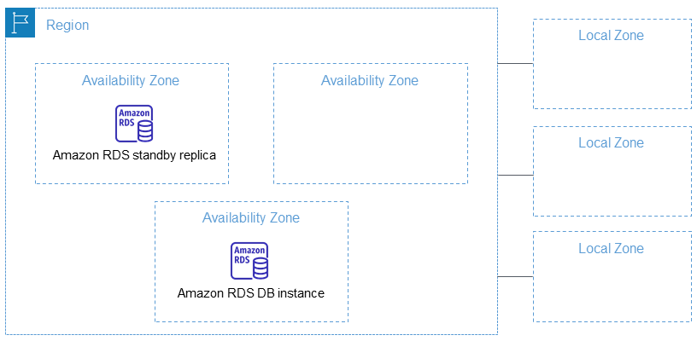

The chief benefits of running your DB instance as a Multi-AZ deployment are enhanced database durability and availability. The increased availability and fault tolerance offered by Multi-AZ deployments make them a natural fit for production environments.

Hence, the correct answers are the following options:

**- Increased database availability in the case of system upgrades like OS patching or DB Instance scaling.**

**- Provides enhanced database durability in the event of a DB instance component failure or an Availability Zone outage.**

The option that says: **Creates a primary DB Instance and synchronously replicates the data to a standby instance in a different Availability Zone (AZ) in a different region** is almost correct. RDS synchronously replicates the data to a standby instance in a different Availability Zone (AZ) that is in the same region and not in a different one.

The options that say: **Significantly increases the database performance** and **Provides SQL optimization** are incorrect as it does not affect the performance nor provide SQL optimization.

**References:**

<https://aws.amazon.com/rds/details/multi-az/>

<https://aws.amazon.com/rds/faqs/>

**Check out this Amazon RDS Cheat Sheet:**

[https://tutorialsdojo.com/amazon-relational-database-service-amazon-rds/](https://tutorialsdojo.com/amazon-relational-database-service-amazon-rds/?src=udemy)

Bottom of Form

Top of Form

Question 2: Skipped

A top university has recently launched its online learning portal where the students can take e-learning courses from the comforts of their homes. The portal is on a large On-Demand EC2 instance with a single Amazon Aurora database.

How can you improve the availability of your Aurora database to prevent any unnecessary downtime of the online portal?

* ​

Create Amazon Aurora Replicas.

**(Correct)**

* ​

Enable Hash Joins to improve the database query performance.

* ​

Deploy Aurora to two Auto-Scaling groups of EC2 instances across two Availability Zones with an elastic load balancer which handles load balancing.

* ​

Use an Asynchronous Key Prefetch in Amazon Aurora to improve the performance of queries that join tables across indexes.

**Explanation**

**Amazon Aurora MySQL** and **Amazon Aurora PostgreSQL** support Amazon Aurora Replicas, which share the same underlying volume as the primary instance. Updates made by the primary are visible to all Amazon Aurora Replicas. With Amazon Aurora MySQL, you can also create MySQL Read Replicas based on MySQL's binlog-based replication engine. In MySQL Read Replicas, data from your primary instance is replayed on your replica as transactions. For most use cases, including read scaling and high availability, it is recommended using Amazon Aurora Replicas.

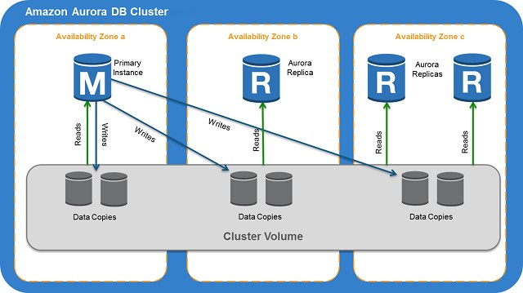

Read Replicas are primarily used for improving the read performance of the application. The most suitable solution in this scenario is to use Multi-AZ deployments instead but since this option is not available, you can still set up Read Replicas which you can promote as your primary stand-alone DB cluster in the event of an outage.

Hence, the correct answer here is to **create Amazon Aurora Replicas**.

**Deploying Aurora to two Auto-Scaling groups of EC2 instances across two Availability Zones with an elastic load balancer which handles load balancing** is incorrect because Aurora is a managed database engine for RDS and not deployed on typical EC2 instances that you manually provision.

**Enabling Hash Joins to improve the database query performance** is incorrect because Hash Joins are mainly used if you need to join a large amount of data by using an equijoin and not for improving availability.

**Using an Asynchronous Key Prefetch in Amazon Aurora to improve the performance of queries that join tables across indexes** is incorrect because the Asynchronous Key Prefetch is mainly used to improve the performance of queries that join tables across indexes.

**References:**

<https://docs.aws.amazon.com/AmazonRDS/latest/UserGuide/AuroraMySQL.BestPractices.html>

<https://aws.amazon.com/rds/aurora/faqs/>

**Check out this Amazon Aurora Cheat Sheet:**

[https://tutorialsdojo.com/amazon-aurora/](https://tutorialsdojo.com/amazon-aurora/?src=udemy)

Bottom of Form

Top of Form

Question 3: Skipped

**There is a technical requirement by a financial firm that does online credit card processing to have a secure application environment on AWS. They are trying to decide on whether to use KMS or CloudHSM.  
  
Which of the following statements is right when it comes to CloudHSM and KMS?**

* ​

You should consider using AWS CloudHSM over AWS KMS if you require your keys stored in dedicated, third-party validated hardware security modules under your exclusive control.

**(Correct)**

* ​

AWS CloudHSM should always be used for any payment transactions.

* ​

If you want a managed service for creating and controlling your encryption keys but don't want or need to operate your own HSM, consider using AWS CloudHSM.

* ​

No major difference. They both do the same thing.

**Explanation**

**AWS Key Management Service (AWS KMS)** is a managed service that makes it easy for you to create and control the encryption keys used to encrypt your data. The master keys that you create in AWS KMS are protected by FIPS 140-2 validated cryptographic modules. AWS KMS is integrated with most other AWS services that encrypt your data with encryption keys that you manage. AWS KMS is also integrated with AWS CloudTrail to provide encryption key usage logs to help meet your auditing, regulatory and compliance needs.

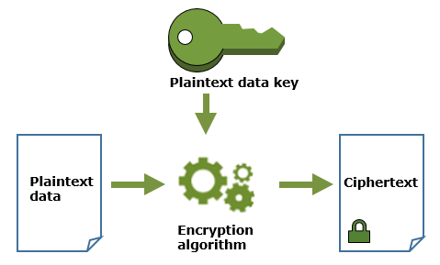

By using AWS KMS, you gain more control over access to data you encrypt. You can use the key management and cryptographic features directly in your applications or through AWS services that are integrated with AWS KMS. Whether you are writing applications for AWS or using AWS services, AWS KMS enables you to maintain control over who can use your customer master keys and gain access to your encrypted data. AWS KMS is integrated with AWS CloudTrail, a service that delivers log files to an Amazon S3 bucket that you designate. By using CloudTrail you can monitor and investigate how and when your master keys have been used and by whom.

If you want a managed service for creating and controlling your encryption keys, but you don't want or need to operate your own HSM, consider using AWS Key Management Service.

Hence, the correct answer is: ***You should consider using AWS CloudHSM over AWS KMS if you require your keys stored in dedicated, third-party validated hardware security modules under your exclusive control.***

The option that says: ***No major difference. They both do the same thing***is incorrect because KMS and CloudHSM are two different services. If you want a managed service for creating and controlling your encryption keys, without operating your own HSM, you have to consider using AWS Key Management Service.

The option that says:***If you want a managed service for creating and controlling your encryption keys, but you don't want or need to operate your own HSM, consider using AWS CloudHSM*** is incorrect because you have to consider using AWS KMS if you want a managed service for creating and controlling your encryption keys, without operating your own HSM.

The option that says:***AWS CloudHSM should always be used for any payment transactions***is incorrect because this is not always the case. AWS CloudHSM is a cloud-based hardware security module (HSM) that enables you to easily generate and use your own encryption keys on the AWS Cloud.

**References:**

<https://docs.aws.amazon.com/kms/latest/developerguide/overview.html>

<https://docs.aws.amazon.com/kms/latest/developerguide/concepts.html#data-keys>

<https://docs.aws.amazon.com/cloudhsm/latest/userguide/introduction.html>

**Check out this AWS Key Management Service Cheat Sheet:**

[https://tutorialsdojo.com/aws-key-management-service-aws-kms/](https://tutorialsdojo.com/aws-key-management-service-aws-kms/?src=udemy)

Bottom of Form

Top of Form

Question 4: Skipped

A company is using Amazon S3 to store frequently accessed data. The S3 bucket is shared with external users that will upload files regularly. A Solutions Architect needs to implement a solution that will grant the bucket owner full access to all uploaded objects in the S3 bucket.

What action should be done to achieve this task?

* ​

Create a bucket policy that will require the users to set the object's ACL to bucket-owner-full-control.

**(Correct)**

* ​

Create a CORS configuration in the S3 bucket.

* ​

Enable the Requester Pays feature in the Amazon S3 bucket.

* ​

Enable server access logging and set up an IAM policy that will require the users to set the object's ACL to bucket-owner-full-control.

**Explanation**

**Amazon S3** stores data as objects within buckets. An object is a file and any optional metadata that describes the file. To store a file in Amazon S3, you upload it to a bucket. When you upload a file as an object, you can set permissions on the object and any metadata. Buckets are containers for objects. You can have one or more buckets. You can control access for each bucket, deciding who can create, delete, and list objects in it. You can also choose the geographical Region where Amazon S3 will store the bucket and its contents and view access logs for the bucket and its objects.

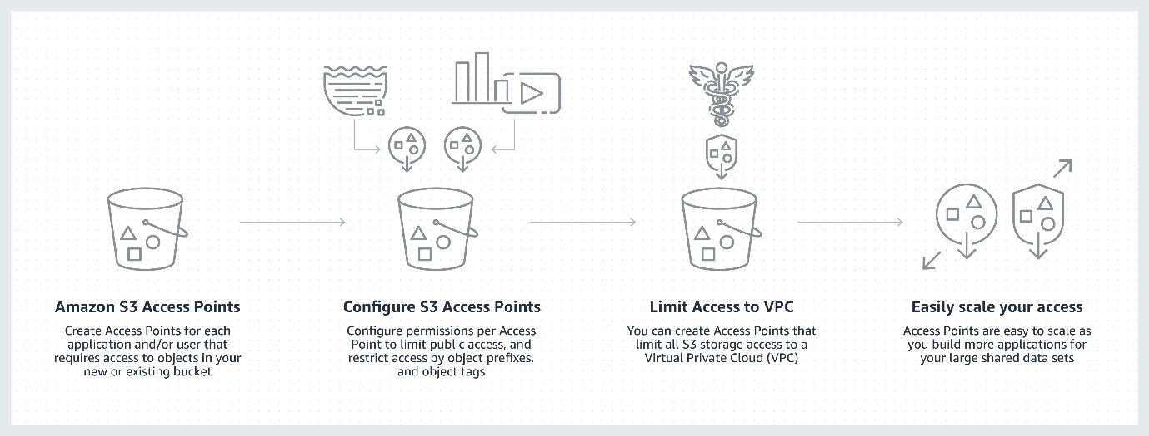

By default, an S3 object is owned by the AWS account that uploaded it even though the bucket is owned by another account. To get full access to the object, the object owner must explicitly grant the bucket owner access. You can create a bucket policy to require external users to grant bucket-owner-full-control when uploading objects so the bucket owner can have full access to the objects.

Hence, the correct answer is:**Create a bucket policy that will require the users to set the object's ACL to bucket-owner-full-control**.

The option that says:**Enable the Requester Pays feature in the Amazon S3 bucket**is incorrect because this option won't grant the bucket owner full access to the uploaded objects in the S3 bucket. With Requester Pays buckets, the requester, instead of the bucket owner, pays the cost of the request and the data download from the bucket.

The option that says:**Create a CORS configuration in the S3 bucket**is incorrect because this option only allows cross-origin access to your Amazon S3 resources. If you need to grant the bucket owner full control in the uploaded objects, you must create a bucket policy and require external users to grant bucket-owner-full-control when uploading objects.

The option that says:**Enable server access logging and set up an IAM policy that will require the users to set the bucket's ACL to bucket-owner-full-control**is incorrect because this option only provides detailed records for the requests that are made to a bucket. In addition, the **bucket-owner-full-control** canned ACL must be associated with the bucket policy and not to an IAM policy. This will require the users to set the object's ACL (not the bucket's) to bucket-owner-full-control.

**References:**

<https://aws.amazon.com/premiumsupport/knowledge-center/s3-bucket-owner-access/>

[https://aws.amazon.com//premiumsupport/knowledge-center/s3-require-object-ownership/](https://aws.amazon.com/premiumsupport/knowledge-center/s3-require-object-ownership/)

**Check out this Amazon S3 Cheat Sheet:**

[https://tutorialsdojo.com/amazon-s3/](https://tutorialsdojo.com/amazon-s3/?src=udemy)

Bottom of Form

Top of Form

Question 5: Skipped

A company has several unencrypted EBS snapshots in their VPC. The Solutions Architect must ensure that all of the new EBS volumes restored from the unencrypted snapshots are automatically encrypted.

What should be done to accomplish this requirement?

* ​

Launch new EBS volumes and specify the symmetric customer master key (CMK) for encryption.

* ​

Enable the EBS Encryption By Default feature for specific EBS volumes.

* ​

Launch new EBS volumes and encrypt them using an asymmetric customer master key (CMK).

* ​

Enable the EBS Encryption By Default feature for the AWS Region.

**(Correct)**

**Explanation**

You can configure your AWS account to enforce the encryption of the new EBS volumes and snapshot copies that you create. For example, Amazon EBS encrypts the EBS volumes created when you launch an instance and the snapshots that you copy from an unencrypted snapshot.

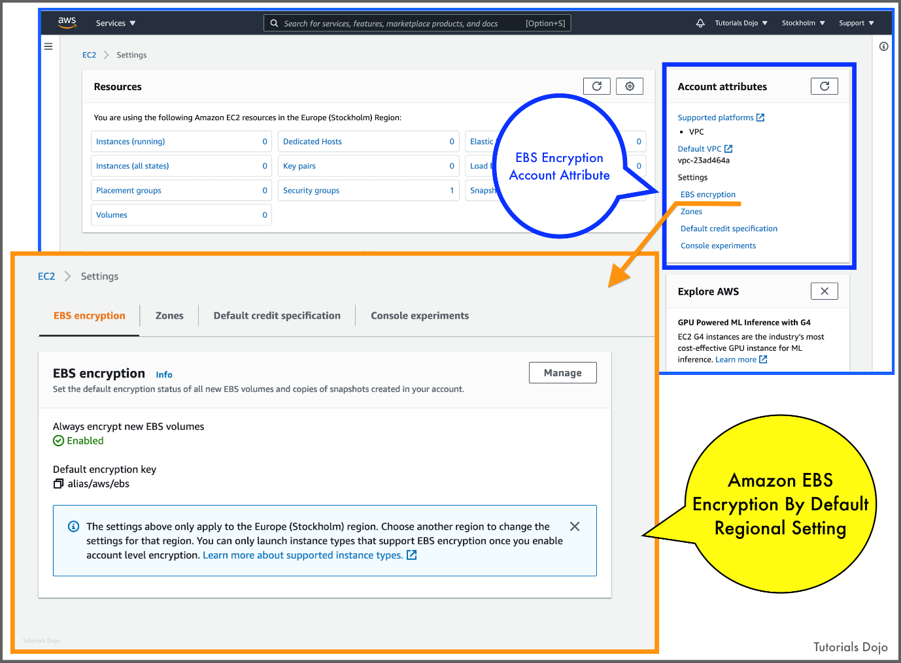

Encryption by default has no effect on existing EBS volumes or snapshots. The following are important considerations in EBS encryption:

**- Encryption by default** is a Region-specific setting. If you enable it for a Region, you cannot disable it for individual volumes or snapshots in that Region.

- When you enable encryption by default, you can launch an instance only if the instance type supports EBS encryption.

- Amazon EBS does not support asymmetric CMKs.

When migrating servers using AWS Server Migration Service (SMS), do not turn on encryption by default. If encryption by default is already on and you are experiencing delta replication failures, turn off encryption by default. Instead, enable AMI encryption when you create the replication job.

You cannot change the CMK that is associated with an existing snapshot or encrypted volume. However, you can associate a different CMK during a snapshot copy operation so that the resulting copied snapshot is encrypted by the new CMK.

Although there is no direct way to encrypt an existing unencrypted volume or snapshot, you can encrypt them by creating either a volume or a snapshot. If you enabled encryption by default, Amazon EBS encrypts the resulting new volume or snapshot using your default key for EBS encryption. Even if you have not enabled encryption by default, you can enable encryption when you create an individual volume or snapshot. Whether you enable encryption by default or in individual creation operations, you can override the default key for EBS encryption and use symmetric customer-managed CMK.

Hence, the correct answer is: **Enable the EBS Encryption By Default feature for the AWS Region.**

The option that says:**Launch new EBS volumes and encrypt them using an asymmetric customer master key (CMK)**is incorrect because Amazon EBS does not support asymmetric CMKs. To encrypt an EBS snapshot, you need to use symmetric CMK.

The option that says:**Launch new EBS volumes and specify the symmetric customer master key (CMK) for encryption** is incorrect. Although this solution will enable data encryption, this process is manual and can potentially cause some unencrypted EBS volumes to be launched. A better solution is to enable the EBS Encryption By Default feature. It is stated in the scenario that all of the new EBS volumes restored from the unencrypted snapshots must be automatically encrypted.

The option that says:**Enable the EBS Encryption By Default feature for specific EBS volumes** is incorrect because the Encryption By Default feature is a Region-specific setting and thus, you can't enable it to selected EBS volumes only.

**References:**

<https://docs.aws.amazon.com/AWSEC2/latest/UserGuide/EBSEncryption.html#encryption-by-default>

<https://docs.aws.amazon.com/kms/latest/developerguide/services-ebs.html>

**Check out this Amazon EBS Cheat Sheet:**

[https://tutorialsdojo.com/amazon-ebs/](https://tutorialsdojo.com/amazon-ebs/?src=udemy)

**Comparison of Amazon S3 vs Amazon EBS vs Amazon EFS:**

[https://tutorialsdojo.com/amazon-s3-vs-ebs-vs-efs/](https://tutorialsdojo.com/amazon-s3-vs-ebs-vs-efs/?src=udemy)

Bottom of Form

Top of Form

Question 6: Skipped

A company plans to use a cloud storage service to temporarily store its log files. The number of files to be stored is still unknown, but it only needs to be kept for 12 hours.

Which of the following is the most cost-effective storage class to use in this scenario?

* ​

Amazon S3 Glacier Deep Archive

* ​

Amazon S3 Standard-IA

* ​

Amazon S3 Intelligent-Tiering

* ​

Amazon S3 Standard

**(Correct)**

**Explanation**

**Amazon Simple Storage Service (Amazon S3)** is an object storage service that offers industry-leading scalability, data availability, security, and performance. Amazon S3 also offers a range of storage classes for the objects that you store. You choose a class depending on your use case scenario and performance access requirements. All of these storage classes offer high durability.

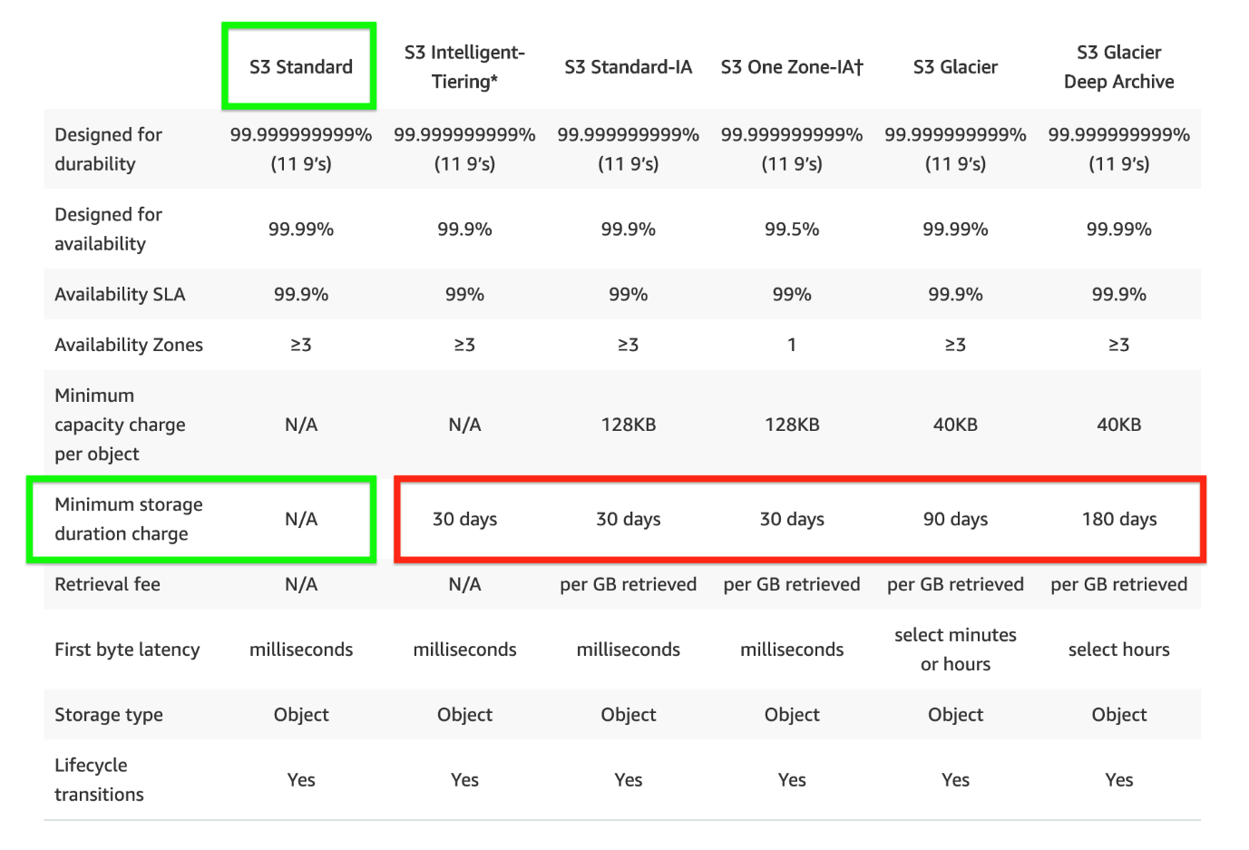

The scenario requires you to select a cost-effective service that does not have a **minimum storage duration** since the data will only last for 12 hours. Among the options given, only Amazon S3 Standard has the feature of no minimum storage duration. It is also the most cost-effective storage service because you will only be charged for the last 12 hours, unlike in other storage classes where you will still be charged based on its respective storage duration (e.g. 30 days, 90 days, 180 days).

S3 Standard-IA is designed for long-lived but infrequently accessed data that is retained for months or years. Data that is deleted from S3 Standard-IA within 30 days will still be charged for a full 30 days. S3 Intelligent-Tiering also has a minimum storage duration of 30 days, which means data that is deleted, overwritten, or transitioned to a different S3 Storage class before 30 days will incur the normal usage charge plus a pro-rated charge for the remainder of the 30-day minimum.

S3 Glacier Deep Archive is designed for long-lived but rarely accessed data that is retained for 7-10 years or more. Objects that are archived to S3 Glacier Deep Archive have a minimum of 180 days of storage, and objects deleted before 180 days incur a pro-rated charge equal to the storage charge for the remaining days.

Hence, the correct answer is: **Amazon S3 Standard**.

**Amazon S3 Standard-IA** is incorrect because this storage class has a minimum storage duration of at least 30 days. Remember that the scenario requires the data to be kept for 12 hours only.

**Amazon S3 Intelligent-Tiering** is incorrect. Although this is used for files that have unknown or unpredictable access patterns, just like S3 Standard-IA, this storage class has a minimum storage duration of at least 30 days.

**Amazon S3 Glacier Deep Archive** is incorrect. Although it is the most cost-effective storage class among all other options, it has a minimum storage duration of at least 180 days which is only suitable for backup and data archival. If you store your data in Glacier Deep Archive for only 12 hours, you will still be charged for the full 180 days.

**References:**

<https://docs.aws.amazon.com/AmazonS3/latest/dev/storage-class-intro.html>

<https://aws.amazon.com/s3/storage-classes/>

**Check out this Amazon S3 Cheat Sheet:**

[https://tutorialsdojo.com/amazon-s3/](https://tutorialsdojo.com/amazon-s3/?src=udemy)

**S3 Standard vs S3 Standard-IA vs S3 One Zone-IA Cheat Sheet:**

[https://tutorialsdojo.com/s3-standard-vs-s3-standard-ia-vs-s3-one-zone-ia/](https://tutorialsdojo.com/s3-standard-vs-s3-standard-ia-vs-s3-one-zone-ia/?src=udemy)

Bottom of Form

Top of Form

Question 7: Skipped

A company deployed a web application to an EC2 instance that adds a variety of photo effects to a picture uploaded by the users. The application will put the generated photos to an S3 bucket by sending PUT requests to the S3 API.

What is the best option for this scenario considering that you need to have API credentials to be able to send a request to the S3 API?

* ​

Store the API credentials in the root web application directory of the EC2 instance.

* ​

Store your API credentials in Amazon Glacier.

* ​

Encrypt the API credentials and store in any directory of the EC2 instance.

* ​

Create a role in IAM. Afterwards, assign this role to a new EC2 instance.

**(Correct)**

**Explanation**

The best option is to create a role in IAM. Afterward, assign this role to a new EC2 instance. Applications must sign their API requests with AWS credentials. Therefore, if you are an application developer, you need a strategy for managing credentials for your applications that run on EC2 instances.

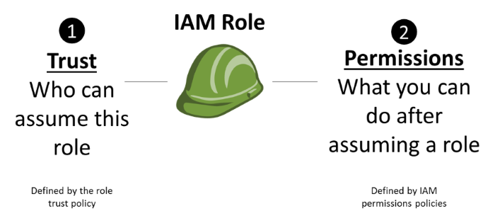

You can securely distribute your AWS credentials to the instances, enabling the applications on those instances to use your credentials to sign requests while protecting your credentials from other users. However, it's challenging to securely distribute credentials to each instance, especially those that AWS creates on your behalf such as Spot Instances or instances in Auto Scaling groups. You must also be able to update the credentials on each instance when you rotate your AWS credentials.

In this scenario, you have to use IAM roles so that your applications can securely make API requests from your instances without requiring you to manage the security credentials that the applications use. Instead of creating and distributing your AWS credentials, you can delegate permission to make API requests using IAM roles.

Hence, the correct answer is: **Create a role in IAM. Afterwards, assign this role to a new EC2 instance.**

The option that says: **Encrypt the API credentials and storing in any directory of the EC2 instance** and **Store the API credentials in the root web application directory of the EC2 instance** are incorrect. Though you can store and use the API credentials in the EC2 instance, it will be difficult to manage just as mentioned above. You have to use IAM Roles.

The option that says: **Store your API credentials in Amazon S3 Glacier** is incorrect as Amazon S3 Glacier is used for data archives and not for managing API credentials.

**Reference:**

<http://docs.aws.amazon.com/AWSEC2/latest/UserGuide/iam-roles-for-amazon-ec2.html>

**Check out this Amazon EC2 Cheat Sheet:**

[https://tutorialsdojo.com/amazon-elastic-compute-cloud-amazon-ec2/](https://tutorialsdojo.com/amazon-elastic-compute-cloud-amazon-ec2/?src=udemy)

Bottom of Form

Top of Form

Question 8: Skipped

A manufacturing company launched a new type of IoT sensor. The sensor will be used to collect large streams of data records. You need to create a solution that can ingest and analyze the data in real-time with millisecond response times.

Which of the following is the best option that you should implement in this scenario?

* ​

Ingest the data using Amazon Kinesis Data Firehose and create an AWS Lambda function to store the data in Amazon DynamoDB.

* ​

Ingest the data using Amazon Kinesis Data Streams and create an AWS Lambda function to store the data in Amazon DynamoDB.

**(Correct)**

* ​

Ingest the data using Amazon Simple Queue Service and create an AWS Lambda function to store the data in Amazon Redshift.

* ​

Ingest the data using Amazon Kinesis Data Streams and create an AWS Lambda function to store the data in Amazon Redshift.

**Explanation**

**Amazon Kinesis Data Streams**enables you to build custom applications that process or analyze streaming data for specialized needs. You can continuously add various types of data such as clickstreams, application logs, and social media to an Amazon Kinesis data stream from hundreds of thousands of sources. Within seconds, the data will be available for your Amazon Kinesis Applications to read and process from the stream.

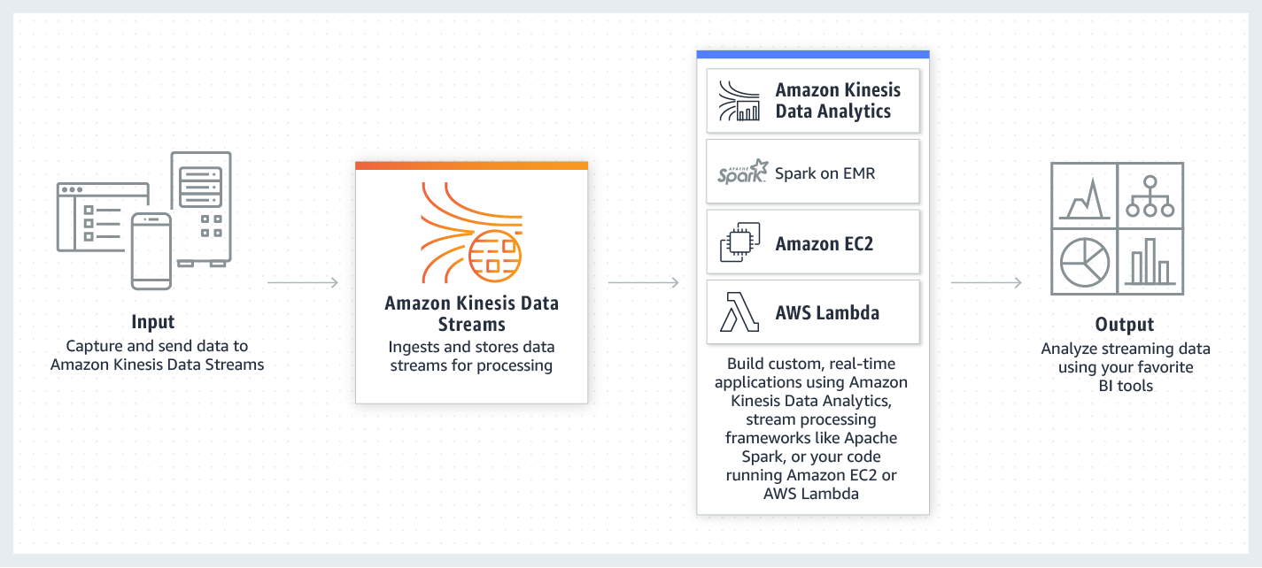

Based on the given scenario, the key points are "ingest and analyze the data in real-time" and "millisecond response times". For the first key point and based on the given options, you can use Amazon Kinesis Data Streams because it can collect and process large streams of data records in real-time. For the second key point, you should use Amazon DynamoDB since it supports single-digit millisecond response times at any scale.

Hence, the correct answer is:**Ingest the data using Amazon Kinesis Data Streams and create an AWS Lambda function to store the data in Amazon DynamoDB.**

The option that says:**Ingest the data using Amazon Kinesis Data Streams and create an AWS Lambda function to store the data in Amazon Redshift**is incorrect because Amazon Redshift only delivers sub-second response times. Take note that as per the scenario, the solution must have millisecond response times to meet the requirements. Amazon DynamoDB Accelerator (DAX), which is a fully managed, highly available, in-memory cache for Amazon DynamoDB, can deliver microsecond response times.

The option that says:**Ingest the data using Amazon Kinesis Data Firehose and create an AWS Lambda function to store the data in Amazon DynamoDB** is incorrect. Amazon Kinesis Data Firehose only supports Amazon S3, Amazon Redshift, Amazon Elasticsearch, and an HTTP endpoint as the destination.

The option that says:**Ingest the data using Amazon Simple Queue Service and create an AWS Lambda function to store the data in Amazon Redshift** is incorrect because Amazon SQS can't analyze data in real-time. You have to use an Amazon Kinesis Data Stream to process the data in near-real-time.

**References:**

<https://aws.amazon.com/kinesis/data-streams/faqs/>

<https://aws.amazon.com/dynamodb/>

**Check out this Amazon Kinesis Cheat Sheet:**

[https://tutorialsdojo.com/amazon-kinesis/](https://tutorialsdojo.com/amazon-kinesis/?src=udemy)

Bottom of Form

Top of Form

Question 9: Skipped

A company has an application that uses multiple EC2 instances located in various AWS regions such as US East (Ohio), US West (N. California), and EU (Ireland). The manager instructed the Solutions Architect to set up a latency-based routing to route incoming traffic for www.tutorialsdojo.com to all the EC2 instances across all AWS regions.

Which of the following options can satisfy the given requirement?

* ​

Use an Application Load Balancer to distribute the load to the multiple EC2 instances across all AWS Regions.

* ​

Use AWS DataSync to distribute the load to the multiple EC2 instances across all AWS Regions.

* ​

Use a Network Load Balancer to distribute the load to the multiple EC2 instances across all AWS Regions.

* ​

Use Route 53 to distribute the load to the multiple EC2 instances across all AWS Regions.

**(Correct)**

**Explanation**

If your application is hosted in multiple AWS Regions, you can improve performance for your users by serving their requests from the AWS Region that provides the lowest latency.

You can create latency records for your resources in multiple AWS Regions by using latency-based routing. In the event that Route 53 receives a DNS query for your domain or subdomain such as tutorialsdojo.com or portal.tutorialsdojo.com, it determines which AWS Regions you've created latency records for, determines which region gives the user the lowest latency and then selects a latency record for that region. Route 53 responds with the value from the selected record which can be the IP address for a web server or the CNAME of your elastic load balancer.

Hence, **using Route 53 to distribute the load to the multiple EC2 instances across all AWS Regions** is the correct answer.

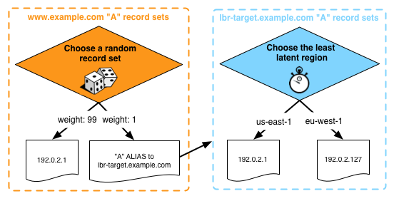

**Using a Network Load Balancer to distribute the load to the multiple EC2 instances across all AWS Regions** and **using an Application Load Balancer to distribute the load to the multiple EC2 instances across all AWS Regions** are both incorrect because load balancers distribute traffic only within their respective regions and not to other AWS regions by default. Although Network Load Balancers support connections from clients to IP-based targets in peered VPCs across different AWS Regions, the scenario didn't mention that the VPCs are peered with each other. It is best to use Route 53 instead to balance the incoming load to two or more AWS regions more effectively.

**Using AWS DataSync to distribute the load to the multiple EC2 instances across all AWS Regions** is incorrect because the AWS DataSync service simply provides a fast way to move large amounts of data online between on-premises storage and Amazon S3 or Amazon Elastic File System (Amazon EFS).

**References:**

<https://docs.aws.amazon.com/Route53/latest/DeveloperGuide/routing-policy.html#routing-policy-latency>

<https://docs.aws.amazon.com/Route53/latest/DeveloperGuide/TutorialAddingLBRRegion.html>

**Check out this Amazon Route 53 Cheat Sheet:**

[https://tutorialsdojo.com/amazon-route-53/](https://tutorialsdojo.com/amazon-route-53/?src=udemy)

Bottom of Form

Top of Form

Question 10: Skipped

A tech company is having an issue whenever they try to connect to the newly created EC2 instance using a Remote Desktop connection from a computer. Upon checking, the Solutions Architect has verified that the instance has a public IP and the Internet gateway and route tables are in place.

What else should he do to resolve this issue?

* ​

Adjust the security group to allow inbound traffic on port 3389 from the company’s IP address.

**(Correct)**

* ​

You should restart the EC2 instance since there might be some issue with the instance

* ​

You should create a new instance since there might be some issue with the instance

* ​

Adjust the security group to allow inbound traffic on port 22 from the company’s IP address.

**Explanation**

Since you are using a Remote Desktop connection to access your EC2 instance, you have to ensure that the Remote Desktop Protocol is allowed in the security group. By default, the server listens on TCP port 3389 and UDP port 3389.

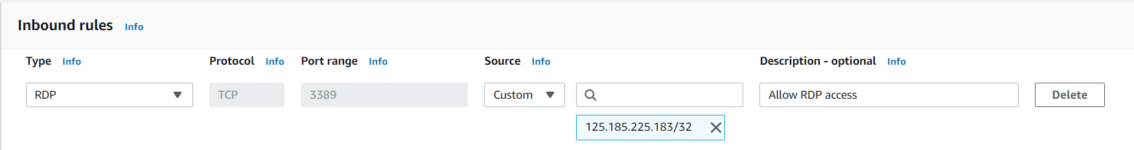

Hence, the correct answer is: **Adjust the security group to allow inbound traffic on port 3389 from the company’s IP address.**

The option that says: **Adjust the security group to allow inbound traffic on port 22 from the company’s IP address** is incorrect as port 22 is used for SSH connections and not for RDP.

The options that say: **You should restart the EC2 instance since there might be some issue with the instance** and **You should create a new instance since there might be some issue with the instance** are incorrect as the EC2 instance is newly created and hence, unlikely to cause the issue. You have to check the security group first if it allows the Remote Desktop Protocol (3389) before investigating if there is indeed an issue on the specific instance.

**Reference:**

<https://docs.aws.amazon.com/AWSEC2/latest/WindowsGuide/troubleshooting-windows-instances.html#rdp-issues>

<https://docs.aws.amazon.com/vpc/latest/userguide/VPC_SecurityGroups.html>

**Check out this Amazon EC2 Cheat Sheet:**

[https://tutorialsdojo.com/amazon-elastic-compute-cloud-amazon-ec2/](https://tutorialsdojo.com/amazon-elastic-compute-cloud-amazon-ec2/?src=udemy)

Bottom of Form

Top of Form

Question 11: Skipped

A company deployed a fleet of Windows-based EC2 instances with IPv4 addresses launched in a private subnet. Several software installed in the EC2 instances are required to be updated via the Internet.

Which of the following services can provide the firm a highly available solution to safely allow the instances to fetch the software patches from the Internet but prevent outside network from initiating a connection?

* ​

VPC Endpoint

* ​

NAT Gateway

**(Correct)**

* ​

NAT Instance

* ​

Egress-Only Internet Gateway

**Explanation**

AWS offers two kinds of NAT devices — a NAT gateway or a NAT instance. It is recommended to use NAT gateways, as they provide better availability and bandwidth over NAT instances. The NAT Gateway service is also a managed service that does not require your administration efforts. A NAT instance is launched from a NAT AMI.

Just like a NAT instance, you can use a network address translation (NAT) gateway to enable instances in a private subnet to connect to the internet or other AWS services, but prevent the internet from initiating a connection with those instances.

Here is a diagram showing the differences between NAT gateway and NAT instance:

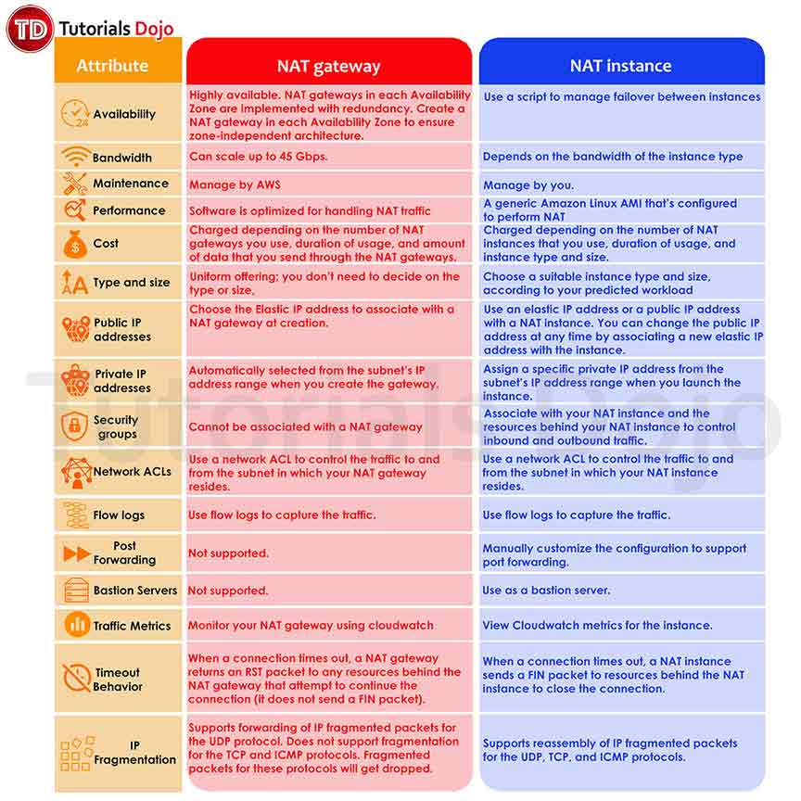

**Egress-Only Internet Gateway** is incorrect because this is primarily used for VPCs that use IPv6 to enable instances in a private subnet to connect to the Internet or other AWS services, but prevent the Internet from initiating a connection with those instances, just like what NAT Instance and NAT Gateway do. The scenario explicitly says that the EC2 instances are using IPv4 addresses which is why Egress-only Internet gateway is invalid, even though it can provide the required high availability.

**VPC Endpoint** is incorrect because this simply enables you to privately connect your VPC to supported AWS services and VPC endpoint services powered by PrivateLink without requiring an Internet gateway, NAT device, VPN connection, or AWS Direct Connect connection.

**NAT Instance** is incorrect because although this can also enable instances in a private subnet to connect to the Internet or other AWS services and prevent the Internet from initiating a connection with those instances, it is not as highly available compared to a NAT Gateway.

**References:**

<https://docs.aws.amazon.com/AmazonVPC/latest/UserGuide/vpc-nat-gateway.html>

<https://docs.aws.amazon.com/vpc/latest/userguide/vpc-nat-comparison.html>

<https://docs.aws.amazon.com/vpc/latest/userguide/egress-only-internet-gateway.html>

**Check out this Amazon VPC Cheat Sheet:**

[https://tutorialsdojo.com/amazon-vpc/](https://tutorialsdojo.com/amazon-vpc/?src=udemy)

Bottom of Form

Top of Form

Question 12: Skipped

An application is using a Lambda function to process complex financial data thatrun for 15 minutes on average. Most invocations were successfully processed. However, you noticed that there are a few terminated invocations throughout the day, which caused data discrepancy in the application.

Which of the following is the most likely cause of this issue?

* ​

The failed Lambda Invocations contain a ServiceException error which means that the AWS Lambda service encountered an internal error.

* ​

The concurrent execution limit has been reached.

* ​

The Lambda function contains a recursive code and has been running for over 15 minutes.

* ​

The failed Lambda functions have been running for over 15 minutes and reached the maximum execution time.

**(Correct)**

**Explanation**

A **Lambda function** consists of code and any associated dependencies. In addition, a Lambda function also has configuration information associated with it. Initially, you specify the configuration information when you create a Lambda function. Lambda provides an API for you to update some of the configuration data.

You pay for the AWS resources that are used to run your Lambda function. To prevent your Lambda function from running indefinitely, you specify a **timeout**. When the specified timeout is reached, AWS Lambda terminates execution of your Lambda function. It is recommended that you set this value based on your expected execution time. The default timeout is 3 seconds and the maximum execution duration per request in AWS Lambda is 900 seconds, which is equivalent to 15 minutes.

Hence, the correct answer is the option that says: **The failed Lambda functions have been running for over 15 minutes and reached the maximum execution time**.

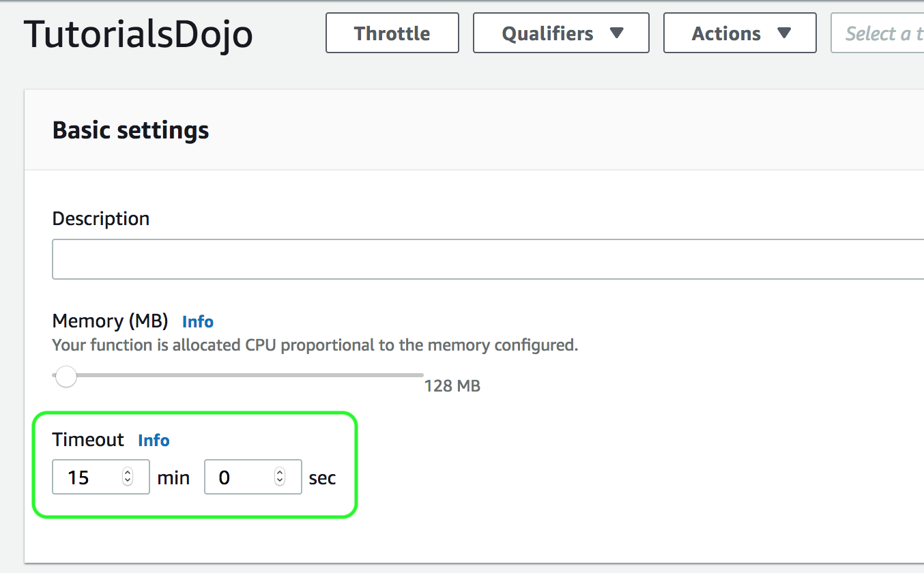

Take note that you can invoke a Lambda function synchronously either by calling the Invoke operation or by using an AWS SDK in your preferred runtime. If you anticipate a long-running Lambda function, your client may time out before function execution completes. To avoid this, update the client timeout or your SDK configuration.

The option that says: **The concurrent execution limit has been reached** is incorrect because, by default, the AWS Lambda limits the total concurrent executions across all functions within a given region to 1000. By setting a concurrency limit on a function, Lambda guarantees that allocation will be applied specifically to that function, regardless of the amount of traffic processing the remaining functions. If that limit is exceeded, the function will be throttled but not terminated, which is in contrast with what is happening in the scenario.

The option that says: **The Lambda function contains a recursive code and has been running for over 15 minutes** is incorrect because having a recursive code in your Lambda function does not directly result to an abrupt termination of the function execution. This is a scenario wherein the function automatically calls itself until some arbitrary criteria is met. This could lead to an unintended volume of function invocations and escalated costs, but not an abrupt termination because Lambda will throttle all invocations to the function.

The option that says: **The failed Lambda Invocations contain a ServiceException error which means that the AWS Lambda service encountered an internal error** is incorrect because although this is a valid root cause, it is unlikely to have several **ServiceException** errors throughout the day unless there is an outage or disruption in AWS. Since the scenario says that the Lambda function runs for about 10 to 15 minutes, the maximum execution duration is the most likely cause of the issue and not the AWS Lambda service encountering an internal error.

**References:**

<https://docs.aws.amazon.com/lambda/latest/dg/limits.html>

<https://docs.aws.amazon.com/lambda/latest/dg/resource-model.html>

**AWS Lambda Overview - Serverless Computing in AWS:**

<https://www.youtube.com/watch?v=bPVX1zHwAnY>

**Check out this AWS Lambda Cheat Sheet:**

[https://tutorialsdojo.com/aws-lambda/](https://tutorialsdojo.com/aws-lambda/%20?src=udemy)

Bottom of Form

Top of Form

Question 13: Skipped

A software development company needs to connect its on-premises infrastructure to the AWS cloud. Which of the following AWS services can you use to accomplish this? (Select TWO.)

* ​

VPC Peering

* ​

NAT Gateway

* ​

Amazon Connect

* ​

IPsec VPN connection

**(Correct)**

* ​

AWS Direct Connect

**(Correct)**

**Explanation**

You can connect your VPC to remote networks by using a VPN connection which can be IPsec VPN connection, AWS VPN CloudHub, or a third party software VPN appliance. A VPC VPN Connection utilizes IPSec to establish encrypted network connectivity between your intranet and Amazon VPC over the Internet.

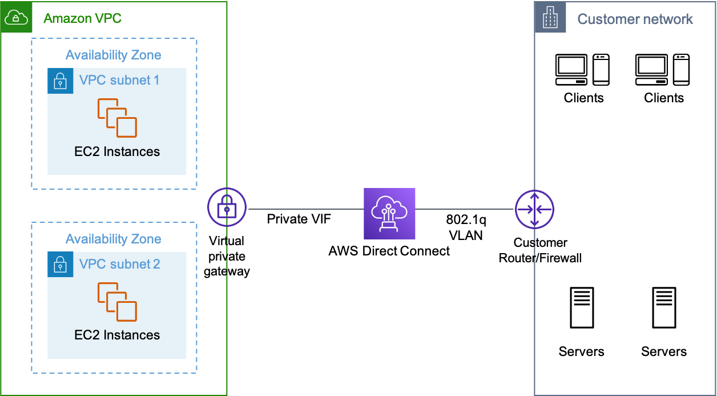

**AWS Direct Connect** is a network service that provides an alternative to using the Internet to connect customer's on-premises sites to AWS. AWS Direct Connect does not involve the Internet; instead, it uses dedicated, private network connections between your intranet and Amazon VPC.

Hence, **IPsec VPN connection** and **AWS Direct Connect** are the correct answers.

**Amazon Connect** is incorrect because this is not a VPN connectivity option. It is actually a self-service, cloud-based contact center service in AWS that makes it easy for any business to deliver better customer service at a lower cost. Amazon Connect is based on the same contact center technology used by Amazon customer service associates around the world to power millions of customer conversations.

**VPC Peering** is incorrect because this is a networking connection between two VPCs only, which enables you to route traffic between them privately. This can't be used to connect your on-premises network to your VPC.

**NAT Gateway** is incorrect because you only use a network address translation (NAT) gateway to enable instances in a private subnet to connect to the Internet or other AWS services, but prevent the Internet from initiating a connection with those instances. This is not used to connect to your on-premises network.

**References:**

<https://docs.aws.amazon.com/AmazonVPC/latest/UserGuide/vpn-connections.html>

<https://aws.amazon.com/directconnect/faqs>

**Check out this Amazon VPC Cheat Sheet:**

[https://tutorialsdojo.com/amazon-vpc/](https://tutorialsdojo.com/amazon-vpc/?src=udemy)

Bottom of Form

Top of Form

Question 14: Skipped

**A large Philippine-based Business Process Outsourcing company is building a two-tier web application in their VPC to serve dynamic transaction-based content. The data tier is leveraging an Online Transactional Processing (OLTP) database but for the web tier, they are still deciding what service they will use.  
  
What AWS services should you leverage to build an elastic and scalable web tier?**

* ​

Amazon RDS with Multi-AZ and Auto Scaling

* ​

Amazon EC2, Amazon DynamoDB, and Amazon S3

* ​

Elastic Load Balancing, Amazon EC2, and Auto Scaling

**(Correct)**

* ​

Elastic Load Balancing, Amazon RDS with Multi-AZ, and Amazon S3

**Explanation**

**Amazon RDS** is a suitable database service for online transaction processing (OLTP) applications. However, the question asks for a list of AWS services for the web tier and not the database tier. Also, when it comes to services providing scalability and elasticity for your web tier, you should always consider using Auto Scaling and Elastic Load Balancer.

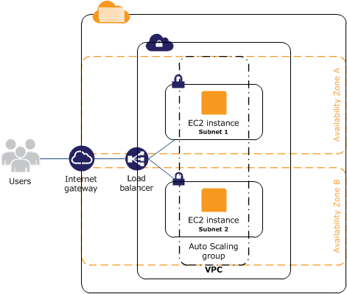

To build an elastic and a highly-available web tier, you can use Amazon EC2, Auto Scaling, and Elastic Load Balancing. You can deploy your web servers on a fleet of EC2 instances to an Auto Scaling group, which will automatically monitor your applications and automatically adjust capacity to maintain steady, predictable performance at the lowest possible cost. Load balancing is an effective way to increase the availability of a system. Instances that fail can be replaced seamlessly behind the load balancer while other instances continue to operate. Elastic Load Balancing can be used to balance across instances in multiple availability zones of a region.

The rest of the options are all incorrect since they don't mention all of the required services in building a highly available and scalable web tier, such as EC2, Auto Scaling, and Elastic Load Balancer. Although Amazon RDS with Multi-AZ and DynamoDB are highly scalable databases, the scenario is more focused on building its web tier and not the database tier.

Hence, the correct answer is ***Elastic Load Balancing, Amazon EC2, and Auto Scaling.***

The option that says: ***Elastic Load Balancing, Amazon RDS with Multi-AZ, and Amazon S3***is incorrect because you can't host your web tier using Amazon S3 since the application is doing a dynamic transactions. Amazon S3 is only suitable if you plan to have a static website.

The option that says: ***Amazon RDS with Multi-AZ and Auto Scaling*** is incorrect because the focus of the question is building a scalable web tier. You need a service, like EC2, in which you can run your web tier.

The option that says: ***Amazon EC2, Amazon DynamoDB, and Amazon S3*** is incorrect because you need Auto Scaling and ELB in order to scale the web tier.

**References:**

<https://media.amazonwebservices.com/AWS_Building_Fault_Tolerant_Applications.pdf>

<https://d1.awsstatic.com/whitepapers/aws-building-fault-tolerant-applications.pdf>

<https://docs.aws.amazon.com/AWSEC2/latest/UserGuide/ec2-increase-availability.html>

Bottom of Form

Top of Form

Question 15: Skipped

A company has an application architecture that stores both the access key ID and the secret access key in a plain text file on a custom Amazon Machine Image (AMI). The EC2 instances, which are created by using this AMI, are using the stored access keys to connect to a DynamoDB table.

What should the Solutions Architect do to make the current architecture more secure?

* ​

Do nothing. The architecture is already secure because the access keys are already in the Amazon Machine Image.

* ​

Remove the stored access keys in the AMI. Create a new IAM role with permissions to access the DynamoDB table and assign it to the EC2 instances.

**(Correct)**

* ​

Put the access keys in an Amazon S3 bucket instead.

* ​

Put the access keys in Amazon Glacier instead.

**Explanation**

You should use an IAM role to manage *temporary* credentials for applications that run on an EC2 instance. When you use an IAM role, you don't have to distribute long-term credentials (such as a user name and password or access keys) to an EC2 instance.

Instead, the role supplies temporary permissions that applications can use when they make calls to other AWS resources. When you launch an EC2 instance, you specify an IAM role to associate with the instance. Applications that run on the instance can then use the role-supplied temporary credentials to sign API requests.

Hence, the best option here is to remove the stored access keys first in the AMI. Then, create a new IAM role with permissions to access the DynamoDB table and assign it to the EC2 instances.

**Putting the access keys in Amazon Glacier** or **in an Amazon S3 bucket** are incorrect because S3 and Glacier are mainly used as a storage option. It is better to use an IAM role instead of storing access keys in these storage services.

The option that says: **Do nothing. The architecture is already secure because the access keys are already in the Amazon Machine Image** is incorrect because you can make the architecture more secure by using IAM.

**Reference:**

<https://docs.aws.amazon.com/IAM/latest/UserGuide/id_roles_use_switch-role-ec2.html>

**Check out this AWS Identity & Access Management (IAM) Cheat Sheet:**

<https://tutorialsdojo.com/aws-identity-and-access-management-iam/>

Bottom of Form

Top of Form

Question 16: Skipped

A website hosted on Amazon ECS container instances loads slowly during peak traffic, affecting its availability. Currently, the container instances are run behind an Application Load Balancer, and CloudWatch alarms are configured to send notifications to the operations team if there is a problem in availability so they can scale out if needed. A solutions architect needs to create an automatic scaling solution when such problems occur.

Which solution could satisfy the requirement? (Select TWO.)

* ​

Create an AWS Auto Scaling policy that scales out the ECS service when the service’s memory utilization is too high.

**(Correct)**

* ​

Create an AWS Auto Scaling policy that scales out the ECS cluster when the cluster’s CPU utilization is too high.

**(Correct)**

* ​

Create an AWS Auto Scaling policy that scales out the ECS cluster when the ALB target group’s CPU utilization is too high.

* ​

Create an AWS Auto Scaling policy that scales out the ECS service when the ALB hits a high CPU utilization.

* ​

Create an AWS Auto Scaling policy that scales out an ECS service when the ALB endpoint becomes unreachable.

**Explanation**

**AWS Auto Scaling** monitors your applications and automatically adjusts capacity to maintain steady, predictable performance at the lowest possible cost. Using AWS Auto Scaling, it’s easy to set up application scaling for multiple resources across multiple services in minutes. The service provides a simple, powerful user interface that lets you build scaling plans for resources including Amazon EC2 instances and Spot Fleets, Amazon ECS tasks, Amazon DynamoDB tables and indexes, and Amazon Aurora Replicas.

In this scenario, you can set up a scaling policy that triggers a scale-out activity to an ECS service or ECS container instance based on the metric that you prefer.

**The following metrics are available for instances:**

CPU Utilization

Disk Reads

Disk Read Operations

Disk Writes

Disk Write Operations

Network In

Network Out

Status Check Failed (Any)

Status Check Failed (Instance)

Status Check Failed (System)

**The following metrics are available for ECS Service:**

**ECSServiceAverageCPUUtilization**—Average CPU utilization of the service.

**ECSServiceAverageMemoryUtilization**—Average memory utilization of the service.

**ALBRequestCountPerTarget**—Number of requests completed per target in an Application Load Balancer target group.

Hence, the correct answers are:

**- Create an AWS Auto scaling policy that scales out the ECS service when the service’s memory utilization is too high.**

**- Create an AWS Auto scaling policy that scales out the ECS cluster when the cluster’s CPU utilization is too high.**

The option that says: **Create an AWS Auto scaling policy that scales out an ECS service when the ALB endpoint becomes unreachable** is incorrect. This would be a different problem that needs to be addressed differently if this is the case. An unreachable ALB endpoint could mean other things like a misconfigured security group or network access control lists.

The option that says: **Create an AWS Auto scaling policy that scales out the ECS service when the ALB hits a high CPU utilization**is incorrect. ALB is a managed resource. You cannot track nor view its resource utilization.

The option that says: **Create an AWS Auto scaling policy that scales out the ECS cluster when the ALB target group’s CPU utilization is too high**is incorrect. AWS Auto Scaling does not support this metric for ALB.

**References:**

<https://docs.aws.amazon.com/AmazonECS/latest/developerguide/service-configure-auto-scaling.html>

<https://docs.aws.amazon.com/autoscaling/ec2/userguide/as-instance-monitoring.html>

**Check out this AWS Auto Scaling Cheat Sheet:**

[https://tutorialsdojo.com/aws-auto-scaling/](https://tutorialsdojo.com/aws-auto-scaling/?src=udemy)

Bottom of Form

Top of Form

Question 17: Skipped

A company has several EC2 Reserved Instances in their account that need to be decommissioned and shut down since they are no longer used by the development team. However, the data is still required by the audit team for compliance purposes.

Which of the following steps can be taken in this scenario? (Select TWO.)

* ​

Convert the EC2 instances to Spot instances with a persistent Spot request type.

* ​

Convert the EC2 instance to On-Demand instances

* ​

Take snapshots of the EBS volumes and terminate the EC2 instances.

**(Correct)**

* ​

You can opt to sell these EC2 instances on the AWS Reserved Instance Marketplace

**(Correct)**

* ​

Stop all the running EC2 instances.

**Explanation**

**Amazon Elastic Compute Cloud (Amazon EC2)** is a web service that provides secure, resizable compute capacity in the cloud. It is designed to make web-scale cloud computing easier for developers. Amazon EC2’s simple web service interface allows you to obtain and configure capacity with minimal friction. It provides you with complete control of your computing resources and lets you run on Amazon’s proven computing environment.

The first requirement as per the scenario is to decommission and shut down several EC2 Reserved Instances. However, it is also mentioned that the audit team still requires the data for compliance purposes. To fulfill the given requirements, you can first create a snapshot of the instance to save its data and then sell the instance to the Reserved Instance Marketplace.

The Reserved Instance Marketplace is a platform that supports the sale of third-party and AWS customers' unused Standard Reserved Instances, which vary in terms of length and pricing options. For example, you may want to sell Reserved Instances after moving instances to a new AWS region, changing to a new instance type, ending projects before the term expiration, when your business needs change, or if you have unneeded capacity.

Hence, the correct answers are:

**- You can opt to sell these EC2 instances on the AWS Reserved Instance Marketplace.**

**- Take snapshots of the EBS volumes and terminate the EC2 instances.**

The option that says:**Convert the EC2 instance to On-Demand instances**is incorrect because it's stated in the scenario that the development team no longer needs several EC2 Reserved Instances. By converting it to On-Demand instances, the company will still have instances running in their infrastructure and this will result in additional costs.

The option that says:**Convert the EC2 instances to Spot instances with a persistent Spot request type** is incorrect because the requirement in the scenario is to terminate or shut down several EC2 Reserved Instances. Converting the existing instances to Spot instances will not satisfy the given requirement.

The option that says:**Stop all the running EC2 instances** is incorrect because doing so will still incur storage cost. Take note that the requirement in the scenario is to decommission and shut down several EC2 Reserved Instances. Therefore, this approach won't fulfill the given requirement.

**References:**

<https://docs.aws.amazon.com/AWSEC2/latest/UserGuide/ri-market-general.html>

<https://docs.aws.amazon.com/AWSEC2/latest/UserGuide/ebs-creating-snapshot.html>

**Check out this Amazon EC2 Cheat Sheet:**

[https://tutorialsdojo.com/amazon-elastic-compute-cloud-amazon-ec2/](https://tutorialsdojo.com/amazon-elastic-compute-cloud-amazon-ec2/?src=udemy)

**AWS Container Services Overview:**

<https://www.youtube.com/watch?v=5QBgDX7O7pw>

Bottom of Form

Top of Form

Question 18: Skipped

A game development company operates several virtual reality (VR) and augmented reality (AR) games which use various RESTful web APIs hosted on their on-premises data center. Due to the unprecedented growth of their company, they decided to migrate their system to AWS Cloud to scale out their resources as well to minimize costs.

Which of the following should you recommend as the most cost-effective and scalable solution to meet the above requirement?

* ​

Set up a micro-service architecture with ECS, ECR, and Fargate.

* ​

Host the APIs in a static S3 web hosting bucket behind a CloudFront web distribution.

* ​

Use a Spot Fleet of Amazon EC2 instances, each with an Elastic Fabric Adapter (EFA) for more consistent latency and higher network throughput. Set up an Application Load Balancer to distribute traffic to the instances.

* ​

Use AWS Lambda and Amazon API Gateway.

**(Correct)**

**Explanation**

With AWS Lambda, you pay only for what you use. You are charged based on the number of requests for your functions and the duration, the time it takes for your code to execute.

Lambda counts a request each time it starts executing in response to an event notification or invoke call, including test invokes from the console. You are charged for the total number of requests across all your functions. Duration is calculated from the time your code begins executing until it returns or otherwise terminates, rounded up to the nearest 100ms. The price depends on the amount of memory you allocate to your function. The Lambda free tier includes 1M free requests per month and over 400,000 GB-seconds of compute time per month.

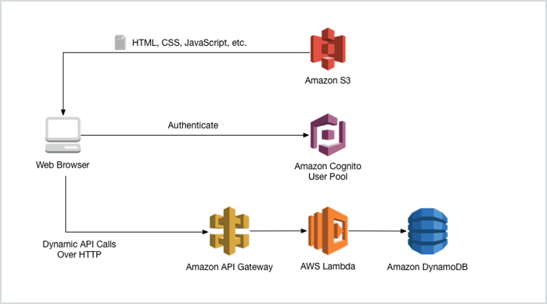

The best possible answer here is to use Lambda and API Gateway because this solution is both scalable and cost-effective. You will only be charged when you use your Lambda function, unlike having an EC2 instance which always runs even though you don’t use it.

**Setting up a micro-service architecture with ECS, ECR, and Fargate** is incorrect because ECS is mainly used to host Docker applications and in addition, using ECS, ECR, and Fargate alone is not scalable and not recommended for this type of scenarios.

**Hosting the APIs in a static S3 web hosting bucket behind a CloudFront web distribution** is not a suitable option as there is no compute capability for S3 and you can only use it as a static website. Although this solution is scalable since it is using CloudFront, the use of S3 to host the web APIs or the dynamic website is still incorrect.

The option that says: **Use a Spot Fleet of Amazon EC2 instances, each with an Elastic Fabric Adapter (EFA) for more consistent latency and higher network throughput. Set up an Application Load Balancer to distribute traffic to the instances** is incorrect because EC2 alone, without Auto Scaling, is not scalable. Even though you use Spot EC2 instance, it is still more expensive compared to Lambda because you will be charged only when your function is being used. An Elastic Fabric Adapter (EFA) is simply a network device that you can attach to your Amazon EC2 instance that enables you to achieve the application performance of an on-premises HPC cluster, with the scalability, flexibility, and elasticity provided by the AWS Cloud. Although EFA is scalable, the Spot Fleet configuration of this option doesn't have Auto Scaling involved.

**References:**

<https://docs.aws.amazon.com/apigateway/latest/developerguide/getting-started-with-lambda-integration.html>

<https://aws.amazon.com/lambda/pricing/>

**Check out this AWS Lambda Cheat Sheet:**

[https://tutorialsdojo.com/aws-lambda/](https://tutorialsdojo.com/aws-lambda/?src=udemy)

**EC2 Container Service (ECS) vs Lambda:**

[https://tutorialsdojo.com/ec2-container-service-ecs-vs-lambda/](https://tutorialsdojo.com/ec2-container-service-ecs-vs-lambda/?src=udemy)

Bottom of Form

Top of Form

Question 19: Skipped

A company hosted a movie streaming app in Amazon Web Services. The application is deployed to several EC2 instances on multiple availability zones.

Which of the following configurations allows the load balancer to distribute incoming requests evenly to all EC2 instances across multiple Availability Zones?

* ​

Cross-zone load balancing

**(Correct)**

* ​

Elastic Load Balancing request routing

* ​

An Amazon Route 53 latency routing policy

* ​

An Amazon Route 53 weighted routing policy

**Explanation**

The right answer is to enable **cross-zone load balancing.**

If the load balancer nodes for your Classic Load Balancer can distribute requests regardless of Availability Zone, this is known as *cross-zone load balancing*. With cross-zone load balancing enabled, your load balancer nodes distribute incoming requests evenly across the Availability Zones enabled for your load balancer. Otherwise, each load balancer node distributes requests only to instances in its Availability Zone.

For example, if you have 10 instances in Availability Zone us-west-2a and 2 instances in us-west-2b, the requests are distributed evenly across all 12 instances if cross-zone load balancing is enabled. Otherwise, the 2 instances in us-west-2b serve the same number of requests as the 10 instances in us-west-2a.

Cross-zone load balancing reduces the need to maintain equivalent numbers of instances in each enabled Availability Zone, and improves your application's ability to handle the loss of one or more instances. However, we still recommend that you maintain approximately equivalent numbers of instances in each enabled Availability Zone for higher fault tolerance.

**Reference:**

<http://docs.aws.amazon.com/elasticloadbalancing/latest/classic/enable-disable-crosszone-lb.html>

**AWS Elastic Load Balancing Overview:**

<https://www.youtube.com/watch?v=UBl5dw59DO8>

**Check out this AWS Elastic Load Balancing (ELB) Cheat Sheet:**

[https://tutorialsdojo.com/aws-elastic-load-balancing-elb/](https://tutorialsdojo.com/aws-elastic-load-balancing-elb/?src=udemy)

Bottom of Form

Top of Form

Question 20: Skipped

A Solutions Architect needs to create a publicly accessible EC2 instance by using an Elastic IP (EIP) address and generate a report on how much it will cost to use that EIP.

Which of the following statements is correct regarding the pricing of EIP?

* ​

There is no cost if the instance is running and it has at least two associated EIP.

* ​

There is no cost if the instance is stopped and it has only one associated EIP.

* ​

There is no cost if the instance is terminated and it has only one associated EIP.

* ​

There is no cost if the instance is running and it has only one associated EIP.

**(Correct)**

**Explanation**

An Elastic IP address doesn’t incur charges as long as the following conditions are true:

- The Elastic IP address is associated with an Amazon EC2 instance.

- The instance associated with the Elastic IP address is running.

- The instance has only one Elastic IP address attached to it.

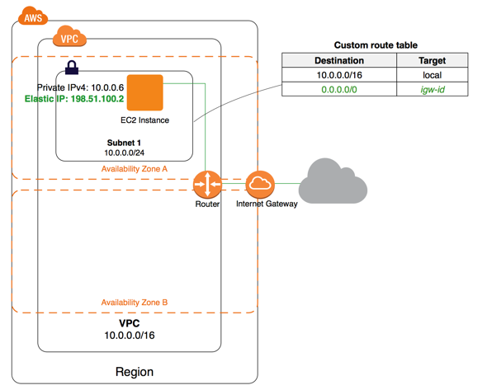

If you’ve stopped or terminated an EC2 instance with an associated Elastic IP address and you don’t need that Elastic IP address anymore, consider disassociating or releasing the Elastic IP address.

**Reference:**

<https://aws.amazon.com/premiumsupport/knowledge-center/elastic-ip-charges/>

**Tutorials Dojo's AWS Certified Solutions Architect Associate Exam Study Guide:**

[https://tutorialsdojo.com/aws-certified-solutions-architect-associate/](https://tutorialsdojo.com/aws-certified-solutions-architect-associate/?src=udemy)

Bottom of Form

Top of Form

Question 21: Skipped

A Solutions Architect needs to set up the required compute resources for the application which have workloads that require high, sequential read and write access to very large data sets on local storage.

Which of the following instance type is the most suitable one to use in this scenario?

* ​

Storage Optimized Instances

**(Correct)**

* ​

Memory Optimized Instances

* ​

Compute Optimized Instances

* ​

General Purpose Instances

**Explanation**

Storage optimized instances are designed for workloads that require high, sequential read and write access to very large data sets on local storage. They are optimized to deliver tens of thousands of low-latency, random I/O operations per second (IOPS) to applications.

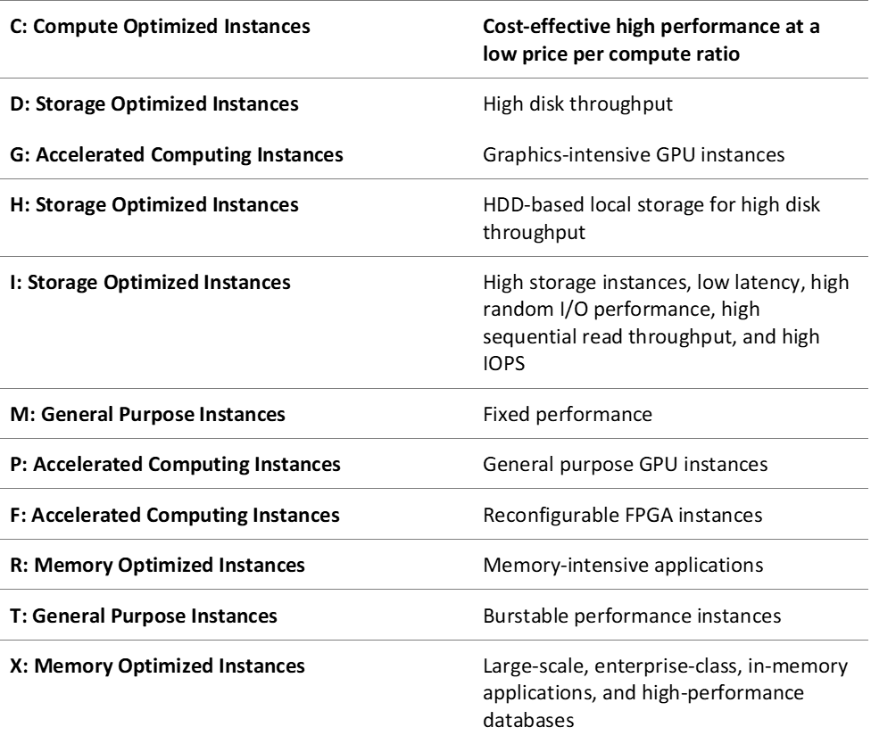

Hence, the correct answer is: **Storage Optimized Instances.**

**Memory Optimized Instances** is incorrect because these are designed to deliver fast performance for workloads that process large data sets in memory, which is quite different from handling high read and write capacity on local storage.

**Compute Optimized Instances** is incorrect because these are ideal for compute-bound applications that benefit from high-performance processors, such as batch processing workloads and media transcoding.

**General Purpose Instances** is incorrect because these are the most basic type of instances. They provide a balance of compute, memory, and networking resources, and can be used for a variety of workloads. Since you are requiring higher read and write capacity, storage optimized instances should be selected instead.

**Reference:**

<https://docs.aws.amazon.com/AWSEC2/latest/UserGuide/storage-optimized-instances.html>

**Check out this Amazon EC2 Cheat Sheet:**

[https://tutorialsdojo.com/amazon-elastic-compute-cloud-amazon-ec2/](https://tutorialsdojo.com/amazon-elastic-compute-cloud-amazon-ec2/?src=udemy)

Bottom of Form

Top of Form

Question 22: Skipped

An online shopping platform has been deployed to AWS using Elastic Beanstalk. They simply uploaded their Node.js application, and Elastic Beanstalk automatically handles the details of capacity provisioning, load balancing, scaling, and application health monitoring. Since the entire deployment process is automated, the DevOps team is not sure where to get the application log files of their shopping platform.

In Elastic Beanstalk, where does it store the application files and server log files?

* ​

Application files are stored in S3. The server log files can be stored directly in Glacier or in CloudWatch Logs.

* ​

Application files are stored in S3. The server log files can also optionally be stored in S3 or in CloudWatch Logs.

**(Correct)**

* ​

Application files are stored in S3. The server log files can be optionally stored in CloudTrail or in CloudWatch Logs.

* ​

Application files are stored in S3. The server log files can only be stored in the attached EBS volumes of the EC2 instances, which were launched by AWS Elastic Beanstalk.

**Explanation**

**AWS Elastic Beanstalk** stores your application files and optionally, server log files in Amazon S3. If you are using the AWS Management Console, the AWS Toolkit for Visual Studio, or AWS Toolkit for Eclipse, an Amazon S3 bucket will be created in your account and the files you upload will be automatically copied from your local client to Amazon S3. Optionally, you may configure Elastic Beanstalk to copy your server log files every hour to Amazon S3. You do this by editing the environment configuration settings.

Thus, the correct answer is the option that says: **Application files are stored in S3. The server log files can also optionally be stored in S3 or in CloudWatch Logs.**

With **CloudWatch Logs**, you can monitor and archive your Elastic Beanstalk application, system, and custom log files from Amazon EC2 instances of your environments. You can also configure alarms that make it easier for you to react to specific log stream events that your metric filters extract. The CloudWatch Logs agent installed on each Amazon EC2 instance in your environment publishes metric data points to the CloudWatch service for each log group you configure. Each log group applies its own filter patterns to determine what log stream events to send to CloudWatch as data points. Log streams that belong to the same log group share the same retention, monitoring, and access control settings. You can configure Elastic Beanstalk to automatically stream logs to the CloudWatch service.

The option that says: **Application files are stored in S3. The server log files can only be stored in the attached EBS volumes of the EC2 instances, which were launched by AWS Elastic Beanstalk** is incorrect because the server log files can also be stored in either S3 or CloudWatch Logs, and not only on the EBS volumes of the EC2 instances which are launched by AWS Elastic Beanstalk.

The option that says: **Application files are stored in S3. The server log files can be stored directly in Glacier or in CloudWatch Logs** is incorrect because the server log files can optionally be stored in either S3 or CloudWatch Logs, but not directly to Glacier. You can create a lifecycle policy to the S3 bucket to store the server logs and archive it in Glacier, but there is no direct way of storing the server logs to Glacier using Elastic Beanstalk unless you do it programmatically.

The option that says: **Application files are stored in S3. The server log files can be optionally stored in CloudTrail or in CloudWatch Logs** is incorrect because the server log files can optionally be stored in either S3 or CloudWatch Logs, but not directly to CloudTrail as this service is primarily used for auditing API calls.

**Reference:**

<https://aws.amazon.com/elasticbeanstalk/faqs/>

**AWS Elastic Beanstalk Overview:**

<https://www.youtube.com/watch?v=rx7e7Fej1Oo>

**Check out this AWS Elastic Beanstalk Cheat Sheet:**

[https://tutorialsdojo.com/aws-elastic-beanstalk/](https://tutorialsdojo.com/aws-elastic-beanstalk/?src=udemy)

Bottom of Form

Top of Form

Question 23: Skipped

A company has a fleet of running Spot EC2 instances behind an Application Load Balancer. The incoming traffic comes from various users across multiple AWS regions and you would like to have the user's session shared among the fleet of instances. You are required to set up a distributed session management layer that will provide a scalable and shared data storage for the user sessions.

Which of the following would be the best choice to meet the requirement while still providing sub-millisecond latency for the users?

* ​

Multi-AZ RDS

* ​

Multi-master DynamoDB

* ​

ElastiCache in-memory caching

**(Correct)**

* ​

ELB sticky sessions

**Explanation**

For sub-millisecond latency caching, **ElastiCache** is the best choice. In order to address scalability and to provide a shared data storage for sessions that can be accessed from any individual web server, you can abstract the HTTP sessions from the web servers themselves. A common solution for this is to leverage an In-Memory Key/Value store such as Redis and Memcached.

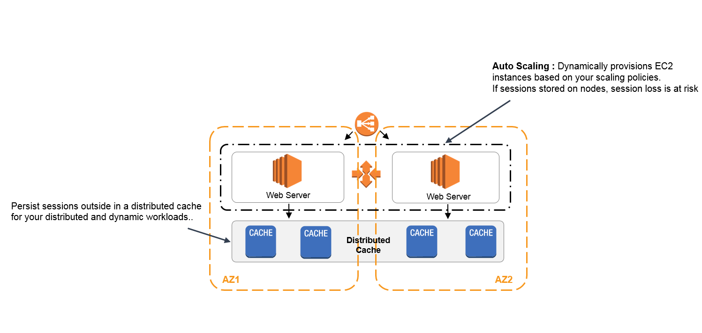

**ELB sticky sessions** is incorrect because the scenario does not require you to route a user to the particular web server that is managing that individual user’s session. Since the session state is shared among the instances, the use of the ELB sticky sessions feature is not recommended in this scenario.

**Multi-master DynamoDB** and **Multi-AZ RDS** are incorrect. Although you can use DynamoDB and RDS for storing session state, these two are not the best choices in terms of cost-effectiveness and performance when compared to ElastiCache. There is a significant difference in terms of latency if you used DynamoDB and RDS when you store the session data.

**References:**

<https://aws.amazon.com/caching/session-management/>

<https://d0.awsstatic.com/whitepapers/performance-at-scale-with-amazon-elasticache.pdf>

**Check out this Amazon Elasticache Cheat Sheet:**

[https://tutorialsdojo.com/amazon-elasticache/](https://tutorialsdojo.com/amazon-elasticache/?src=udemy)

**Redis (cluster mode enabled vs disabled) vs Memcached:**

[https://tutorialsdojo.com/redis-cluster-mode-enabled-vs-disabled-vs-memcached/](https://tutorialsdojo.com/redis-cluster-mode-enabled-vs-disabled-vs-memcached/?src=udemy)

Bottom of Form

Top of Form

Question 24: Skipped

A software development company has hundreds of Amazon EC2 instances with multiple Application Load Balancers (ALBs) across multiple AWS Regions. The public applications hosted in their EC2 instances are accessed on their on-premises network. The company needs to reduce the number of IP addresses that it needs to regularly whitelist on the corporate firewall device.

Which of the following approach can be used to fulfill this requirement?

* ​

Use AWS Global Accelerator and create multiple endpoints for all the available AWS Regions. Associate all the private IP addresses of the EC2 instances to the corresponding endpoints.

* ​

Use AWS Global Accelerator and create an endpoint group for each AWS Region. Associate the Application Load Balancer from each region to the corresponding endpoint group.

**(Correct)**

* ​

Launch a Network Load Balancer with an associated Elastic IP address. Set the ALBs in multiple Regions as targets.

* ​

Create a new Lambda function that tracks the changes in the IP addresses of all ALBs across multiple AWS Regions. Schedule the function to run and update the corporate firewall every hour using Amazon CloudWatch Events.

**Explanation**

**AWS Global Accelerator**is a service that improves the availability and performance of your applications with local or global users. It provides static IP addresses that act as a fixed entry point to your application endpoints in a single or multiple AWS Regions, such as your Application Load Balancers, Network Load Balancers, or Amazon EC2 instances.

When the application usage grows, the number of IP addresses and endpoints that you need to manage also increase. AWS Global Accelerator allows you to scale your network up or down. AWS Global Accelerator lets you associate regional resources, such as load balancers and EC2 instances, to two static IP addresses. You only whitelist these addresses once in your client applications, firewalls, and DNS records.

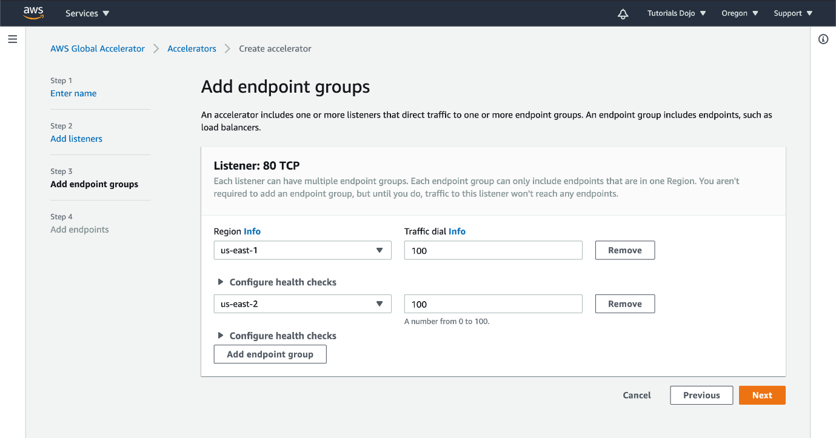

With AWS Global Accelerator, you can add or remove endpoints in the AWS Regions, run blue/green deployment, and A/B test without needing to update the IP addresses in your client applications. This is particularly useful for IoT, retail, media, automotive, and healthcare use cases in which client applications cannot be updated frequently.

If you have multiple resources in multiple regions, you can use AWS Global Accelerator to reduce the number of IP addresses. By creating an endpoint group, you can add all of your EC2 instances from a single region in that group. You can add additional endpoint groups for instances in other regions. After it, you can then associate the appropriate ALB endpoints to each of your endpoint groups. The created accelerator would have two static IP addresses that you can use to create a security rule in your firewall device. Instead of regularly adding the Amazon EC2 IP addresses in your firewall, you can use the static IP addresses of AWS Global Accelerator to automate the process and eliminate this repetitive task.

Hence, the correct answer is:**Use AWS Global Accelerator and create an endpoint group for each AWS Region. Associate the Application Load Balancer from each region to the corresponding endpoint group.**

The option that says:**Use AWS Global Accelerator and create multiple endpoints for all the available AWS Regions. Associate all the private IP addresses of the EC2 instances to the corresponding endpoints** is incorrect. It is better to create one endpoint group instead of multiple endpoints. Moreover, you have to associate the ALBs in AWS Global Accelerator and not the underlying EC2 instances.

The option that says:**Create a new Lambda function that tracks the changes in the IP addresses of all ALBs across multiple AWS Regions. Schedule the function to run and update the corporate firewall every hour using Amazon CloudWatch Events** is incorrect because this approach entails a lot of administrative overhead and takes a significant amount of time to implement. Using a custom Lambda function is actually not necessary since you can simply use AWS Global Accelerator to achieve this requirement.

The option that says:**Launch a Network Load Balancer with an associated Elastic IP address. Set the ALBs in multiple Regions as targets** is incorrect. Although you can allocate an Elastic IP address to your ELB, it is not suitable to route traffic to your ALBs across multiple Regions. You have to use AWS Global Accelerator instead.

**References:**

<https://docs.aws.amazon.com/global-accelerator/latest/dg/about-endpoint-groups.html>

<https://aws.amazon.com/global-accelerator/faqs/>

<https://docs.aws.amazon.com/global-accelerator/latest/dg/introduction-how-it-works.html>

**Check out this AWS Global Accelerator Cheat Sheet:**

[https://tutorialsdojo.com/aws-global-accelerator/](https://tutorialsdojo.com/aws-global-accelerator/%20?src=udemy)

Bottom of Form

Top of Form

Question 25: Skipped

A Solutions Architect is working for a weather station in Asia with a weather monitoring system that needs to be migrated to AWS. Since the monitoring system requires a low network latency and high network throughput, the Architect decided to launch the EC2 instances to a new cluster placement group. The system was working fine for a couple of weeks, however, when they try to add new instances to the placement group that already has running EC2 instances, they receive an 'insufficient capacity error'.

How will the Architect fix this issue?

* ​

Submit a capacity increase request to AWS as you are initially limited to only 12 instances per Placement Group.

* ​

Stop and restart the instances in the Placement Group and then try the launch again.

**(Correct)**

* ​

Verify all running instances are of the same size and type and then try the launch again.

* ​

Create another Placement Group and launch the new instances in the new group.

**Explanation**

It is recommended that you launch the number of instances that you need in the placement group in a single launch request and that you use the same instance type for all instances in the placement group. If you try to add more instances to the placement group later, or if you try to launch more than one instance type in the placement group, you increase your chances of getting an insufficient capacity error.

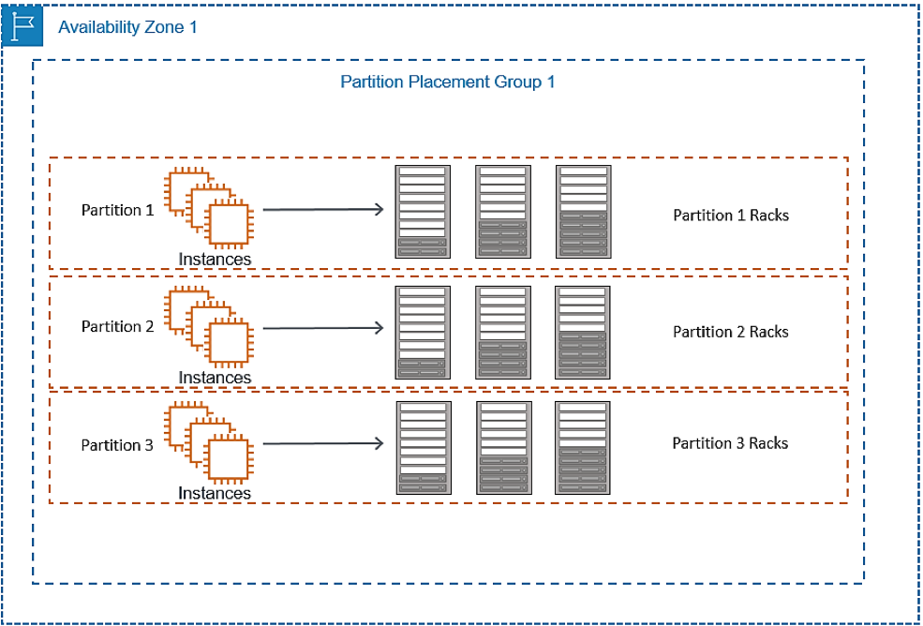

If you stop an instance in a placement group and then start it again, it still runs in the placement group. However, the start fails if there isn't enough capacity for the instance.

If you receive a capacity error when launching an instance in a placement group that already has running instances, stop and start all of the instances in the placement group, and try the launch again. Restarting the instances may migrate them to hardware that has capacity for all the requested instances.

Stop and restart the instances in the Placement group and then try the launch again can resolve this issue. If the instances are stopped and restarted, AWS may move the instances to a hardware that has the capacity for all the requested instances.

Hence, the correct answer is:**Stop and restart the instances in the Placement Group and then try the launch again.**

The option that says: **Create another Placement Group and launch the new instances in the new group** is incorrect because to benefit from the enhanced networking, all the instances should be in the same Placement Group. Launching the new ones in a new Placement Group will not work in this case.

The option that says: **Verify all running instances are of the same size and type and then try the launch again** is incorrect because the capacity error is not related to the instance size.

The option that says: **Submit a capacity increase request to AWS as you are initially limited to only 12 instances per Placement Group** is incorrect because there is no such limit on the number of instances in a Placement Group.

**References:**  
  
<https://docs.aws.amazon.com/AWSEC2/latest/UserGuide/placement-groups.html#placement-groups-cluster>

<http://docs.amazonaws.cn/en_us/AWSEC2/latest/UserGuide/troubleshooting-launch.html#troubleshooting-launch-capacity>

**Check out this Amazon EC2 Cheat Sheet:**

[https://tutorialsdojo.com/amazon-elastic-compute-cloud-amazon-ec2/](https://tutorialsdojo.com/amazon-elastic-compute-cloud-amazon-ec2/?src=udemy)

Bottom of Form

Top of Form

Question 26: Skipped

A company requires corporate IT governance and cost oversight of all of its AWS resources across its divisions around the world. Their corporate divisions want to maintain administrative control of the discrete AWS resources they consume and ensure that those resources are separate from other divisions.

Which of the following options will support the autonomy of each corporate division while enabling the corporate IT to maintain governance and cost oversight? (Select TWO.)

* ​

Create separate VPCs for each division within the corporate IT AWS account.

* ​

Use AWS Trusted Advisor

* ​

Use AWS Consolidated Billing by creating AWS Organizations to link the divisions’ accounts to a parent corporate account.

**(Correct)**

* ​

Enable IAM cross-account access for all corporate IT administrators in each child account.

**(Correct)**

* ​

Create separate Availability Zones for each division within the corporate IT AWS account.

**Explanation**

In this scenario, **enabling IAM cross-account access for all corporate IT administrators in each child account** and **using AWS Consolidated Billing by creating AWS Organizations to link the divisions’ accounts to a parent corporate account** are the correct choices. The combined use of IAM and Consolidated Billing will support the autonomy of each corporate division while enabling corporate IT to maintain governance and cost oversight.

You can use an IAM role to delegate access to resources that are in different AWS accounts that you own. You share resources in one account with users in a different account. By setting up cross-account access in this way, you don't need to create individual IAM users in each account. In addition, users don't have to sign out of one account and sign into another in order to access resources that are in different AWS accounts.

You can use the consolidated billing feature in AWS Organizations to consolidate payment for multiple AWS accounts or multiple AISPL accounts. With consolidated billing, you can see a combined view of AWS charges incurred by all of your accounts. You can also get a cost report for each member account that is associated with your master account. Consolidated billing is offered at no additional charge. AWS and AISPL accounts can't be consolidated together.

**Using AWS Trusted Advisor** is incorrect. Trusted Advisor is an online tool that provides you real-time guidance to help you provision your resources following AWS best practices. It only provides you alerts on areas where you do not adhere to best practices and tells you how to improve them. It does not assist in maintaining governance over your AWS accounts.

**Creating separate VPCs for each division within the corporate IT AWS account** is incorrect because creating separate VPCs would not separate the divisions from each other since they will still be operating under the same account and therefore contribute to the same billing each month.

**Creating separate Availability Zones for each division within the corporate IT AWS account** is incorrect because you do not need to create Availability Zones. They are already provided for you by AWS right from the start, and not all services support multiple AZ deployments. In addition, having separate Availability Zones in your VPC does not meet the requirement of supporting the autonomy of each corporate division.

**References:**

<http://docs.aws.amazon.com/awsaccountbilling/latest/aboutv2/consolidated-billing.html>

<https://docs.aws.amazon.com/IAM/latest/UserGuide/tutorial_cross-account-with-roles.html>

**Check out this AWS Billing and Cost Management Cheat Sheet:**

[https://tutorialsdojo.com/aws-billing-and-cost-management/](https://tutorialsdojo.com/aws-billing-and-cost-management/?src=udemy)

Bottom of Form

Top of Form

Question 27: Skipped

A Solutions Architect created a brand new IAM User with a default setting using AWS CLI. This is intended to be used to send API requests to Amazon S3, DynamoDB, Lambda, and other AWS resources of the company’s cloud infrastructure.

Which of the following must be done to allow the user to make API calls to the AWS resources?

* ​

Do nothing as the IAM User is already capable of sending API calls to your AWS resources.

* ​

Create a set of Access Keys for the user and attach the necessary permissions.

**(Correct)**

* ​

Assign an IAM Policy to the user to allow it to send API calls.

* ​

Enable Multi-Factor Authentication for the user.

**Explanation**

You can choose the credentials that are right for your IAM user. When you use the AWS Management Console to create a user, you must choose to at least include a console password or access keys. By default, a brand new IAM user created using the AWS CLI or AWS API has no credentials of any kind. You must create the type of credentials for an IAM user based on the needs of your user.

Access keys are long-term credentials for an IAM user or the AWS account root user. You can use access keys to sign programmatic requests to the AWS CLI or AWS API (directly or using the AWS SDK). Users need their own access keys to make programmatic calls to AWS from the AWS Command Line Interface (AWS CLI), Tools for Windows PowerShell, the AWS SDKs, or direct HTTP calls using the APIs for individual AWS services.

To fill this need, you can create, modify, view, or rotate access keys (access key IDs and secret access keys) for IAM users. When you create an access key, IAM returns the access key ID and secret access key. You should save these in a secure location and give them to the user.

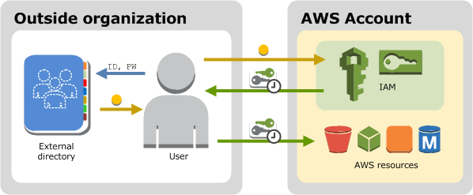

The option that says: **Do nothing as the IAM User is already capable of sending API calls to your AWS resources** is incorrect because by default, a brand new IAM user created using the AWS CLI or AWS API has no credentials of any kind. Take note that in the scenario, you created the new IAM user using the AWS CLI and not via the AWS Management Console, where you must choose to at least include a console password or access keys when creating a new IAM user.

**Enabling Multi-Factor Authentication for the user** is incorrect because this will still not provide the required Access Keys needed to send API calls to your AWS resources. You have to grant the IAM user with Access Keys to meet the requirement.

**Assigning an IAM Policy to the user to allow it to send API calls** is incorrect because adding a new IAM policy to the new user will not grant the needed Access Keys needed to make API calls to the AWS resources.

**References:**

<https://docs.aws.amazon.com/IAM/latest/UserGuide/id_credentials_access-keys.html>

<https://docs.aws.amazon.com/IAM/latest/UserGuide/id_users.html#id_users_creds>

**Check out this AWS IAM Cheat Sheet:**

[https://tutorialsdojo.com/aws-identity-and-access-management-iam/](https://tutorialsdojo.com/aws-identity-and-access-management-iam/?src=udemy)

Bottom of Form

Top of Form

Question 28: Skipped

A global medical research company has a molecular imaging system which provides each client with frequently updated images of what is happening inside the human body at the molecular and cellular level. The system is hosted in AWS and the images are hosted in an S3 bucket behind a CloudFront web distribution. There was a new batch of updated images that were uploaded in S3, however, the users were reporting that they were still seeing the old content. You need to control which image will be returned by the system even when the user has another version cached either locally or behind a corporate caching proxy.

Which of the following is the most suitable solution to solve this issue?

* ​

Use versioned objects

**(Correct)**

* ​

Add Cache-Control no-cache, no-store, or private directives in the S3 bucket

* ​

Invalidate the files in your CloudFront web distribution

* ​

Add a separate cache behavior path for the content and configure a custom object caching with a Minimum TTL of 0

**Explanation**

To control the versions of files that are served from your distribution, you can either invalidate files or give them versioned file names. If you want to update your files frequently, AWS recommends that you primarily use file versioning for the following reasons:

- Versioning enables you to control which file a request returns even when the user has a version cached either locally or behind a corporate caching proxy. If you invalidate the file, the user might continue to see the old version until it expires from those caches.

- CloudFront access logs include the names of your files, so versioning makes it easier to analyze the results of file changes.

- Versioning provides a way to serve different versions of files to different users.

- Versioning simplifies rolling forward and back between file revisions.

- Versioning is less expensive. You still have to pay for CloudFront to transfer new versions of your files to edge locations, but you don't have to pay for invalidating files.

**Invalidating the files in your CloudFront web distribution** is incorrect because even though using invalidation will solve this issue, this solution is more expensive as compared to **using versioned objects**.

**Adding a separate cache behavior path for the content and configuring a custom object caching with a Minimum TTL of 0** is incorrect because this alone is not enough to solve the problem. A cache behavior is primarily used to configure a variety of CloudFront functionality for a given URL path pattern for files on your website. Although this solution may work, it is still better to use versioned objects where you can control which image will be returned by the system even when the user has another version cached either locally or behind a corporate caching proxy.

**Adding Cache-Control no-cache, no-store, or private directives in the S3 bucket** is incorrect because although it is right to configure your origin to add the ***Cache-Control*** or ***Expires*** header field, you should do this to your objects and not on the entire S3 bucket.

**References:**

<https://docs.aws.amazon.com/AmazonCloudFront/latest/DeveloperGuide/UpdatingExistingObjects.html>

<https://aws.amazon.com/premiumsupport/knowledge-center/prevent-cloudfront-from-caching-files/>

<https://docs.aws.amazon.com/AmazonCloudFront/latest/DeveloperGuide/Invalidation.html#PayingForInvalidation>

**Check out this Amazon CloudFront Cheat Sheet:**

[https://tutorialsdojo.com/amazon-cloudfront/](https://tutorialsdojo.com/amazon-cloudfront/?src=udemy)

Bottom of Form

Top of Form

Question 29: Skipped

A Solutions Architect is managing a three-tier web application that processes credit card payments and online transactions. Static web pages are used on the front-end tier while the application tier contains a single Amazon EC2 instance that handles long-running processes. The data is stored in a MySQL database. The Solutions Architect is instructed to decouple the tiers to create a highly available application.

Which of the following options can satisfy the given requirement?

* ​

Move all the static assets, web pages, and the backend application to a larger instance. Use Auto Scaling in Amazon EC2 instance. Migrate the database to Amazon Aurora.

* ​

Move all the static assets and web pages to Amazon CloudFront. Use Auto Scaling in Amazon EC2 instance. Migrate the database to Amazon RDS with Multi-AZ deployments configuration.

* ​

Move all the static assets to Amazon S3. Set concurrency limit in AWS Lambda to move the application to a serverless architecture. Migrate the database to Amazon DynamoDB.

* ​

Move all the static assets and web pages to Amazon S3. Re-host the application to Amazon Elastic Container Service (Amazon ECS) containers and enable Service Auto Scaling. Migrate the database to Amazon RDS with Multi-AZ deployments configuration.

**(Correct)**

**Explanation**

**Amazon Elastic Container Service (ECS)** is a highly scalable, high performance container management service that supports Docker containers and allows you to easily run applications on a managed cluster of Amazon EC2 instances. Amazon ECS makes it easy to use containers as a building block for your applications by eliminating the need for you to install, operate, and scale your own cluster management infrastructure. Amazon ECS lets you schedule long-running applications, services, and batch processes using Docker containers. Amazon ECS maintains application availability and allows you to scale your containers up or down to meet your application's capacity requirements.

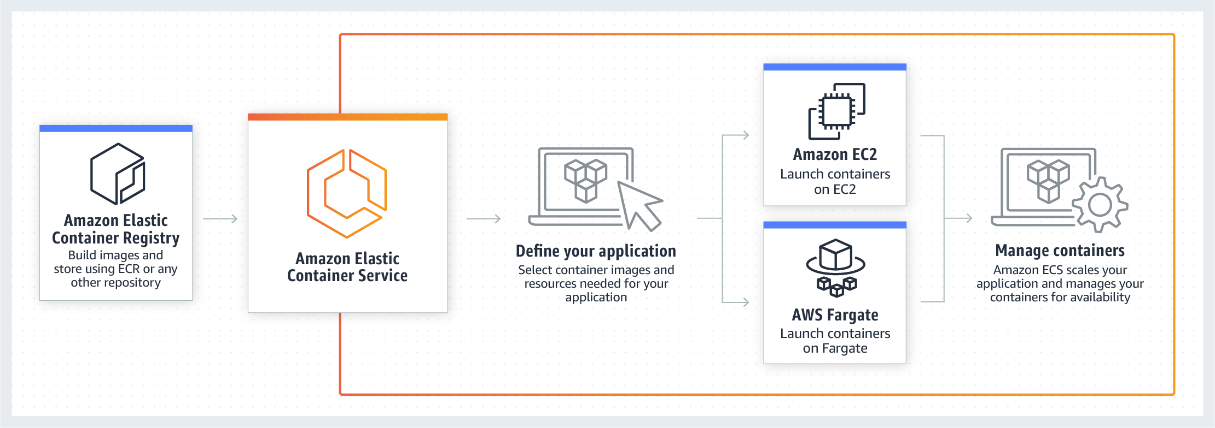

The requirement in the scenario is to decouple the services to achieve a highly available architecture. To accomplish this requirement, you must move the existing set up to each AWS services. For static assets, you should use Amazon S3. You can use Amazon ECS for your web application and then migrate the database to Amazon RDS with Multi-AZ deployment. Decoupling your app with application integration services allows them to remain interoperable, but if one service has a failure or spike in workload, it won’t affect the rest of them.

Hence, the correct answer is:**Move all the static assets and web pages to Amazon S3. Re-host the application to Amazon Elastic Container Service (Amazon ECS) containers and enable Service Auto Scaling. Migrate the database to Amazon RDS with Multi-AZ deployments configuration.**

The option that says: **Move all the static assets to Amazon S3. Set concurrency limit in AWS Lambda to move the application to a serverless architecture. Migrate the database to Amazon DynamoDB**is incorrect because Lambda functions can’t process long-running processes. Take note that a Lambda function has a maximum processing time of 15 minutes.

The option that says: **Move all the static assets, web pages, and the backend application to a larger instance. Use Auto Scaling in Amazon EC2 instance. Migrate the database to Amazon Aurora** is incorrect because static assets are more suitable and cost-effective to be stored in S3 instead of storing them in an EC2 instance.

The option that says: **Move all the static assets and web pages to Amazon CloudFront. Use Auto Scaling in Amazon EC2 instance. Migrate the database to Amazon RDS with Multi-AZ deployments configuration**is incorrect because you can't store data in Amazon CloudFront. Technically, you only store cache data in CloudFront, but you can't host applications or web pages using this service. You have to use Amazon S3 to host the static web pages and use CloudFront as the CDN.

**References:**

<https://docs.aws.amazon.com/AmazonECS/latest/developerguide/service-auto-scaling.html>

<https://docs.aws.amazon.com/AmazonRDS/latest/UserGuide/Concepts.MultiAZ.html>

**Check out this Amazon ECS Cheat Sheet:**

[https://tutorialsdojo.com/amazon-elastic-container-service-amazon-ecs/](https://tutorialsdojo.com/amazon-elastic-container-service-amazon-ecs/?src=udemy)

Bottom of Form

Top of Form

Question 30: Skipped

A multinational manufacturing company has multiple accounts in AWS to separate their various departments such as finance, human resources, engineering and many others. There is a requirement to ensure that certain access to services and actions are properly controlled to comply with the security policy of the company.

As the Solutions Architect, which is the most suitable way to set up the multi-account AWS environment of the company?

* ​

Connect all departments by setting up a cross-account access to each of the AWS accounts of the company. Create and attach IAM policies to your resources based on their respective departments to control access.

* ​

Provide access to externally authenticated users via Identity Federation. Set up an IAM role to specify permissions for users from each department whose identity is federated from your organization or a third-party identity provider.

* ​

Set up a common IAM policy that can be applied across all AWS accounts.

* ​

Use AWS Organizations and Service Control Policies to control services on each account.

**(Correct)**

**Explanation**

**Using AWS Organizations and Service Control Policies to control services on each account** is the correct answer. Refer to the diagram below:

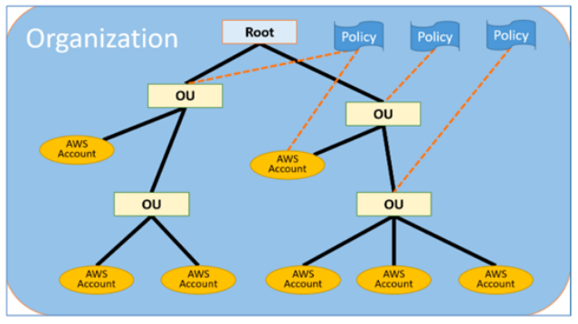

AWS Organizations offers policy-based management for multiple AWS accounts. With Organizations, you can create groups of accounts, automate account creation, apply and manage policies for those groups. Organizations enables you to centrally manage policies across multiple accounts, without requiring custom scripts and manual processes. It allows you to create Service Control Policies (SCPs) that centrally control AWS service use across multiple AWS accounts.

**Setting up a common IAM policy that can be applied across all AWS accounts** is incorrect because it is not possible to create a common IAM policy for multiple AWS accounts.

The option that says: **Connect all departments by setting up a cross-account access to each of the AWS accounts of the company. Create and attach IAM policies to your resources based on their respective departments to control access** is incorrect because although you can set up cross-account access to each department, this entails a lot of configuration compared with using AWS Organizations and Service Control Policies (SCPs). Cross-account access would be a more suitable choice if you only have two accounts to manage, but not for multiple accounts.

The option that says: **Provide access to externally authenticated users via Identity Federation. Set up an IAM role to specify permissions for users from each department whose identity is federated from your organization or a third-party identity provider** is incorrect as this option is focused on the Identity Federation authentication set up for your AWS accounts but not the IAM policy management for multiple AWS accounts. A combination of AWS Organizations and Service Control Policies (SCPs) is a better choice compared to this option.

**Reference:**

<https://aws.amazon.com/organizations/>

**Check out this AWS Organizations Cheat Sheet:**

[https://tutorialsdojo.com/aws-organizations/](https://tutorialsdojo.com/aws-organizations/?src=udemy)

**Service Control Policies (SCP) vs IAM Policies:**

[https://tutorialsdojo.com/service-control-policies-scp-vs-iam-policies/](https://tutorialsdojo.com/service-control-policies-scp-vs-iam-policies/?src=udemy)

**Comparison of AWS Services Cheat Sheets:**

[https://tutorialsdojo.com/comparison-of-aws-services/](https://tutorialsdojo.com/comparison-of-aws-services/?src=udemy)

Bottom of Form

Top of Form

Question 31: Skipped

**A mobile application stores pictures in Amazon Simple Storage Service (S3) and allows application sign-in using an OpenID Connect-compatible identity provider.  
  
Which AWS Security Token Service approach to temporary access should you use for this scenario?**

* ​

Web Identity Federation

**(Correct)**

* ​

AWS Identity and Access Management roles

* ​

Cross-Account Access

* ​

SAML-based Identity Federation

**Explanation**

With web identity federation, you don't need to create custom sign-in code or manage your own user identities. Instead, users of your app can sign in using a well-known identity provider (IdP) —such as Login with Amazon, Facebook, Google, or any other OpenID Connect (OIDC)-compatible IdP, receive an authentication token, and then exchange that token for temporary security credentials in AWS that map to an IAM role with permissions to use the resources in your AWS account. Using an IdP helps you keep your AWS account secure because you don't have to embed and distribute long-term security credentials with your application.

**Reference:**

<http://docs.aws.amazon.com/IAM/latest/UserGuide/id_roles_providers_oidc.html>

**Check out this AWS IAM Cheat Sheet:**

[https://tutorialsdojo.com/aws-identity-and-access-management-iam/](https://tutorialsdojo.com/aws-identity-and-access-management-iam/?src=udemy)

Bottom of Form

Top of Form

Question 32: Skipped

A startup is building a microservices architecture in which the software is composed of small independent services that communicate over well-defined APIs. In building large-scale systems, fine-grained decoupling of microservices is a recommended practice to implement. The decoupled services should scale horizontally from each other to improve scalability.

What is the difference between Horizontal scaling and Vertical scaling?

* ​

Vertical scaling means running the same software on a fully serverless architecture using Lambda. Horizontal scaling means adding more servers to the existing pool and it doesn’t run into limitations of individual servers.

* ​

Horizontal scaling means running the same software on smaller containers such as Docker and Kubernetes using ECS or EKS. Vertical scaling is adding more servers to the existing pool and doesn’t run into limitations of individual servers.

* ​

Horizontal scaling means running the same software on bigger machines which is limited by the capacity of individual servers. Vertical scaling is adding more servers to the existing pool and doesn’t run into limitations of individual servers.

* ​

Vertical scaling means running the same software on bigger machines which is limited by the capacity of the individual server. Horizontal scaling is adding more servers to the existing pool and doesn’t run into limitations of individual servers.

**(Correct)**

**Explanation**

Vertical scaling means running the same software on bigger machines which is limited by the capacity of the individual server. Horizontal scaling is adding more servers to the existing pool and doesn’t run into limitations of individual servers.

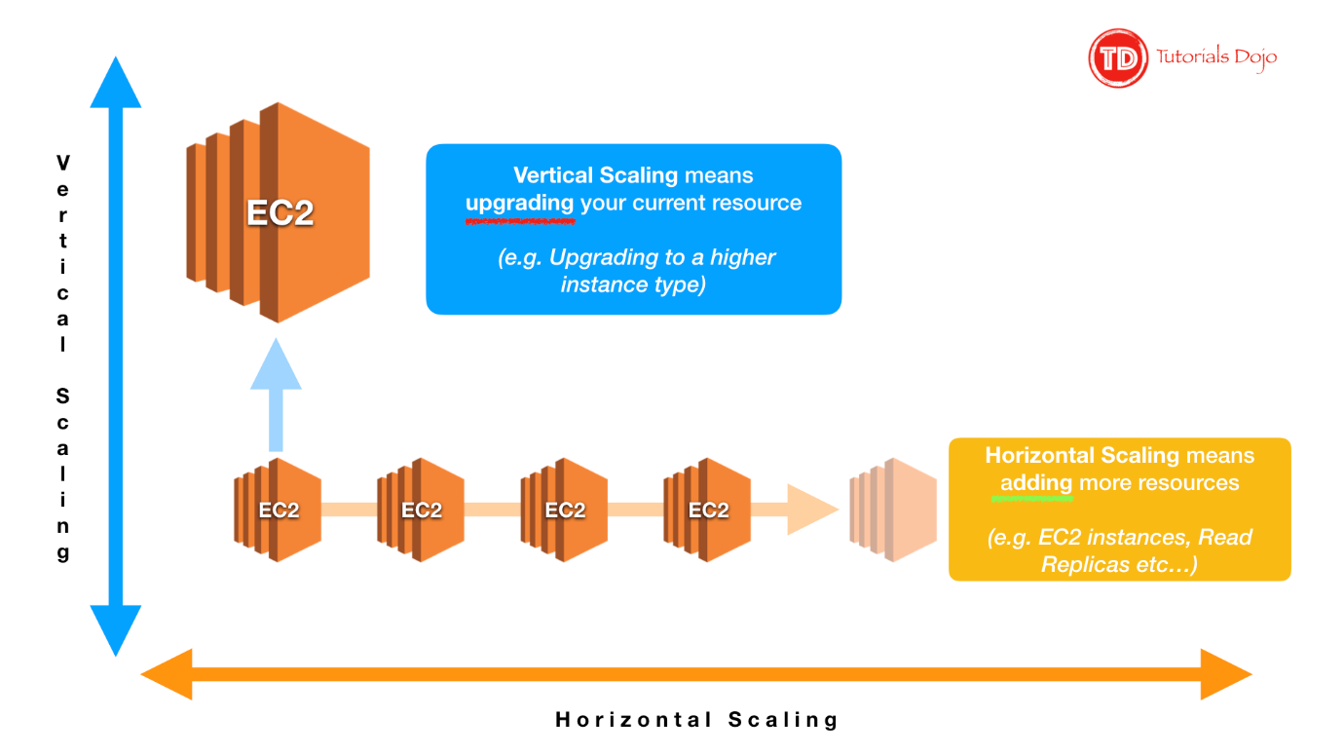

Fine-grained decoupling of microservices is a best practice for building large-scale systems. It’s a prerequisite for performance optimization since it allows choosing the appropriate and optimal technologies for a specific service. Each service can be implemented with the appropriate programming languages and frameworks, leverage the optimal data persistence solution, and be fine-tuned with the best performing service configurations.

Properly decoupled services can be scaled horizontally and independently from each other. Vertical scaling, which is running the same software on bigger machines, is limited by the capacity of individual servers and can incur downtime during the scaling process. Horizontal scaling, which is adding more servers to the existing pool, is highly dynamic and doesn’t run into limitations of individual servers. The scaling process can be completely automated.

Furthermore, the resiliency of the application can be improved because failing components can be easily and automatically replaced. Hence, the correct answer is the option that says: **Vertical scaling means running the same software on bigger machines which is limited by the capacity of the individual server. Horizontal scaling is adding more servers to the existing pool and doesn’t run into limitations of individual servers.**

The option that says: **Vertical scaling means running the same software on a fully serverless architecture using Lambda. Horizontal scaling means adding more servers to the existing pool and it doesn’t run into limitations of individual servers** is incorrect because Vertical scaling is not about running the same software on a fully serverless architecture. AWS Lambda is not required for scaling.

The option that says: **Horizontal scaling means running the same software on bigger machines which is limited by the capacity of individual servers. Vertical scaling is adding more servers to the existing pool and doesn’t run into limitations of individual servers** is incorrect because the definitions for the two concepts were switched. Vertical scaling means running the same software on bigger machines which is limited by the capacity of the individual server. Horizontal scaling is adding more servers to the existing pool and doesn’t run into limitations of individual servers.

The option that says: **Horizontal scaling means running the same software on smaller containers such as Docker and Kubernetes using ECS or EKS. Vertical scaling is adding more servers to the existing pool and doesn’t run into limitations of individual servers** is incorrect because Horizontal scaling is not related to using ECS or EKS containers on a smaller instance.

**Reference:**

<https://docs.aws.amazon.com/aws-technical-content/latest/microservices-on-aws/microservices-on-aws.pdf#page=8>

**Tutorials Dojo's AWS Certified Solutions Architect Associate Exam Study Guide:**

<https://tutorialsdojo.com/aws-certified-solutions-architect-associate/>

Bottom of Form

Top of Form

Question 33: Skipped

An online stock trading system is hosted in AWS and uses an Auto Scaling group of EC2 instances, an RDS database, and an Amazon ElastiCache for Redis. You need to improve the data security of your in-memory data store by requiring the user to enter a password before they are granted permission to execute Redis commands.

Which of the following should you do to meet the above requirement?

* ​

Create a new Redis replication group and set the AtRestEncryptionEnabled parameter to true.

* ​

Authenticate the users using Redis AUTH by creating a new Redis Cluster with both the --transit-encryption-enabled and --auth-token parameters enabled.

**(Correct)**

* ​

None of the above.

* ​

Enable the in-transit encryption for Redis replication groups.

* ​

Do nothing. This feature is already enabled by default.

**Explanation**

Using Redis AUTH command can improve data security by requiring the user to enter a password before they are granted permission to execute Redis commands on a password-protected Redis server.

Hence, the correct answer is to **authenticate the users using Redis AUTH by creating a new Redis Cluster with both the --transit-encryption-enabled and --auth-token parameters enabled**.

To require that users enter a password on a password-protected Redis server, include the parameter **--auth-token** with the correct password when you create your replication group or cluster and on all subsequent commands to the replication group or cluster.

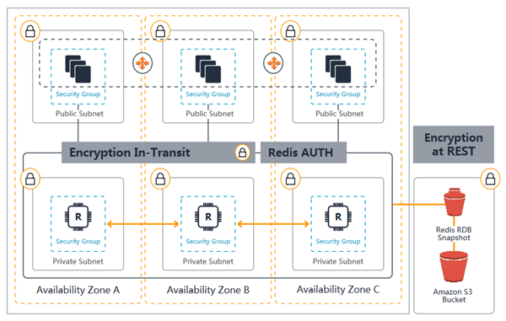

**Enabling the in-transit encryption for Redis replication groups** is incorrect because although in-transit encryption is part of the solution, it is missing the most important thing which is the Redis AUTH option.

**Creating a new Redis replication group and setting the AtRestEncryptionEnabled parameter to true** is incorrect because the Redis At-Rest Encryption feature only secures the data inside the in-memory data store. You have to use Redis AUTH option instead.

The option that says: **Do nothing. This feature is already enabled by default** is incorrect because the Redis AUTH option is disabled by default.

**References**:

<https://docs.aws.amazon.com/AmazonElastiCache/latest/red-ug/auth.html>

<https://docs.aws.amazon.com/AmazonElastiCache/latest/red-ug/encryption.html>

**Check out this Amazon ElastiCache Cheat Sheet:**

[https://tutorialsdojo.com/amazon-elasticache/](https://tutorialsdojo.com/amazon-elasticache/?src=udemy)

**Redis Append-Only Files vs Redis Replication:**

[https://tutorialsdojo.com/redis-append-only-files-vs-redis-replication/](https://tutorialsdojo.com/redis-append-only-files-vs-redis-replication/?src=udemy)

**Comparison of AWS Services Cheat Sheets:**

[https://tutorialsdojo.com/comparison-of-aws-services/](https://tutorialsdojo.com/comparison-of-aws-services/?src=udemy)

Bottom of Form

Top of Form

Question 34: Skipped

A company is using an Amazon RDS for MySQL 5.6 with Multi-AZ deployment enabled and several web servers across two AWS Regions. The database is currently experiencing highly dynamic reads due to the growth of the company’s website. The Solutions Architect tried to test the read performance from the secondary AWS Region and noticed a notable slowdown on the SQL queries.

Which of the following options would provide a read replication latency of less than 1 second?

* ​

Use Amazon ElastiCache to improve database performance.

* ​

Create an Amazon RDS for MySQL read replica in the secondary AWS Region.

* ​

Migrate the existing database to Amazon Aurora and create a cross-region read replica.

**(Correct)**

* ​

Upgrade the MySQL database engine.

**Explanation**

**Amazon Aurora** is a MySQL and PostgreSQL-compatible relational database built for the cloud, that combines the performance and availability of traditional enterprise databases with the simplicity and cost-effectiveness of open source databases. Amazon Aurora is up to five times faster than standard MySQL databases and three times faster than standard PostgreSQL databases.

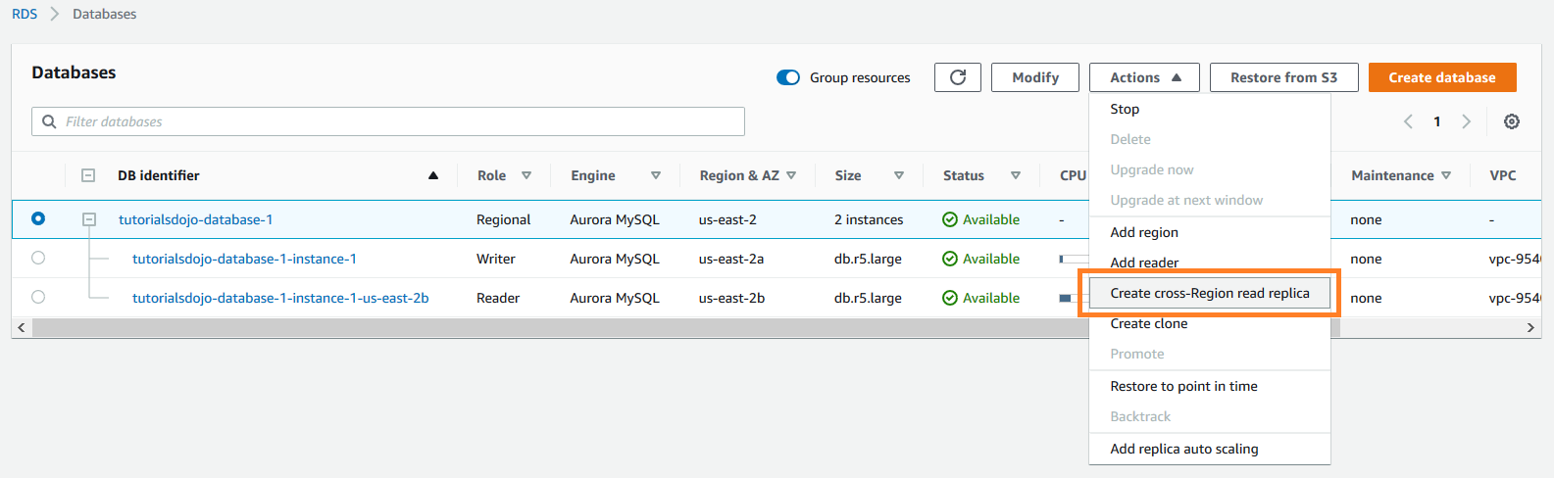

It provides the security, availability, and reliability of commercial databases at 1/10th the cost. Amazon Aurora is fully managed by Amazon RDS, which automates time-consuming administration tasks like hardware provisioning, database setup, patching, and backups.

Based on the given scenario, there is a significant slowdown after testing the read performance from the secondary AWS Region. Since the existing setup is an Amazon RDS for MySQL, you should migrate the database to Amazon Aurora and create a cross-region read replica.

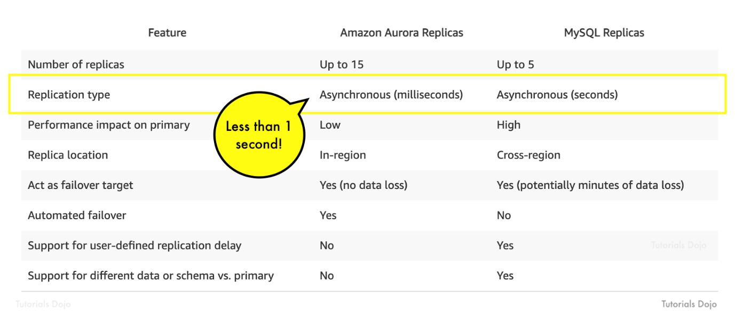

The read replication latency of less than 1 second is only possible if you would use Amazon Aurora replicas. Aurora replicas are independent endpoints in an Aurora DB cluster, best used for scaling read operations and increasing availability. You can create up to 15 replicas within an AWS Region.

Hence, the correct answer is: **Migrate the existing database to Amazon Aurora and create a cross-region read replica.**

The option that says:**Upgrade the MySQL database engine**is incorrect because upgrading the database engine wouldn't improve the read replication latency to milliseconds. To achieve the read replication latency of less than 1-second requirement, you need to use Amazon Aurora replicas.

The option that says:**Use Amazon ElastiCache to improve database performance**is incorrect. Amazon ElastiCache won't be able to improve the database performance because it is experiencing highly dynamic reads. This option would be helpful if the database frequently receives the same queries.

The option that says:**Create an Amazon RDS for MySQL read replica in the secondary AWS Region**is incorrect because MySQL replicas won't provide you a read replication latency of less than 1 second. RDS Read Replicas can only provide asynchronous replication in seconds and not in milliseconds. You have to use Amazon Aurora replicas in this scenario.

**References:**

<https://aws.amazon.com/rds/aurora/faqs/>

<https://docs.aws.amazon.com/AmazonRDS/latest/AuroraUserGuide/AuroraMySQL.Replication.CrossRegion.html>

**Check out this Amazon Aurora Cheat Sheet:**

[https://tutorialsdojo.com/amazon-aurora/](https://tutorialsdojo.com/amazon-aurora/?src=udemy)

Bottom of Form

Top of Form

Question 35: Skipped

A multinational corporate and investment bank is regularly processing steady workloads of accruals, loan interests, and other critical financial calculations every night at 10 PM to 3 AM on their on-premises data center for their corporate clients. Once the process is done, the results are then uploaded to the Oracle General Ledger which means that the processing should not be delayed nor interrupted. The CTO has decided to move their IT infrastructure to AWS to save cost and to improve the scalability of their digital financial services.

As the Senior Solutions Architect, how can you implement a cost-effective architecture in AWS for their financial system?

* ​

Use Dedicated Hosts which provide a physical host that is fully dedicated to running your instances, and bring your existing per-socket, per-core, or per-VM software licenses to reduce costs.

* ​

Use Spot EC2 Instances launched by a persistent Spot request, which can significantly lower your Amazon EC2 costs.

* ​

Use Scheduled Reserved Instances, which provide compute capacity that is always available on the specified recurring schedule.

**(Correct)**

* ​

Use On-Demand EC2 instances which allows you to pay for the instances that you launch and use by the second.

**Explanation**

Scheduled Reserved Instances (Scheduled Instances) enable you to purchase capacity reservations that recur on a daily, weekly, or monthly basis, with a specified start time and duration, for a one-year term. You reserve the capacity in advance, so that you know it is available when you need it. You pay for the time that the instances are scheduled, even if you do not use them.

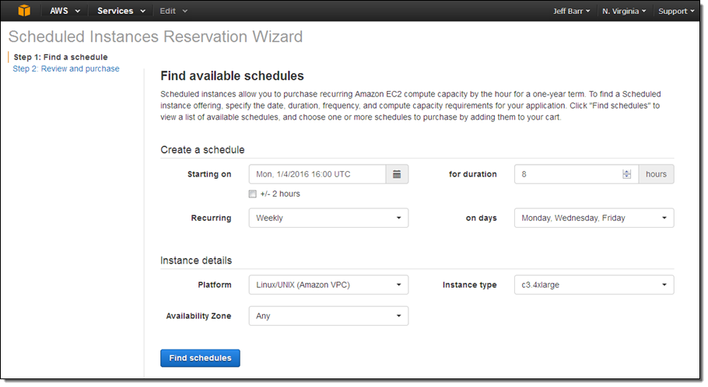

Scheduled Instances are a good choice for workloads that do not run continuously, but do run on a regular schedule. For example, you can use Scheduled Instances for an application that runs during business hours or for batch processing that runs at the end of the week.

Hence, the correct answer is to **use Scheduled Reserved Instances, which provide compute capacity that is always available on the specified recurring schedule**.

**Using On-Demand EC2 instances which allows you to pay for the instances that you launch and use by the second** is incorrect because although an On-Demand instance is stable and suitable for processing critical data, it costs more than any other option. Moreover, the critical financial calculations are only done every night from 10 PM to 3 AM only and not 24/7. This means that your compute capacity will not be utilized for a total of 19 hours every single day.

**Using Spot EC2 Instances launched by a persistent Spot request, which can significantly lower your Amazon EC2 costs** is incorrect because although this is the most cost-effective solution, this type is not suitable for processing critical financial data since a Spot Instance has a risk of being interrupted.

**Using Dedicated Hosts which provide a physical host that is fully dedicated to running your instances, and bringing your existing per-socket, per-core, or per-VM software licenses to reduce costs** is incorrect because the use of a fully dedicated physical host is not warranted in this scenario. Moreover, this will be underutilized since you only run the process for 5 hours (from 10 PM to 3 AM only), wasting 19 hours of compute capacity every single day.

**References:**

<https://aws.amazon.com/blogs/aws/new-scheduled-reserved-instances/>

<https://docs.aws.amazon.com/AWSEC2/latest/UserGuide/ec2-scheduled-instances.html>

**Check out this Amazon EC2 Cheat Sheet:**

[https://tutorialsdojo.com/amazon-elastic-compute-cloud-amazon-ec2/](https://tutorialsdojo.com/amazon-elastic-compute-cloud-amazon-ec2/?src=udemy)

Bottom of Form

Top of Form

Question 36: Skipped

A disaster recovery team is planning to back up on-premises records to a local file server share through SMB protocol. To meet the company’s business continuity plan, the team must ensure that a copy of data from 48 hours ago is available for immediate access. Accessing older records with delay is tolerable.

Which should the DR team implement to meet the objective with the LEAST amount of configuration effort?

* ​

Use an AWS Storage File gateway with enough storage to keep data from the last 48 hours. Send the backups to an SMB share mounted as a local disk.

**(Correct)**

* ​

Create an AWS Backup plan to copy data backups to a local SMB share every 48 hours.

* ​

Create an SMB file share in Amazon FSx for Windows File Server that has enough storage to store all backups. Access the file share from on-premises.

* ​

Mount an Amazon EFS file system on the on-premises client and copy all backups to an NFS share.

**Explanation**

**Amazon S3 File Gateway** presents a file interface that enables you to store files as objects in Amazon S3 using the industry-standard NFS and SMB file protocols, and access those files via NFS and SMB from your data center or Amazon EC2, or access those files as objects directly in Amazon S3.

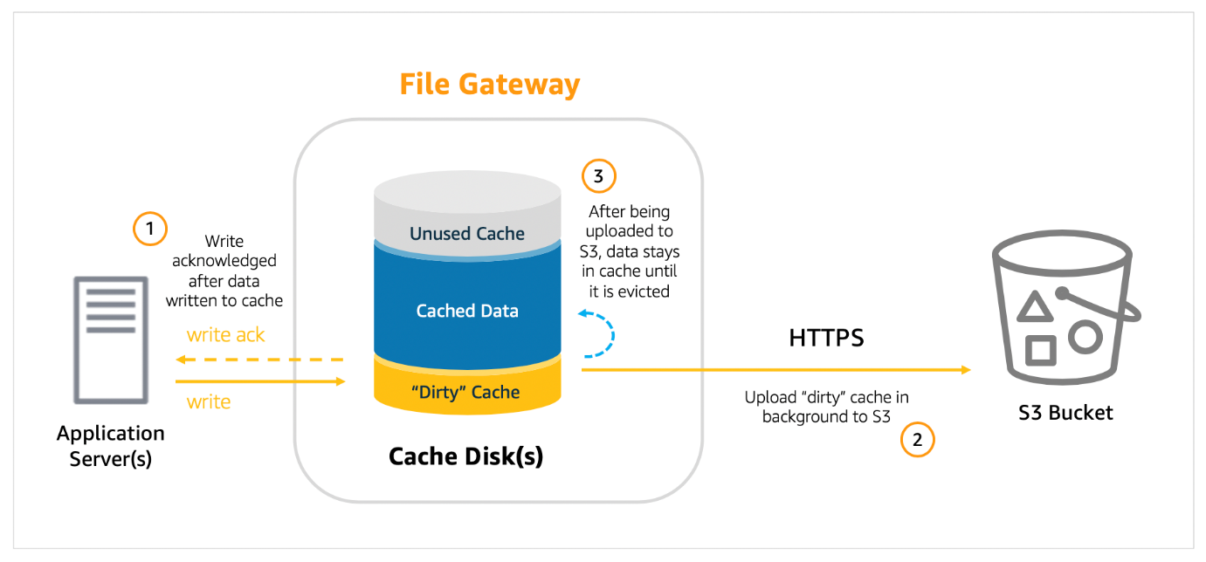

When you deploy File Gateway, you specify how much disk space you want to allocate for local cache. This local cache acts as a buffer for writes and provides low latency access to data that was recently written to or read from Amazon S3. When a client writes data to a file via File Gateway, that data is first written to the local cache disk on the gateway itself. Once the data has been safely persisted to the local cache, only then does the File Gateway acknowledge the write back to the client. From there, File Gateway transfers the data to the S3 bucket asynchronously in the background, optimizing data transfer using multipart parallel uploads, and encrypting data in transit using HTTPS.

In this scenario, you can deploy an AWS Storage File Gateway to the on-premises client. After activating the File Gateway, create an SMB share and mount it as a local disk at the on-premises end. Copy the backups to the SMB share. You must ensure that you size the File Gateway's local cache appropriately to the backup data that needs immediate access. After the backup is done, you will be able to access the older data but with a delay. There will be a small delay since data (not in cache) needs to be retrieved from Amazon S3.

Hence, the correct answer is: **Use an AWS Storage File gateway with enough storage to keep data from the last 48 hours. Send the backups to an SMB share mounted as a local disk.**

The option that says: **Create an SMB file share in Amazon FSx for Windows File Server that has enough storage to store all backups. Access the file share from on-premises** is incorrect because this requires additional setup. You need to set up a Direct Connect or VPN connection from on-premises to AWS first in order for this to work.

The option that says: **Mount an Amazon EFS file system on the on-premises client and copy all backups to an NFS share**is incorrect because the file share required in the scenario needs to be using the SMB protocol.

The option that says: **Create an AWS Backup plan to copy data backups to a local SMB share every 48 hours**is incorrect. AWS Backup only works on AWS resources.

**References:**

<https://aws.amazon.com/blogs/storage/easily-store-your-sql-server-backups-in-amazon-s3-using-file-gateway/>

<https://aws.amazon.com/storagegateway/faqs/>

**AWS Storage Gateway Overview:**

<https://www.youtube.com/watch?v=pNb7xOBJjHE>

**Check out this AWS Storage Gateway Cheat Sheet:**

[https://tutorialsdojo.com/aws-storage-gateway/](https://tutorialsdojo.com/aws-storage-gateway/?src=udemy)

Bottom of Form

Top of Form

Question 37: Skipped

A commercial bank has designed its next-generation online banking platform to use a distributed system architecture. As their Software Architect, you have to ensure that their architecture is highly scalable, yet still cost-effective. Which of the following will provide the most suitable solution for this scenario?

* ​

Launch multiple EC2 instances behind an Application Load Balancer to host your application services and SNS which will act as a highly-scalable buffer that stores messages as they travel between distributed applications.

* ​

Launch multiple On-Demand EC2 instances to host your application services and an SQS queue which will act as a highly-scalable buffer that stores messages as they travel between distributed applications.

* ​

Launch an Auto-Scaling group of EC2 instances to host your application services and an SQS queue. Include an Auto Scaling trigger to watch the SQS queue size which will either scale in or scale out the number of EC2 instances based on the queue.

**(Correct)**

* ​

Launch multiple EC2 instances behind an Application Load Balancer to host your application services, and SWF which will act as a highly-scalable buffer that stores messages as they travel between distributed applications.

**Explanation**

There are three main parts in a distributed messaging system: the components of your distributed system which can be hosted on EC2 instance; your queue (distributed on Amazon SQS servers); and the messages in the queue.

To improve the scalability of your distributed system, you can add Auto Scaling group to your EC2 instances.

**References:**

<https://docs.aws.amazon.com/autoscaling/ec2/userguide/as-using-sqs-queue.html>

<https://docs.aws.amazon.com/AWSSimpleQueueService/latest/SQSDeveloperGuide/sqs-basic-architecture.html>

**Check out this AWS Auto Scaling Cheat Sheet:**

[https://tutorialsdojo.com/aws-auto-scaling/](https://tutorialsdojo.com/aws-auto-scaling/?src=udemy)

Bottom of Form

Top of Form

Question 38: Skipped

A company plans to implement a network monitoring system in AWS. The Solutions Architect launched an EC2 instance to host the monitoring system and used CloudWatch to monitor, store, and access the log files of the instance.

Which of the following provides an automated way to send log data to CloudWatch Logs from the Amazon EC2 instance?

* ​

CloudWatch Logs agent

**(Correct)**

* ​

CloudTrail Logs agent

* ​

VPC Flow Logs

* ​

CloudTrail

**Explanation**

CloudWatch Logs agent provides an automated way to send log data to CloudWatch Logs from Amazon EC2 instances hence, **CloudWatch Logs agent** is the correct answer.

The CloudWatch Logs agent is comprised of the following components:

- A plug-in to the AWS CLI that pushes log data to CloudWatch Logs.

- A script (daemon) that initiates the process to push data to CloudWatch Logs.

- A cron job that ensures that the daemon is always running.

**CloudTrail** is incorrect as this is mainly used for tracking the API calls of your AWS resources and not for sending EC2 logs to CloudWatch.

**VPC Flow Logs** is incorrect as this is mainly used for tracking the traffic coming into the VPC and not for EC2 instance monitoring.

**CloudTrail Logs agent** is incorrect because this does not exist.

**Reference:**

<https://docs.aws.amazon.com/AmazonCloudWatch/latest/logs/AgentReference.html>

**Check out this Amazon CloudWatch Cheat Sheet:**

[https://tutorialsdojo.com/amazon-cloudwatch/](https://tutorialsdojo.com/amazon-cloudwatch/?src=udemy)

Bottom of Form

Top of Form

Question 39: Skipped

A Solutions Architect is trying to enable Cross-Region Replication to an S3 bucket but this option is disabled. Which of the following options is a valid reason for this?

* ​

The Cross-Region Replication feature is only available for Amazon S3 - One Zone-IA

* ​

In order to use the Cross-Region Replication feature in S3, you need to first enable versioning on the bucket.

**(Correct)**

* ​

This is a premium feature which is only for AWS Enterprise accounts.

* ​

The Cross-Region Replication feature is only available for Amazon S3 - Infrequent Access.

**Explanation**

To enable the cross-region replication feature in S3, the following items should be met:

The source and destination buckets must have versioning enabled.

The source and destination buckets must be in different AWS Regions.

Amazon S3 must have permissions to replicate objects from that source bucket to the destination bucket on your behalf.

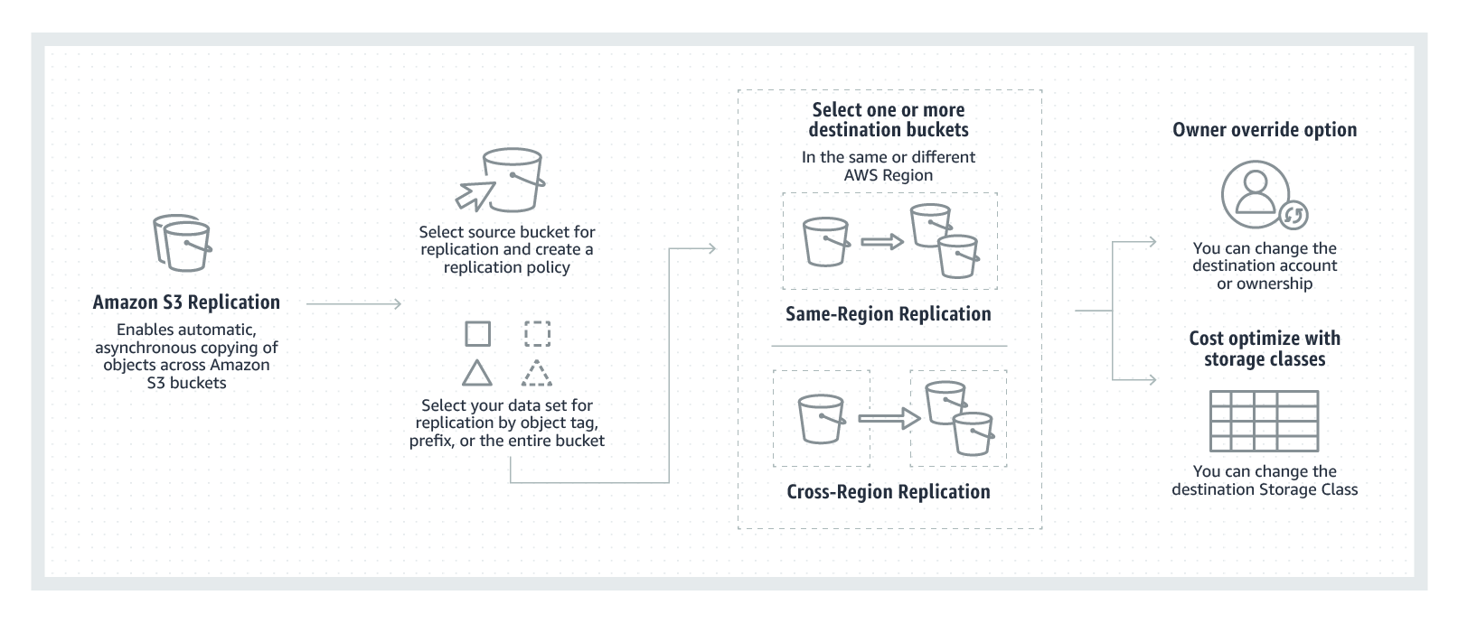

The options that say: **The Cross-Region Replication feature is only available for Amazon S3 - One Zone-IA** and **The Cross-Region Replication feature is only available for Amazon S3 - Infrequent Access** are incorrect as this feature is available to all types of S3 classes.

The option that says: **This is a premium feature which is only for AWS Enterprise accounts** is incorrect as this CRR feature is available to all Support Plans.

**References:**

<https://docs.aws.amazon.com/AmazonS3/latest/dev/crr.html>

<https://aws.amazon.com/blogs/aws/new-cross-region-replication-for-amazon-s3/>

**Check out this Amazon S3 Cheat Sheet:**

[https://tutorialsdojo.com/amazon-s3/](https://tutorialsdojo.com/amazon-s3/?src=udemy)

Bottom of Form

Top of Form

Question 40: Skipped

A Solutions Architect is developing a three-tier cryptocurrency web application for a FinTech startup. The Architect has been instructed to restrict access to the database tier to only accept traffic from the application-tier and deny traffic from other sources. The application-tier is composed of application servers hosted in an Auto Scaling group of EC2 instances.

Which of the following options is the MOST suitable solution to implement in this scenario?

* ​

Set up the Network ACL of the database subnet to deny all inbound non-database traffic from the subnet of the application-tier.

* ​

Set up the security group of the database tier to allow database traffic from the security group of the application servers.

**(Correct)**

* ​

Set up the security group of the database tier to allow database traffic from a specified list of application server IP addresses.

* ​

Set up the Network ACL of the database subnet to allow inbound database traffic from the subnet of the application-tier.

**Explanation**

A **security group** acts as a virtual firewall for your instance to control inbound and outbound traffic. When you launch an instance in a VPC, you can assign up to five security groups to the instance. Security groups act at the instance level, not the subnet level. Therefore, each instance in a subnet in your VPC could be assigned to a different set of security groups. If you don't specify a particular group at launch time, the instance is automatically assigned to the default security group for the VPC.

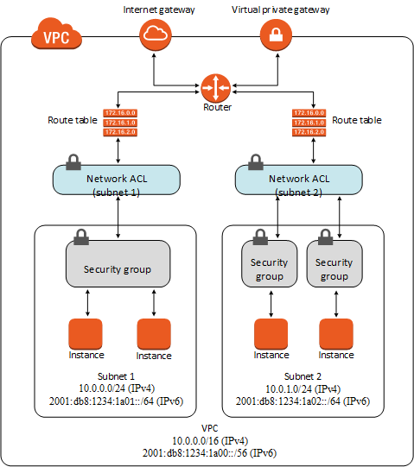

For each security group, you add *rules* that control the inbound traffic to instances, and a separate set of rules that control the outbound traffic. This section describes the basic things you need to know about security groups for your VPC and their rules.

You can add or remove rules for a security group which is also referred to as *authorizing* or *revoking* inbound or outbound access. A rule applies either to inbound traffic (ingress) or outbound traffic (egress). You can grant access to a specific CIDR range, or to another security group in your VPC or in a peer VPC (requires a VPC peering connection).

In the scenario, the servers of the application-tier are in an Auto Scaling group which means that the number of EC2 instances could grow or shrink over time. An Auto Scaling group could also cover one or more Availability Zones (AZ) which have their own subnets. Hence, the most suitable solution would be to **set up the security group of the database tier to allow database traffic from the security group of the application servers** since you can utilize the security group of the application-tier Auto Scaling group as the source for the security group rule in your database tier.

**Setting up the security group of the database tier to allow database traffic from a specified list of application server IP addresses** is incorrect because the list of application server IP addresses will change over time since an Auto Scaling group can add or remove EC2 instances based on the configured scaling policy. This will create inconsistencies in your application because the newly launched instances, which are not included in the initial list of IP addresses, will not be able to access the database.

**Setting up the Network ACL of the database subnet to deny all inbound non-database traffic from the subnet of the application-tier** is incorrect because doing this could affect the other EC2 instances of other applications, which are also hosted in the same subnet of the application-tier. For example, a large subnet with a CIDR block of /16 could be shared by several applications. Denying all inbound non-database traffic from the entire subnet will impact other applications which use this subnet.

**Setting up the Network ACL of the database subnet to allow inbound database traffic from the subnet of the application-tier** is incorrect because although this solution can work, the subnet of the application-tier could be shared by another tier or another set of EC2 instances other than the application-tier. This means that you would inadvertently be granting database access to unauthorized servers hosted in the same subnet other than the application-tier.

**References:**

<https://docs.aws.amazon.com/vpc/latest/userguide/VPC_Security.html#VPC_Security_Comparison>

<http://docs.aws.amazon.com/AmazonVPC/latest/UserGuide/VPC_SecurityGroups.html>

**Check out this Amazon VPC Cheat Sheet:**

[https://tutorialsdojo.com/amazon-vpc/](https://tutorialsdojo.com/amazon-vpc/?src=udemy)

Bottom of Form

Top of Form

Question 41: Skipped

A company launched a cryptocurrency mining server on a Reserved EC2 instance in us-east-1 region's private subnet that uses IPv6. Due to the financial data that the server contains, the system should be secured to prevent any unauthorized access and to meet the regulatory compliance requirements.

In this scenario, which VPC feature allows the EC2 instance to communicate to the Internet but prevents inbound traffic?

* ​

Egress-only Internet gateway

**(Correct)**

* ​

Internet Gateway

* ​

NAT instances

* ​

NAT Gateway

**Explanation**

An **egress-only Internet gateway** is a horizontally scaled, redundant, and highly available VPC component that allows outbound communication over IPv6 from instances in your VPC to the Internet, and prevents the Internet from initiating an IPv6 connection with your instances.

Take note that an egress-only Internet gateway is for use with IPv6 traffic only. To enable outbound-only Internet communication over IPv4, use a NAT gateway instead.

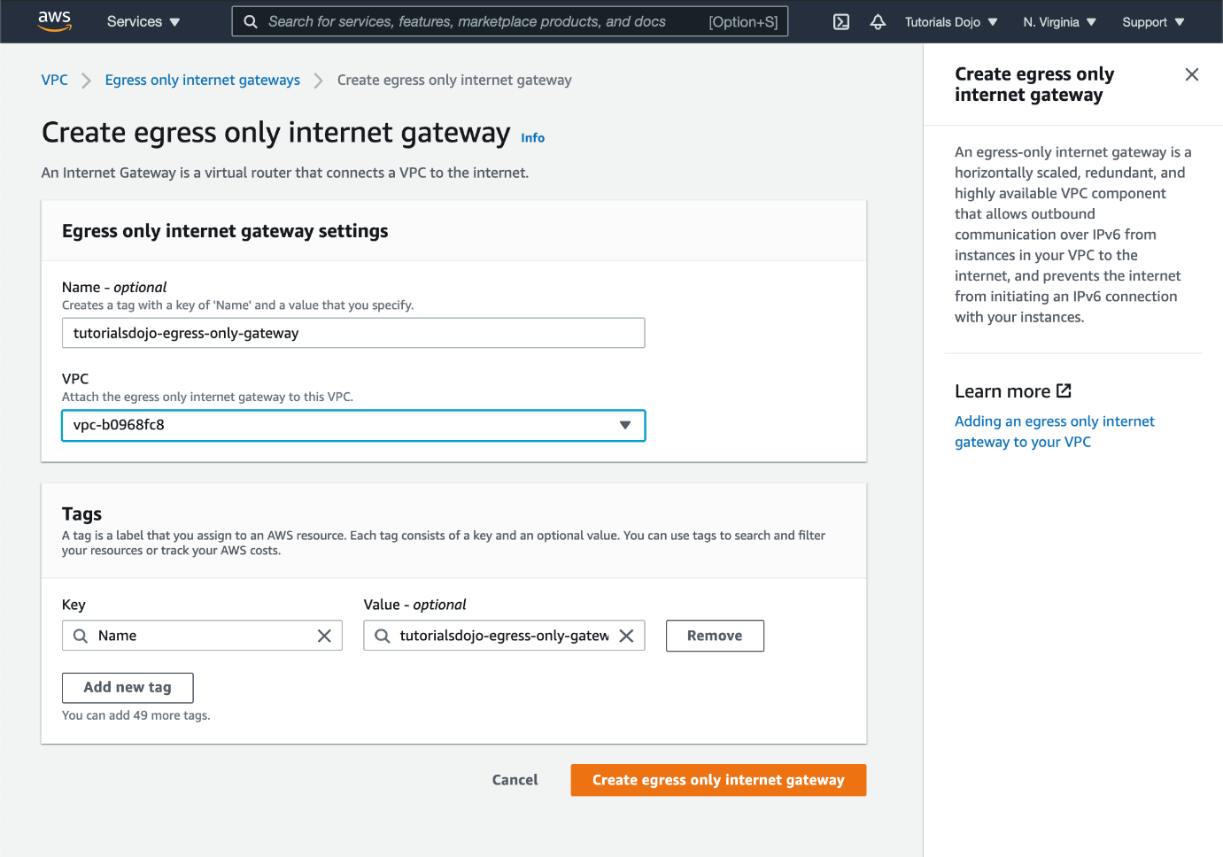

Hence, the correct answer is: **Egress-only Internet gateway.**

**NAT Gateway** and **NAT instances** are incorrect because these are only applicable for IPv4 and not IPv6. Even though these two components can enable the EC2 instance in a private subnet to communicate to the Internet and prevent inbound traffic, it is only limited to instances which are using IPv4 addresses and not IPv6. The most suitable VPC component to use is the egress-only Internet gateway.

**Internet Gateway** is incorrect because this is primarily used to provide Internet access to your instances in the public subnet of your VPC, and not for private subnets. However, with an Internet gateway, traffic originating from the public Internet will also be able to reach your instances. The scenario is asking you to prevent inbound access, so this is not the correct answer.

**Reference:**

<https://docs.aws.amazon.com/vpc/latest/userguide/egress-only-internet-gateway.html>

**Check out this Amazon VPC Cheat Sheet:**

[https://tutorialsdojo.com/amazon-vpc/](https://tutorialsdojo.com/amazon-vpc/?src=udemy)

Bottom of Form

Top of Form

Question 42: Skipped

A web application, which is hosted in your on-premises data center and uses a MySQL database, must be migrated to AWS Cloud. You need to ensure that the network traffic to and from your RDS database instance is encrypted using SSL. For improved security, you have to use the profile credentials specific to your EC2 instance to access your database, instead of a password.

Which of the following should you do to meet the above requirement?

* ​

Launch a new RDS database instance with the Backtrack feature enabled.

* ​

Configure your RDS database to enable encryption.

* ​

Launch the mysql client using the --ssl-ca parameter when connecting to the database.

* ​

Set up an RDS database and enable the IAM DB Authentication.

**(Correct)**

**Explanation**

You can authenticate to your DB instance using AWS Identity and Access Management (IAM) database authentication. IAM database authentication works with MySQL and PostgreSQL. With this authentication method, you don't need to use a password when you connect to a DB instance. Instead, you use an authentication token.

An *authentication token* is a unique string of characters that Amazon RDS generates on request. Authentication tokens are generated using AWS Signature Version 4. Each token has a lifetime of 15 minutes. You don't need to store user credentials in the database, because authentication is managed externally using IAM. You can also still use standard database authentication.

IAM database authentication provides the following benefits:

- Network traffic to and from the database is encrypted using Secure Sockets Layer (SSL).

- You can use IAM to centrally manage access to your database resources, instead of managing access individually on each DB instance.

- For applications running on Amazon EC2, you can use profile credentials specific to your EC2 instance to access your database instead of a password, for greater security

Hence, **setting up an RDS database and enable the IAM DB Authentication** is the correct answer based on the above reference.

**Launching a new RDS database instance with the Backtrack feature enabled** is incorrect because the Backtrack feature simply "rewinds" the DB cluster to the time you specify. Backtracking is not a replacement for backing up your DB cluster so that you can restore it to a point in time. However, you can easily undo mistakes using the backtrack feature if you mistakenly perform a destructive action, such as a DELETE without a WHERE clause.

**Configuring your RDS database to enable encryption** is incorrect because this encryption feature in RDS is mainly for securing your Amazon RDS DB instances and snapshots at rest. The data that is encrypted at rest includes the underlying storage for DB instances, its automated backups, Read Replicas, and snapshots.

**Launching the mysql client using the --ssl-ca parameter when connecting to the database** is incorrect because even though using the --ssl-ca parameter can provide SSL connection to your database, you still need to use IAM database connection to use the profile credentials specific to your EC2 instance to access your database instead of a password.

**Reference:**

<https://docs.aws.amazon.com/AmazonRDS/latest/UserGuide/UsingWithRDS.IAMDBAuth.html>

**Check out this Amazon RDS cheat sheet:**

[https://tutorialsdojo.com/amazon-relational-database-service-amazon-rds/](https://tutorialsdojo.com/amazon-relational-database-service-amazon-rds/?src=udemy)

Bottom of Form

Top of Form

Question 43: Skipped

A company is planning to deploy a High Performance Computing (HPC) cluster in its VPC that requires a scalable, high-performance file system. The storage service must be optimized for efficient workload processing, and the data must be accessible via a fast and scalable file system interface. It should also work natively with Amazon S3 that enables you to easily process your S3 data with a high-performance POSIX interface.

Which of the following is the MOST suitable service that you should use for this scenario?

* ​

Amazon Elastic File System (EFS)

* ​

Amazon Elastic Block Storage (EBS)

* ​

Amazon FSx for Windows File Server

* ​

Amazon FSx for Lustre

**(Correct)**

**Explanation**

**Amazon FSx for Lustre** provides a high-performance file system optimized for fast processing of workloads such as machine learning, high performance computing (HPC), video processing, financial modeling, and electronic design automation (EDA). These workloads commonly require data to be presented via a fast and scalable file system interface, and typically have data sets stored on long-term data stores like Amazon S3.

Operating high-performance file systems typically require specialized expertise and administrative overhead, requiring you to provision storage servers and tune complex performance parameters. With Amazon FSx, you can launch and run a file system that provides sub-millisecond access to your data and allows you to read and write data at speeds of up to hundreds of gigabytes per second of throughput and millions of IOPS.

Amazon FSx for Lustre works natively with Amazon S3, making it easy for you to process cloud data sets with high-performance file systems. When linked to an S3 bucket, an FSx for Lustre file system transparently presents S3 objects as files and allows you to write results back to S3. You can also use FSx for Lustre as a standalone high-performance file system to burst your workloads from on-premises to the cloud. By copying on-premises data to an FSx for Lustre file system, you can make that data available for fast processing by compute instances running on AWS. With Amazon FSx, you pay for only the resources you use. There are no minimum commitments, upfront hardware or software costs, or additional fees.

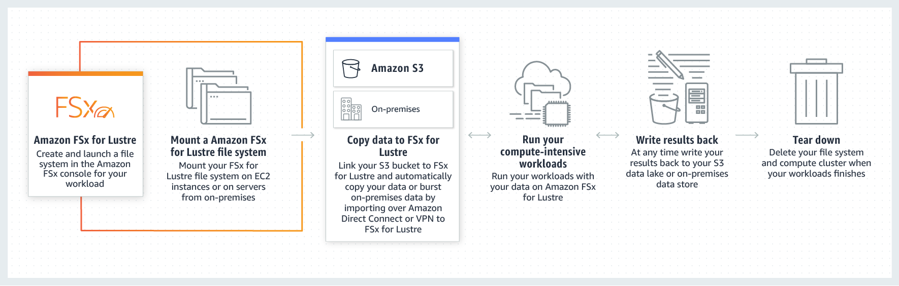

For Windows-based applications, Amazon FSx provides fully managed Windows file servers with features and performance optimized for "lift-and-shift" business-critical application workloads including home directories (user shares), media workflows, and ERP applications. It is accessible from Windows and Linux instances via the SMB protocol. If you have Linux-based applications, Amazon EFS is a cloud-native fully managed file system that provides simple, scalable, elastic file storage accessible from Linux instances via the NFS protocol.

For compute-intensive and fast processing workloads, like high-performance computing (HPC), machine learning, EDA, and media processing, Amazon FSx for Lustre, provides a file system that’s optimized for performance, with input and output stored on Amazon S3.

Hence, the correct answer is: ***Amazon FSx for Lustre.***

***Amazon Elastic File System (EFS)*** is incorrect because although the EFS service can be used for HPC applications, it doesn't natively work with Amazon S3. It doesn't have the capability to easily process your S3 data with a high-performance POSIX interface, unlike Amazon FSx for Lustre.

***Amazon FSx for Windows File Server*** is incorrect because although this service is a type of Amazon FSx, it does not work natively with Amazon S3. This service is a fully managed native Microsoft Windows file system that is primarily used for your Windows-based applications that require shared file storage to AWS.

***Amazon Elastic Block Storage (EBS)*** is incorrect because this service is not a scalable, high-performance file system.

**References:**

<https://aws.amazon.com/fsx/lustre/>

<https://aws.amazon.com/getting-started/use-cases/hpc/3/>

**Check out this Amazon FSx Cheat Sheet:**

[https://tutorialsdojo.com/amazon-fsx/](https://tutorialsdojo.com/amazon-fsx/?src=udemy)

Bottom of Form

Top of Form

Question 44: Skipped

A startup is building IoT devices and monitoring applications. They are using IoT sensors to monitor the traffic in real-time by using an Amazon Kinesis Stream that is configured with default settings. It then sends the data to an Amazon S3 bucket every 3 days. When you checked the data in S3 on the 3rd day, only the data for the last day is present and no data is present from 2 days ago.

Which of the following is the MOST likely cause of this issue?

* ​

By default, data records in Kinesis are only accessible for 24 hours from the time they are added to a stream.

**(Correct)**

* ​

The access of the Kinesis stream to the S3 bucket is insufficient.

* ​

Someone has manually deleted the record in Amazon S3.

* ​

Amazon S3 bucket has encountered a data loss.

**Explanation**

By default, records of a stream in Amazon Kinesis are accessible for up to 24 hours from the time they are added to the stream. You can raise this limit to up to 7 days by enabling extended data retention.

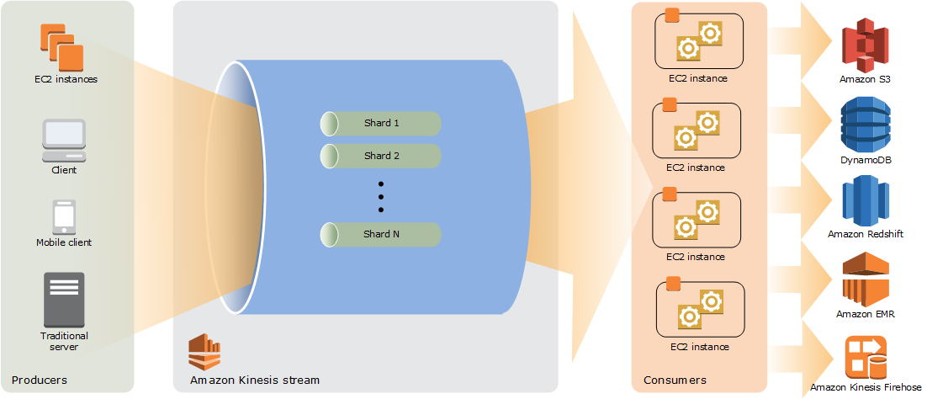

Hence, the correct answer is: **By default, data records in Kinesis are only accessible for 24 hours from the time they are added to a stream.**

The option that says: **Amazon S3 bucket has encountered a data loss** is incorrect because Amazon S3 rarely experiences data loss. Amazon has an SLA for S3 that it commits to its customers. Amazon S3 Standard, S3 Standard–IA, S3 One Zone-IA, and S3 Glacier are all designed to provide 99.999999999% durability of objects over a given year. This durability level corresponds to an average annual expected loss of 0.000000001% of objects. Hence, Amazon S3 bucket data loss is highly unlikely.

The option that says: **Someone has manually deleted the record in Amazon S3** is incorrect because if someone has deleted the data, this should have been visible in CloudTrail. Also, deleting that much data manually shouldn't have occurred in the first place if you have put in the appropriate security measures.

The option that says: **The access of the Kinesis stream to the S3 bucket is insufficient** is incorrect because having insufficient access is highly unlikely since you are able to access the bucket and view the contents of the previous day's data collected by Kinesis.

**Reference:**

<https://aws.amazon.com/kinesis/data-streams/faqs/>

<https://docs.aws.amazon.com/AmazonS3/latest/dev/DataDurability.html>

**Check out this Amazon Kinesis Cheat Sheet:**

[https://tutorialsdojo.com/amazon-kinesis/](https://tutorialsdojo.com/amazon-kinesis/?src=udemy)

Bottom of Form

Top of Form

Question 45: Skipped

A Solutions Architect designed a real-time data analytics system based on Kinesis Data Stream and Lambda. A week after the system has been deployed, the users noticed that it performed slowly as the data rate increases. The Architect identified that the performance of the Kinesis Data Streams is causing this problem.

Which of the following should the Architect do to improve performance?

* ​

Replace the data stream with Amazon Kinesis Data Firehose instead.

* ​

Improve the performance of the stream by decreasing the number of its shards using the MergeShard command.

* ​

Increase the number of shards of the Kinesis stream by using the UpdateShardCount command.

**(Correct)**

* ​

Implement Step Scaling to the Kinesis Data Stream.

**Explanation**

Amazon Kinesis Data Streams supports *resharding*, which lets you adjust the number of shards in your stream to adapt to changes in the rate of data flow through the stream. Resharding is considered an advanced operation.

There are two types of resharding operations: shard split and shard merge. In a shard split, you divide a single shard into two shards. In a shard merge, you combine two shards into a single shard. Resharding is always *pairwise* in the sense that you cannot split into more than two shards in a single operation, and you cannot merge more than two shards in a single operation. The shard or pair of shards that the resharding operation acts on are referred to as *parent* shards. The shard or pair of shards that result from the resharding operation are referred to as *child*shards.

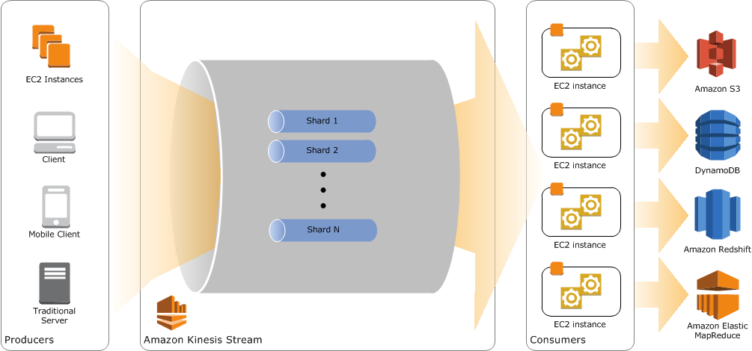

Splitting increases the number of shards in your stream and therefore increases the data capacity of the stream. Because you are charged on a per-shard basis, splitting increases the cost of your stream. Similarly, merging reduces the number of shards in your stream and therefore decreases the data capacity—and cost—of the stream.

If your data rate increases, you can also increase the number of shards allocated to your stream to maintain the application performance. You can reshard your stream using the **UpdateShardCount** API. The throughput of an Amazon Kinesis data stream is designed to scale without limits via increasing the number of shards within a data stream. Hence, the correct answer is to **increase the number of shards of the Kinesis stream by using the UpdateShardCount command**.

**Replacing the data stream with Amazon Kinesis Data Firehose instead** is incorrect because the throughput of Kinesis Firehose is not exceptionally higher than Kinesis Data Streams. In fact, the throughput of an Amazon Kinesis data stream is designed to scale **without** limits via increasing the number of shards within a data stream.

**Improving the performance of the stream by decreasing the number of its shards using the MergeShard command** is incorrect because merging the shards will effectively decrease the performance of the stream rather than improve it.

**Implementing Step Scaling to the Kinesis Data Stream** is incorrect because there is no Step Scaling feature for Kinesis Data Streams. This is only applicable for EC2.

**References:**

<https://aws.amazon.com/blogs/big-data/scale-your-amazon-kinesis-stream-capacity-with-updateshardcount/>

<https://aws.amazon.com/kinesis/data-streams/faqs/>

<https://docs.aws.amazon.com/streams/latest/dev/kinesis-using-sdk-java-resharding.html>

**Check out this Amazon Kinesis Cheat Sheet:**

[https://tutorialsdojo.com/amazon-kinesis/](https://tutorialsdojo.com/amazon-kinesis/?src=udemy)

Bottom of Form

Top of Form

Question 46: Skipped

An intelligence agency is currently hosting a learning and training portal in AWS. Your manager instructed you to launch a large EC2 instance with an attached EBS Volume and enable Enhanced Networking. What are the valid case scenarios in using Enhanced Networking? (Select TWO.)

* ​

When you need a dedicated connection to your on-premises data center

* ​

When you need a low packet-per-second performance

* ​

When you need a higher packet per second (PPS) performance

**(Correct)**

* ​

When you need high latency networking

* ​

When you need a consistently lower inter-instance latencies

**(Correct)**

**Explanation**

Enhanced networking uses single root I/O virtualization (SR-IOV) to provide high-performance networking capabilities on supported instance types. SR-IOV is a method of device virtualization that provides higher I/O performance and lower CPU utilization when compared to traditional virtualized network interfaces. Enhanced networking provides higher bandwidth, higher packet per second (PPS) performance, and consistently lower inter-instance latencies. There is no additional charge for using enhanced networking.

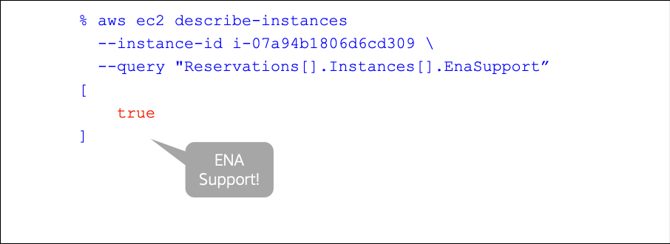

The option that says: **When you need a low packet-per-second performance** is incorrect because you want to increase packet-per-second performance, and not lower it when you enable enhanced networking.

The option that says: **When you need high latency networking** is incorrect because higher latencies mean slower network, which is the opposite of what you want to happen when you enable enhanced networking.

The option that says: **When you need a dedicated connection to your on-premises data center** is incorrect because enabling enhanced networking does not provide a dedicated connection to your on-premises data center. Use AWS Direct Connect or enable VPN tunneling instead for this purpose.

**Reference:**

<http://docs.aws.amazon.com/AWSEC2/latest/UserGuide/enhanced-networking.html>

**Check out this Amazon EC2 Cheat Sheet:**

[https://tutorialsdojo.com/amazon-elastic-compute-cloud-amazon-ec2/](https://tutorialsdojo.com/amazon-elastic-compute-cloud-amazon-ec2/?src=udemy)

Bottom of Form

Top of Form

Question 47: Skipped

A fast food company is using AWS to host their online ordering system which uses an Auto Scaling group of EC2 instances deployed across multiple Availability Zones with an Application Load Balancer in front. To better handle the incoming traffic from various digital devices, you are planning to implement a new routing system where requests which have a URL of <server>/api/android are forwarded to one specific target group named "Android-Target-Group". Conversely, requests which have a URL of <server>/api/ios are forwarded to another separate target group named "iOS-Target-Group".

How can you implement this change in AWS?

* ​

Replace your ALB with a Classic Load Balancer then use path conditions to define rules that forward requests to different target groups based on the URL in the request.

* ​

Use path conditions to define rules that forward requests to different target groups based on the URL in the request.

**(Correct)**

* ​

Replace your ALB with a Network Load Balancer then use host conditions to define rules that forward requests to different target groups based on the URL in the request.

* ​

Use host conditions to define rules that forward requests to different target groups based on the host name in the host header. This enables you to support multiple domains using a single load balancer.

**Explanation**

You can use path conditions to define rules that forward requests to different target groups based on the URL in the request (also known as *path-based routing*). This type of routing is the most appropriate solution for this scenario hence, **using path conditions to define rules that forward requests to different target groups based on the URL in the request** is the correct answer.

Each path condition has one path pattern. If the URL in a request matches the path pattern in a listener rule exactly, the request is routed using that rule.

A path pattern is case-sensitive, can be up to 128 characters in length, and can contain any of the following characters. You can include up to three wildcard characters.

A–Z, a–z, 0–9

_ - . $ / ~ " ' @ : +

& (using &amp;)

* (matches 0 or more characters)

? (matches exactly 1 character)

Example path patterns

/img/*

/js/*

The option that says: **Use host conditions to define rules that forward requests to different target groups based on the host name in the host header. This enables you to support multiple domains using a single load balancer** is incorrect because host-based routing defines rules that forward requests to different target groups based on the host name in the host header instead of the URL, which is what is needed in this scenario.

The option that says: **Replace your ALB with a Classic Load Balancer then use path conditions to define rules that forward requests to different target groups based on the URL in the request** is incorrect because a Classic Load Balancer does not support path-based routing. You must use an Application Load Balancer.

The option that says: **Replace your ALB with a Network Load Balancer then use host conditions to define rules that forward requests to different target groups based on the URL in the request** is incorrect because a Network Load Balancer is used for applications that need extreme network performance and static IP. It also does not support path-based routing which is what is needed in this scenario. Furthermore, the statement mentions host-based routing yet, the description is about path-based routing.

**References:**

<https://docs.aws.amazon.com/elasticloadbalancing/latest/application/introduction.html#application-load-balancer-benefits>

<https://docs.aws.amazon.com/elasticloadbalancing/latest/application/load-balancer-listeners.html#path-conditions>

**Check out this AWS Elastic Load Balancing (ELB) Cheat Sheet:**

[https://tutorialsdojo.com/aws-elastic-load-balancing-elb/](https://tutorialsdojo.com/aws-elastic-load-balancing-elb/?src=udemy)

**Application Load Balancer vs Network Load Balancer vs Classic Load Balancer:**

[https://tutorialsdojo.com/application-load-balancer-vs-network-load-balancer-vs-classic-load-balancer/](https://tutorialsdojo.com/application-load-balancer-vs-network-load-balancer-vs-classic-load-balancer/?src=udemy)

Bottom of Form

Top of Form

Question 48: Skipped

A company plans to design an application that can handle batch processing of large amounts of financial data. The Solutions Architect is tasked to create two Amazon S3 buckets to store the input and output data. The application will transfer the data between multiple EC2 instances over the network to complete the data processing.

Which of the following options would reduce the data transfer costs?

* ​

Deploy the Amazon EC2 instances in the same AWS Region.

* ​

Deploy the Amazon EC2 instances in private subnets in different Availability Zones.

* ​

Deploy the Amazon EC2 instances in the same Availability Zone.

**(Correct)**

* ​

Deploy the Amazon EC2 instances behind an Application Load Balancer.

**Explanation**

**Amazon Elastic Compute Cloud (Amazon EC2)**provides scalable computing capacity in the Amazon Web Services (AWS) Cloud. Using Amazon EC2 eliminates your need to invest in hardware up front, so you can develop and deploy applications faster. You can use Amazon EC2 to launch as many or as few virtual servers as you need, configure security and networking, and manage storage. Amazon EC2 enables you to scale up or down to handle changes in requirements or spikes in popularity, reducing your need to forecast traffic.

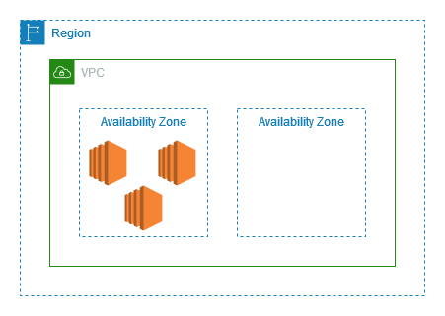

In this scenario, you should deploy all the EC2 instances in the same Availability Zone. If you recall, data transferred between Amazon EC2, Amazon RDS, Amazon Redshift, Amazon ElastiCache instances, and Elastic Network Interfaces in the same Availability Zone is free. Instead of using the public network to transfer the data, you can use the private network to reduce the overall data transfer costs.

Hence, the correct answer is:**Deploy the Amazon EC2 instances in the same Availability Zone.**

The option that says: **Deploy the Amazon EC2 instances in the same AWS Region** is incorrect because even if the instances are deployed in the same Region, they could still be charged with inter-Availability Zone data transfers if the instances are distributed across different availability zones. You must deploy the instances in the same Availability Zone to avoid the data transfer costs.

The option that says: **Deploy the Amazon EC2 instances behind an Application Load Balancer**is incorrect because this approach won't reduce the overall data transfer costs. An Application Load Balancer is primarily used to distribute the incoming traffic to underlying EC2 instances.

The option that says: **Deploy the Amazon EC2 instances in private subnets in different Availability Zones** is incorrect. Although the data transfer between instances in private subnets is free, there will be an issue with retrieving the data in Amazon S3. Remember that you won’t be able to connect to your Amazon S3 bucket if you are using a private subnet unless you have a VPC Endpoint.

**References:**

<https://aws.amazon.com/ec2/pricing/on-demand/>

<https://docs.aws.amazon.com/AWSEC2/latest/UserGuide/concepts.html>

<https://aws.amazon.com/blogs/mt/using-aws-cost-explorer-to-analyze-data-transfer-costs/>

**Check out this Amazon EC2 Cheat Sheet:**

[https://tutorialsdojo.com/amazon-elastic-compute-cloud-amazon-ec2/](https://tutorialsdojo.com/amazon-elastic-compute-cloud-amazon-ec2/?src=udemy)

Bottom of Form

Top of Form

Question 49: Skipped

A game company has a requirement of load balancing the incoming TCP traffic at the transport level (Layer 4) to their containerized gaming servers hosted in AWS Fargate. To maintain performance, it should handle millions of requests per second sent by gamers around the globe while maintaining ultra-low latencies.

Which of the following must be implemented in the current architecture to satisfy the new requirement?

* ​

Create a new record in Amazon Route 53 with Weighted Routing policy to load balance the incoming traffic.

* ​

Launch a new Network Load Balancer.

**(Correct)**

* ​

Launch a new microservice in AWS Fargate that acts as a load balancer since using an ALB or NLB with Fargate is not possible.

* ​

Launch a new Application Load Balancer.

**Explanation**

Elastic Load Balancing automatically distributes incoming application traffic across multiple targets, such as Amazon EC2 instances, containers, IP addresses, and Lambda functions. It can handle the varying load of your application traffic in a single Availability Zone or across multiple Availability Zones. Elastic Load Balancing offers three types of load balancers that all feature the high availability, automatic scaling, and robust security necessary to make your applications fault-tolerant. They are: Application Load Balancer, Network Load Balancer, and Classic Load Balancer

**Network Load Balancer** is best suited for load balancing of TCP traffic where extreme performance is required. Operating at the connection level (Layer 4), Network Load Balancer routes traffic to targets within Amazon Virtual Private Cloud (Amazon VPC) and is capable of handling millions of requests per second while maintaining ultra-low latencies. Network Load Balancer is also optimized to handle sudden and volatile traffic patterns.

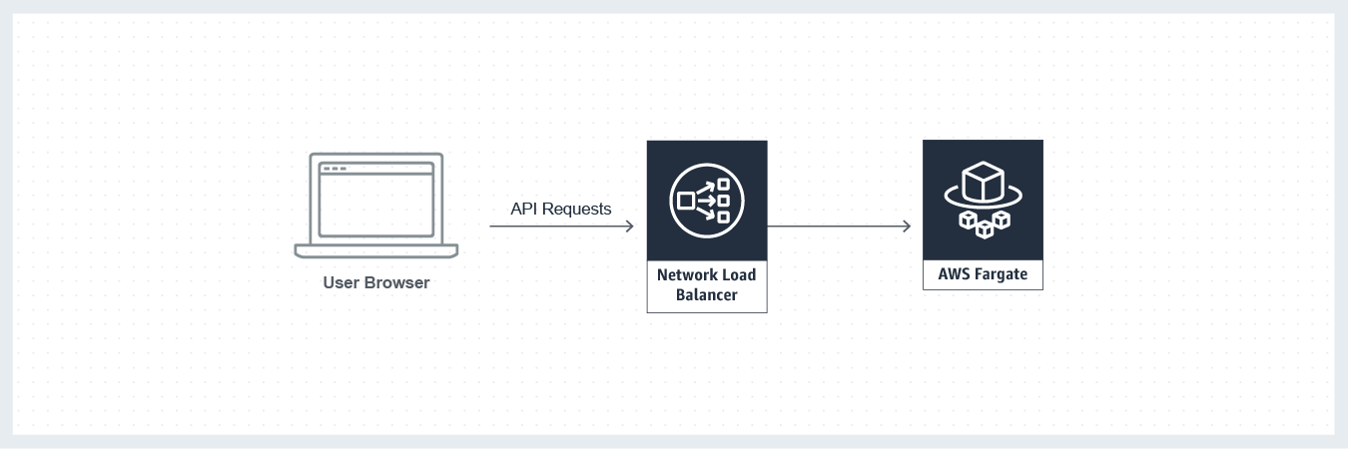

Hence, the correct answer is to ***launch a new Network Load Balancer***.

The option that says:***Launch a new Application Load Balancer*** is incorrect because it cannot handle TCP or Layer 4 connections, only Layer 7 (HTTP and HTTPS).

The option that says:***Create a new record in Amazon Route 53 with Weighted Routing policy to load balance the incoming traffic*** is incorrect because although Route 53 can act as a load balancer by assigning each record a relative weight that corresponds to how much traffic you want to send to each resource, it is still not capable of handling millions of requests per second while maintaining ultra-low latencies. You have to use a Network Load Balancer instead.

The option that says:***Launch a new microservice in AWS Fargate that acts as a load balancer since using an ALB or NLB with Fargate is not possible***is incorrect because you can place an ALB and NLB in front of your AWS Fargate cluster.

**References:**

<https://aws.amazon.com/elasticloadbalancing/features/#compare>

<https://docs.aws.amazon.com/AmazonECS/latest/developerguide/load-balancer-types.html>

<https://aws.amazon.com/getting-started/projects/build-modern-app-fargate-lambda-dynamodb-python/module-two/>

**Check out this AWS Elastic Load Balancing (ELB) Cheat Sheet:**

[https://tutorialsdojo.com/aws-elastic-load-balancing-elb/](https://tutorialsdojo.com/aws-elastic-load-balancing-elb/?src=udemy)

Bottom of Form

Top of Form

Question 50: Skipped

A company created a VPC with a single subnet then launched an On-Demand EC2 instance in that subnet. You have attached an Internet gateway (IGW) to the VPC and verified that the EC2 instance has a public IP. The main route table of the VPC is as shown below:

[Larger image](javascript:void(0))

[[](javascript:void(0))](javascript:void(0))

However, the instance still cannot be reached from the Internet when you tried to connect to it from your computer. Which of the following should be made to the route table to fix this issue?

* ​

Add the following entry to the route table: 10.0.0.0/27 -> Your Internet Gateway

* ​

Add this new entry to the route table: 0.0.0.0/0 -> Your Internet Gateway

**(Correct)**

* ​

Add this new entry to the route table: 0.0.0.0/27 -> Your Internet Gateway

* ​

Modify the above route table: 10.0.0.0/27 -> Your Internet Gateway

**Explanation**

Apparently, the route table does not have an entry for the Internet Gateway. This is why you cannot connect to the EC2 instance. To fix this, you have to add a route with a destination of 0.0.0.0/0 for IPv4 traffic or ::/0 for IPv6 traffic, and then a target of the Internet gateway ID (igw-xxxxxxxx).

This should be the correct route table configuration after adding the new entry.

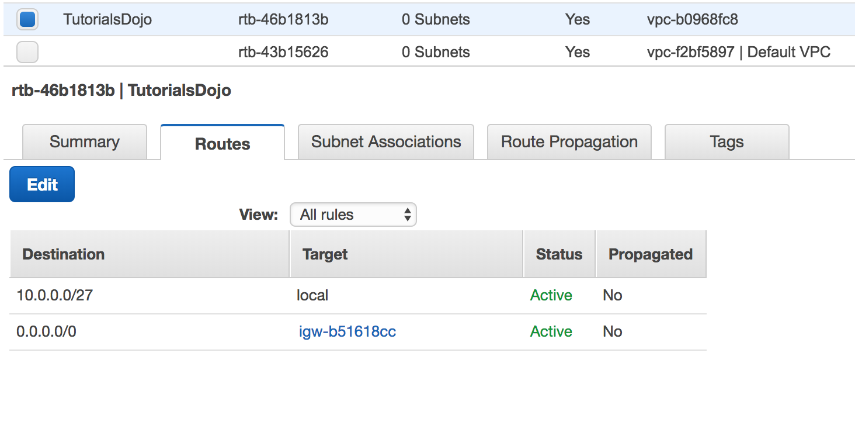

**Reference:**

<http://docs.aws.amazon.com/AmazonVPC/latest/UserGuide/VPC_Route_Tables.html>

**Check out this Amazon VPC Cheat Sheet:**

[https://tutorialsdojo.com/amazon-vpc/](https://tutorialsdojo.com/amazon-vpc/?src=udemy)

Bottom of Form

Top of Form

Question 51: Skipped

A company plans to launch an application that tracks the GPS coordinates of delivery trucks in the country. The coordinates are transmitted from each delivery truck every five seconds. You need to design an architecture that will enable real-time processing of these coordinates from multiple consumers. The aggregated data will be analyzed in a separate reporting application.

Which AWS service should you use for this scenario?

* ​

Amazon Kinesis

**(Correct)**

* ​

AWS Data Pipeline

* ​

Amazon Simple Queue Service

* ​

Amazon AppStream

**Explanation**

**Amazon Kinesis** makes it easy to collect, process, and analyze real-time, streaming data so you can get timely insights and react quickly to new information. It offers key capabilities to cost-effectively process streaming data at any scale, along with the flexibility to choose the tools that best suit the requirements of your application.

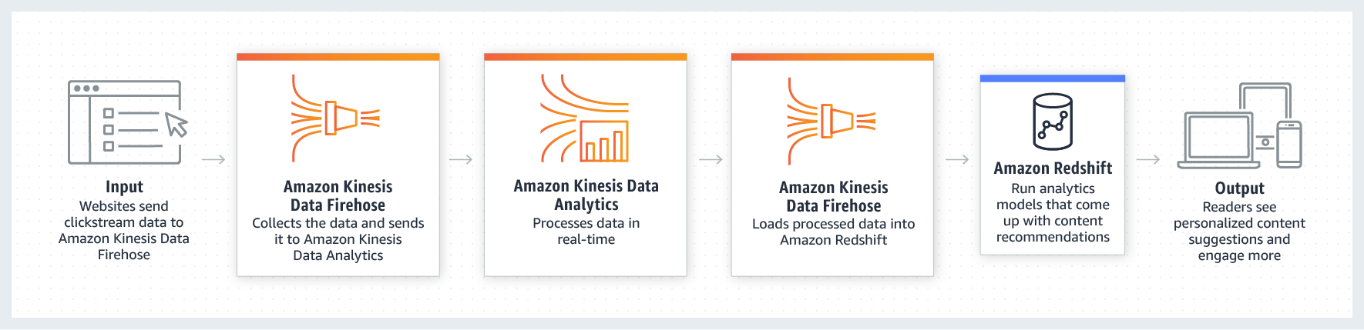

With Amazon Kinesis, you can ingest real-time data such as video, audio, application logs, website clickstreams, and IoT telemetry data for machine learning, analytics, and other applications. Amazon Kinesis enables you to process and analyze data as it arrives and responds instantly instead of having to wait until all your data are collected before the processing can begin.

**Reference:**

<https://aws.amazon.com/kinesis/>

**Check out this Amazon Kinesis Cheat Sheet:**

[https://tutorialsdojo.com/amazon-kinesis/](https://tutorialsdojo.com/amazon-kinesis/?src=udemy)

Bottom of Form

Top of Form

Question 52: Skipped

A startup is building an AI-based face recognition application in AWS, where they store millions of images in an S3 bucket. As the Solutions Architect, you have to ensure that each and every image uploaded to their system is stored without any issues.

What is the correct indication that an object was successfully stored when you put objects in Amazon S3?

* ​

HTTP 200 result code and MD5 checksum.

**(Correct)**

* ​

Amazon S3 has 99.999999999% durability hence, there is no need to confirm that data was inserted.

* ​

You will receive an SMS from Amazon SNS informing you that the object is successfully stored.

* ​

You will receive an email from Amazon SNS informing you that the object is successfully stored.

**Explanation**

If you triggered an S3 API call and got HTTP 200 result code and MD5 checksum, then it is considered as a successful upload. The S3 API will return an error code in case the upload is unsuccessful.

The option that says: **Amazon S3 has 99.999999999% durability hence, there is no need to confirm that data was inserted** is incorrect because although S3 is durable, it is not an assurance that all objects uploaded using S3 API calls will be successful.

The options that say: **You will receive an SMS from Amazon SNS informing you that the object is successfully stored** and **You will receive an email from Amazon SNS informing you that the object is successfully stored** are both incorrect because you don't receive an SMS nor an email notification by default, unless you added an event notification.

**Reference:**

<https://docs.aws.amazon.com/AmazonS3/latest/API/RESTObjectPOST.html>

**Check out this Amazon S3 Cheat Sheet:**

[https://tutorialsdojo.com/amazon-s3/](https://tutorialsdojo.com/amazon-s3/?src=udemy)

Bottom of Form

Top of Form

Question 53: Skipped

A company has a VPC for its human resource department, and another VPC located in a different region for their finance department. The Solutions Architect must redesign the architecture to allow the finance department to access all resources that are in the human resource department, and vice versa.

Which type of networking connection in AWS should the Solutions Architect set up to satisfy the above requirement?

* ​

VPN Connection

* ​

VPC Endpoint

* ​

Inter-Region VPC Peering

**(Correct)**

* ​

AWS Cloud Map

**Explanation**

Amazon Virtual Private Cloud (Amazon VPC) offers a comprehensive set of virtual networking capabilities that provide AWS customers with many options for designing and implementing networks on the AWS cloud. With Amazon VPC, you can provision logically isolated virtual networks to host your AWS resources. You can create multiple VPCs within the same region or in different regions, in the same account or in different accounts. This is useful for customers who require multiple VPCs for security, billing, regulatory, or other purposes, and want to integrate AWS resources between their VPCs more easily. More often than not, these different VPCs need to communicate privately and securely with one another for sharing data or applications.

A VPC peering connection is a networking connection between two VPCs that enables you to route traffic between them privately. Instances in either VPC can communicate with each other as if they are within the same network. You can create a VPC peering connection between your own VPCs, with a VPC in another AWS account, or with a VPC in a different AWS Region.

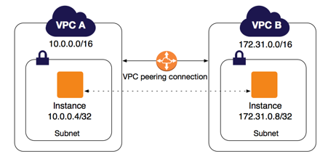

AWS uses the existing infrastructure of a VPC to create a VPC peering connection; it is neither a gateway nor a VPN connection and does not rely on a separate piece of physical hardware. There is no single point of failure for communication or a bandwidth bottleneck.

Hence, the correct answer is: **Inter-Region VPC Peering.**

**AWS Cloud Map** is incorrect because this is simply a cloud resource discovery service. With Cloud Map, you can define custom names for your application resources, and it maintains the updated location of these dynamically changing resources. This increases your application availability because your web service always discovers the most up-to-date locations of its resources.

**VPN Connection** is incorrect. This is technically possible, but since you already have 2 VPCs on AWS, it is easier to set up a VPC peering connection. The bandwidth is also faster for VPC peering since the connection will be going through the AWS backbone network instead of the public Internet when you use a VPN connection.

**VPC Endpoint** is incorrect because this is primarily used to allow you to privately connect your VPC to supported AWS services and VPC endpoint services powered by PrivateLink, but not to the other VPC itself.

**References:**

<https://docs.aws.amazon.com/AmazonVPC/latest/UserGuide/vpc-peering.html>

<https://aws.amazon.com/answers/networking/aws-multiple-region-multi-vpc-connectivity/>

**Check out these Amazon VPC and VPC Peering Cheat Sheets:**

[https://tutorialsdojo.com/amazon-vpc/](https://tutorialsdojo.com/amazon-vpc/?src=udemy)

[https://tutorialsdojo.com/vpc-peering/](https://tutorialsdojo.com/vpc-peering/?src=udemy)

Bottom of Form

Top of Form

Question 54: Skipped

A Solutions Architect needs to launch a web application that will be served globally using Amazon CloudFront. The application is hosted in an Amazon EC2 instance which will be configured as the origin server to process and serve dynamic content to its customers.

Which of the following options provides high availability for the application?

* ​

Use Lambda@Edge to improve the performance of your web application and ensure high availability. Set the Lambda@Edge functions to be part of an origin group.

* ​

Launch an Auto Scaling group of EC2 instances and configure it to be part of an origin group.

* ​

Provision two EC2 instances deployed in different Availability Zones and configure them to be part of an origin group.

**(Correct)**

* ​

Use Amazon S3 to serve the dynamic content of your web application and configure the S3 bucket to be part of an origin group.

**Explanation**

An origin is a location where content is stored, and from which CloudFront gets content to serve to viewers. **Amazon CloudFront** is a service that speeds up the distribution of your static and dynamic web content, such as .html, .css, .js, and image files, to your users. CloudFront delivers your content through a worldwide network of data centers called edge locations. When a user requests content that you're serving with CloudFront, the user is routed to the edge location that provides the lowest latency (time delay), so that content is delivered with the best possible performance.

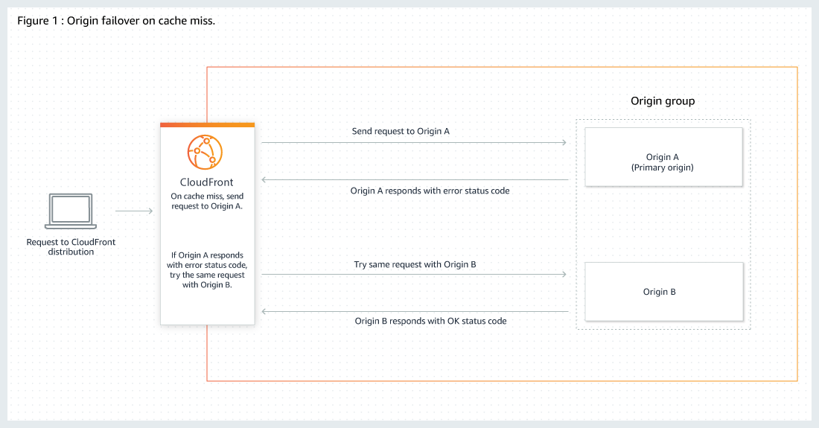

You can also set up CloudFront with origin failover for scenarios that require high availability. An origin group may contain two origins: a primary and a secondary. If the primary origin is unavailable or returns specific HTTP response status codes that indicate a failure, CloudFront automatically switches to the secondary origin. To set up origin failover, you must have a distribution with at least two origins.

The scenario uses an EC2 instance as an origin. Take note that we can also use an EC2 instance or a custom origin in configuring CloudFront. To achieve high availability in an EC2 instance, we need to deploy the instances in two or more Availability Zones. You also need to configure the instances to be part of the origin group to ensure that the application is highly available.

Hence, the correct answer is:**Provision two EC2 instances deployed in different Availability Zones and configure them to be part of an origin group.**

The option that says:**Use Amazon S3 to serve the dynamic content of your web application and configure the S3 bucket to be part of an origin group** is incorrect because Amazon S3 can only serve static content. If you need to host dynamic content, you have to use an Amazon EC2 instance instead.

The option that says:**Launch an Auto Scaling group of EC2 instances and configure it to be part of an origin group** is incorrect because you must have at least two origins to set up an origin failover in CloudFront. In addition, you can't directly use a single Auto Scaling group as an origin.

The option that says:**Use Lambda@Edge to improve the performance of your web application and ensure high availability. Set the Lambda@Edge functions to be part of an origin group** is incorrect because Lambda@Edge is primarily used for serverless edge computing. You can't set Lambda@Edge functions as part of your origin group in CloudFront.

**References:**

<https://docs.aws.amazon.com/AmazonCloudFront/latest/DeveloperGuide/high_availability_origin_failover.html>

<https://docs.aws.amazon.com/AmazonCloudFront/latest/DeveloperGuide/Introduction.html>

<https://aws.amazon.com/cloudfront/faqs/>

**Check out this Amazon CloudFront Cheat Sheet:**

[https://tutorialsdojo.com/amazon-cloudfront/](https://tutorialsdojo.com/amazon-cloudfront/?src=udemy)

Bottom of Form

Top of Form

Question 55: Skipped

A tech company is running two production web servers hosted on Reserved EC2 instances with EBS-backed root volumes. These instances have a consistent CPU load of 90%. Traffic is being distributed to these instances by an Elastic Load Balancer. In addition, they also have Multi-AZ RDS MySQL databases for their production, test, and development environments.

What recommendation would you make to reduce cost in this AWS environment without affecting availability and performance of mission-critical systems? Choose the best answer.

* ​

Consider using Spot instances instead of reserved EC2 instances

* ​

Consider not using a Multi-AZ RDS deployment for the development and test database

**(Correct)**

* ​

Consider using On-demand instances instead of Reserved EC2 instances

* ​

Consider removing the Elastic Load Balancer

**Explanation**

One thing that you should notice here is that the company is using Multi-AZ databases in all of their environments, including their development and test environment. This is costly and unnecessary as these two environments are not critical. It is better to use Multi-AZ for production environments to reduce costs, which is why the option that says: **Consider not using a Multi-AZ RDS deployment for the development and test database** is the correct answer.

The option that says: **Consider using On-demand instances instead of Reserved EC2 instances** is incorrect because selecting Reserved instances is cheaper than On-demand instances for long term usage due to the discounts offered when purchasing reserved instances.

The option that says: **Consider using Spot instances instead of reserved EC2 instances** is incorrect because the web servers are running in a production environment. Never use Spot instances for production level web servers unless you are sure that they are not that critical in your system. This is because your spot instances can be terminated once the maximum price goes over the maximum amount that you specified.

The option that says: **Consider removing the Elastic Load Balancer** is incorrect because the Elastic Load Balancer is crucial in maintaining the elasticity and reliability of your system.

**References:**

<https://aws.amazon.com/rds/details/multi-az/>

<https://aws.amazon.com/pricing/cost-optimization/>

**Amazon RDS Overview:**

<https://www.youtube.com/watch?v=aZmpLl8K1UU>

**Check out this Amazon RDS Cheat Sheet:**

[https://tutorialsdojo.com/amazon-relational-database-service-amazon-rds/](https://tutorialsdojo.com/amazon-relational-database-service-amazon-rds/?src=udemy)

Bottom of Form

Top of Form

Question 56: Skipped

A web application is hosted on a fleet of EC2 instances inside an Auto Scaling Group with a couple of Lambda functions for ad hoc processing. Whenever you release updates to your application every week, there are inconsistencies where some resources are not updated properly. You need a way to group the resources together and deploy the new version of your code consistently among the groups with minimal downtime.

Which among these options should you do to satisfy the given requirement with the least effort?

* ​

Create OpsWorks recipes that will automatically launch resources containing the latest version of the code.

* ​

Use deployment groups in CodeDeploy to automate code deployments in a consistent manner.

**(Correct)**

* ​

Create CloudFormation templates that have the latest configurations and code in them.

* ​

Use CodeCommit to publish your code quickly in a private repository and push them to your resources for fast updates.

**Explanation**

CodeDeploy is a deployment service that automates application deployments to Amazon EC2 instances, on-premises instances, or serverless Lambda functions. It allows you to rapidly release new features, update Lambda function versions, avoid downtime during application deployment, and handle the complexity of updating your applications, without many of the risks associated with error-prone manual deployments.

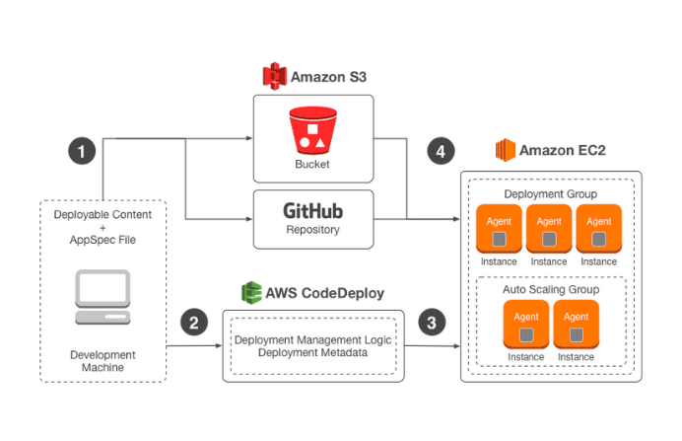

**Creating CloudFormation templates that have the latest configurations and code in them** is incorrect since it is used for provisioning and managing stacks of AWS resources based on templates you create to model your infrastructure architecture. CloudFormation is recommended if you want a tool for granular control over the provisioning and management of your own infrastructure.

**Using CodeCommit to publish your code quickly in a private repository and pushing them to your resources for fast updates** is incorrect as you mainly use CodeCommit for managing a source-control service that hosts private Git repositories. You can store anything from code to binaries and work seamlessly with your existing Git-based tools. CodeCommit integrates with CodePipeline and CodeDeploy to streamline your development and release process.

You could also use OpsWorks to deploy your code, however, **creating OpsWorks recipes that will automatically launch resources containing the latest version of the code** is still incorrect because you don't need to launch new resources containing your new code when you can just update the ones that are already running.

**References:**

<https://docs.aws.amazon.com/codedeploy/latest/userguide/deployment-groups.html>

<https://docs.aws.amazon.com/codedeploy/latest/userguide/welcome.html>

**Overview of Deployment Options on AWS whitepaper**

<https://d0.awsstatic.com/whitepapers/overview-of-deployment-options-on-aws.pdf>

**Check out this AWS CodeDeploy Cheat Sheet:**

[https://tutorialsdojo.com/aws-codedeploy/](https://tutorialsdojo.com/aws-codedeploy/?src=udemy)

**Elastic Beanstalk vs CloudFormation vs OpsWorks vs CodeDeploy:**

[https://tutorialsdojo.com/elastic-beanstalk-vs-cloudformation-vs-opsworks-vs-codedeploy/](https://tutorialsdojo.com/elastic-beanstalk-vs-cloudformation-vs-opsworks-vs-codedeploy/?src=udemy)

Bottom of Form

Top of Form

Question 57: Skipped

A new DevOps engineer has created a CloudFormation template for a web application and she raised a <code>pull request</code> in GIT for you to check and review. After checking the template, you immediately told her that the template will not work. Which of the following is the reason why this CloudFormation template will fail to deploy the stack?

1. {
2. "AWSTemplateFormatVersion":"2010-09-09",
3. "Parameters":{
4. "VPCId":{
5. "Type":"String",
6. "Description":"manila"
7. },
8. "SubnetId":{
9. "Type":"String",
10. "Description":"subnet-b46032ec"
11. }
12. },
13. "Outputs":{
14. "InstanceId":{
15. "Value":{
16. "Ref":"manilaInstance"
17. },
18. "Description":"Instance Id"
19. }
20. }
21. }

* ​

The Conditions section is missing.

* ​

The value of the AWSTemplateFormatVersion is incorrect. It should be 2017-06-06.

* ​

The Resources section is missing.

**(Correct)**

* ​

An invalid section named Parameters is present. This will cause the CloudFormation stack to fail.

**Explanation**

In **CloudFormation**, a template is a JSON or a YAML-formatted text file that describes your AWS infrastructure. Templates include several major sections. The Resources section is the only required section. Some sections in a template can be in any order. However, as you build your template, it might be helpful to use the logical ordering of the following list, as values in one section might refer to values from a previous section. Take note that all of the sections here are optional, except for Resources, which is the only one required.

- Format Version

- Description

- Metadata

- Parameters

- Mappings

- Conditions

- Transform

- Resources (required)

- Outputs

**Reference:**

<http://docs.aws.amazon.com/AWSCloudFormation/latest/UserGuide/template-anatomy.html>

**Check out this AWS CloudFormation Cheat Sheet:**

[https://tutorialsdojo.com/aws-cloudformation/](https://tutorialsdojo.com/aws-cloudformation/?src=udemy)

**AWS CloudFormation - Templates, Stacks, Change Sets:**

<https://www.youtube.com/watch?v=9Xpuprxg7aY>

Bottom of Form

Top of Form

Question 58: Skipped

A global news network created a CloudFront distribution for their web application. However, you noticed that the application's origin server is being hit for each request instead of the AWS Edge locations, which serve the cached objects. The issue occurs even for the commonly requested objects.

What could be a possible cause of this issue?

* ​

You did not add an SSL certificate.

* ​

The Cache-Control max-age directive is set to zero.

**(Correct)**

* ​

An object is only cached by Cloudfront once a successful request has been made hence, the objects were not requested before, which is why the request is still directed to the origin server.

* ​

The file sizes of the cached objects are too large for CloudFront to handle.

**Explanation**

You can control how long your objects stay in a CloudFront cache before CloudFront forwards another request to your origin. Reducing the duration allows you to serve dynamic content. Increasing the duration means your users get better performance because your objects are more likely to be served directly from the edge cache. A longer duration also reduces the load on your origin.

Typically, CloudFront serves an object from an edge location until the cache duration that you specified passes — that is, until the object expires. After it expires, the next time the edge location gets a user request for the object, CloudFront forwards the request to the origin server to verify that the cache contains the latest version of the object.

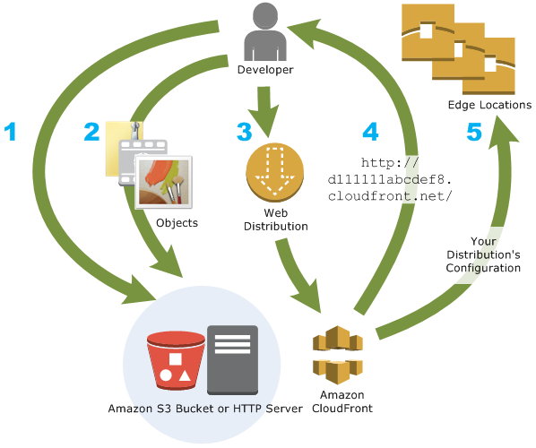

The Cache-Control and Expires headers control how long objects stay in the cache. The Cache-Control max-age directive lets you specify how long (in seconds) you want an object to remain in the cache before CloudFront gets the object again from the origin server. The minimum expiration time CloudFront supports is 0 seconds for web distributions and 3600 seconds for RTMP distributions.

In this scenario, the main culprit is that the Cache-Control max-age directive is set to a low value, which is why the request is always directed to your origin server.

Hence, the correct answer is: **The Cache-Control max-age directive is set to zero.**

The option that says: **An object is only cached by CloudFront once a successful request has been made hence, the objects were not requested before, which is why the request is still directed to the origin server** is incorrect because the issue also occurs even for the commonly requested objects. This means that these objects were successfully requested before but due to a zero Cache-Control max-age directive value, it causes this issue in CloudFront.

The options that say: **The file sizes of the cached objects are too large for CloudFront to handle** and **You did not add an SSL certificate** are incorrect because they are not related to the issue in caching.

**Reference:**

<http://docs.aws.amazon.com/AmazonCloudFront/latest/DeveloperGuide/Expiration.html>

**Check out this Amazon CloudFront Cheat Sheet:**

[https://tutorialsdojo.com/amazon-cloudfront/](https://tutorialsdojo.com/amazon-cloudfront/?src=udemy)

Bottom of Form

Top of Form

Question 59: Skipped

A construction company has an online system that tracks all of the status and progress of their projects. The system is hosted in AWS and there is a requirement to monitor the read and write IOPs metrics for their MySQL RDS instance and send real-time alerts to their DevOps team.

Which of the following services in AWS can you use to meet the requirements? (Select TWO.)

* ​

Amazon Simple Notification Service

**(Correct)**

* ​

SWF

* ​

CloudWatch

**(Correct)**

* ​

Route 53

* ​

Amazon Simple Queue Service

**Explanation**

In this scenario, you can use CloudWatch to monitor your AWS resources and SNS to provide notification. Hence, the correct answers are **CloudWatch** and **Amazon Simple Notification Service**.

**Amazon Simple Notification Service (SNS)** is a flexible, fully managed pub/sub messaging and mobile notifications service for coordinating the delivery of messages to subscribing endpoints and clients.

**Amazon CloudWatch** is a monitoring service for AWS cloud resources and the applications you run on AWS. You can use Amazon CloudWatch to collect and track metrics, collect and monitor log files, set alarms, and automatically react to changes in your AWS resources.

**SWF** is incorrect because this is mainly used for managing workflows and not for monitoring and notifications.

**Amazon Simple Queue Service** is incorrect because this is a messaging queue service and not suitable for this kind of scenario.

**Route 53** is incorrect because this is primarily used for routing and domain name registration and management.

**References:**

<http://docs.aws.amazon.com/AmazonCloudWatch/latest/monitoring/CW_Support_For_AWS.html>

<https://aws.amazon.com/sns/>

**Check out this Amazon CloudWatch Cheat Sheet:**

[https://tutorialsdojo.com/amazon-cloudwatch/](https://tutorialsdojo.com/amazon-cloudwatch/?src=udemy)

Bottom of Form

Top of Form

Question 60: Skipped

An application is hosted in an Auto Scaling group of EC2 instances and a Microsoft SQL Server on Amazon RDS. There is a requirement that all in-flight data between your web servers and RDS should be secured.

Which of the following options is the MOST suitable solution that you should implement? (Select TWO.)

* ​

Configure the security groups of your EC2 instances and RDS to only allow traffic to and from port 443.

* ​

Download the Amazon RDS Root CA certificate. Import the certificate to your servers and configure your application to use SSL to encrypt the connection to RDS.

**(Correct)**

* ​

Enable the IAM DB authentication in RDS using the AWS Management Console.

* ​

Force all connections to your DB instance to use SSL by setting the rds.force_ssl parameter to true. Once done, reboot your DB instance.

**(Correct)**

* ​

Specify the TDE option in an RDS option group that is associated with that DB instance to enable transparent data encryption (TDE).

**Explanation**

You can use Secure Sockets Layer (SSL) to encrypt connections between your client applications and your Amazon RDS DB instances running Microsoft SQL Server. SSL support is available in all AWS regions for all supported SQL Server editions.

When you create an SQL Server DB instance, Amazon RDS creates an SSL certificate for it. The SSL certificate includes the DB instance endpoint as the Common Name (CN) for the SSL certificate to guard against spoofing attacks.

There are 2 ways to use SSL to connect to your SQL Server DB instance:

- Force SSL for all connections — this happens transparently to the client, and the client doesn't have to do any work to use SSL.

- Encrypt specific connections — this sets up an SSL connection from a specific client computer, and you must do work on the client to encrypt connections.

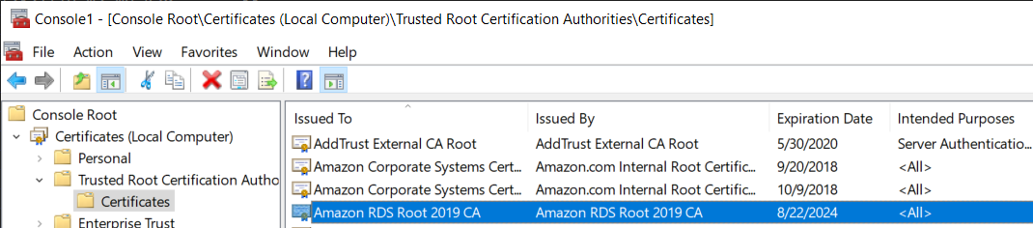

You can force all connections to your DB instance to use SSL, or you can encrypt connections from specific client computers only. To use SSL from a specific client, you must obtain certificates for the client computer, import certificates on the client computer, and then encrypt the connections from the client computer.

If you want to force SSL, use the rds.force_ssl parameter. By default, the rds.force_ssl parameter is set to false. Set the rds.force_ssl parameter to true to force connections to use SSL. The rds.force_ssl parameter is static, so after you change the value, you must reboot your DB instance for the change to take effect.

Hence, the correct answers for this scenario are the options that say:

**- Force all connections to your DB instance to use SSL by setting the rds.force_ssl parameter to true. Once done, reboot your DB instance.**

**- Download the Amazon RDS Root CA certificate. Import the certificate to your servers and configure your application to use SSL to encrypt the connection to RDS.**

**Specifying the TDE option in an RDS option group that is associated with that DB instance to enable transparent data encryption (TDE)** is incorrect because transparent data encryption (TDE) is primarily used to encrypt stored data on your DB instances running Microsoft SQL Server, and not the data that are in transit.

**Enabling the IAM DB authentication in RDS using the AWS Management Console** is incorrect because IAM database authentication is only supported in MySQL and PostgreSQL database engines. With IAM database authentication, you don't need to use a password when you connect to a DB instance but instead, you use an authentication token.

**Configuring the security groups of your EC2 instances and RDS to only allow traffic to and from port 443** is incorrect because it is not enough to do this. You need to either force all connections to your DB instance to use SSL, or you can encrypt connections from specific client computers, just as mentioned above.

**References:**

<https://docs.aws.amazon.com/AmazonRDS/latest/UserGuide/SQLServer.Concepts.General.SSL.Using.html>

<https://docs.aws.amazon.com/AmazonRDS/latest/UserGuide/Appendix.SQLServer.Options.TDE.html>

<https://docs.aws.amazon.com/AmazonRDS/latest/UserGuide/UsingWithRDS.IAMDBAuth.html>

**Check out this Amazon RDS Cheat Sheet:**

[https://tutorialsdojo.com/amazon-relational-database-service-amazon-rds/](https://tutorialsdojo.com/amazon-relational-database-service-amazon-rds/?src=udemy)

Bottom of Form

Top of Form

Question 61: Skipped

In a tech company that you are working for, there is a requirement to allow one IAM user to modify the configuration of one of your Elastic Load Balancers (ELB) which is used in a specific project. Each developer in your company has an individual IAM user and they usually move from one project to another.

Which of the following would be the best way to allow this access?

* ​

Create a new IAM user that has access to modify the ELB. Delete that user when the work is completed.

* ​

Create a new IAM Role which will be assumed by the IAM user. Attach a policy allowing access to modify the ELB and once it is done, remove the IAM role from the user.

**(Correct)**

* ​

Open up the port that ELB uses in a security group and then give the user access to that security group via a policy.

* ​

Provide the user temporary access to the root account for 8 hours only. Afterwards, change the password once the activity is completed.

**Explanation**

In this scenario, the best option is to use **IAM Role** to provide access. You can create a new IAM Role then associate it to the IAM user. Attach a policy allowing access to modify the ELB and once it is done, remove the IAM role to the user.

An **IAM role** is similar to a user in that it is an AWS identity with permission policies that determine what the identity can and cannot do in AWS. However, instead of being uniquely associated with one person, a role is intended to be assumable by anyone who needs it. Also, a role does not have standard long-term credentials (password or access keys) associated with it. Instead, if a user assumes a role, temporary security credentials are created dynamically and provided to the user.

You can use roles to delegate access to users, applications, or services that don't normally have access to your AWS resources. For example, you might want to grant users in your AWS account access to resources they don't usually have, or grant users in one AWS account access to resources in another account. Or you might want to allow a mobile app to use AWS resources, but not want to embed AWS keys within the app (where they can be difficult to rotate and where users can potentially extract them). Sometimes you want to give AWS access to users who already have identities defined outside of AWS, such as in your corporate directory. Or, you might want to grant access to your account to third parties so that they can perform an audit on your resources.

**Reference:**

<https://docs.aws.amazon.com/IAM/latest/UserGuide/id_roles_create_for-user.html>

**Check out this AWS IAM Cheat Sheet:**

[https://tutorialsdojo.com/aws-identity-and-access-management-iam/](https://tutorialsdojo.com/aws-identity-and-access-management-iam/?src=udemy)

Bottom of Form

Top of Form

Question 62: Skipped

A multinational company has been building its new data analytics platform with high-performance computing workloads (HPC) which requires a scalable, POSIX-compliant storage service. The data need to be stored redundantly across multiple AZs and allows concurrent connections from thousands of EC2 instances hosted on multiple Availability Zones.

Which of the following AWS storage service is the most suitable one to use in this scenario?

* ​

Amazon S3

* ​

Amazon ElastiCache

* ​

Amazon Elastic File System

**(Correct)**

* ​

Amazon EBS Volumes

**Explanation**

In this question, you should take note of this phrase, "allows concurrent connections from multiple EC2 instances". There are various AWS storage options that you can choose but whenever these criteria show up, always consider using EFS instead of using EBS Volumes which is mainly used as a "block" storage and can only have one connection to one EC2 instance at a time.

Amazon EFS is a fully-managed service that makes it easy to set up and scale file storage in the Amazon Cloud. With a few clicks in the AWS Management Console, you can create file systems that are accessible to Amazon EC2 instances via a file system interface (using standard operating system file I/O APIs) and supports full file system access semantics (such as strong consistency and file locking).

Amazon EFS file systems can automatically scale from gigabytes to petabytes of data without needing to provision storage. Tens, hundreds, or even thousands of Amazon EC2 instances can access an Amazon EFS file system at the same time, and Amazon EFS provides consistent performance to each Amazon EC2 instance. Amazon EFS is designed to be highly durable and highly available.

**References:**

<https://docs.aws.amazon.com/efs/latest/ug/performance.html>

<https://aws.amazon.com/efs/faq/>

**Check out this Amazon EFS Cheat Sheet:**

[https://tutorialsdojo.com/amazon-efs/](https://tutorialsdojo.com/amazon-efs/?src=udemy)

**Here's a short video tutorial on Amazon EFS:**

https://youtu.be/AvgAozsfCrY

Bottom of Form

Top of Form

Question 63: Skipped

A Solutions Architect is implementing a new High-Performance Computing (HPC) system in AWS that involves orchestrating several Amazon Elastic Container Service (Amazon ECS) tasks with an EC2 launch type that is part of an Amazon ECS cluster. The system will be frequently accessed by users around the globe and it is expected that there would be hundreds of ECS tasks running most of the time. The Architect must ensure that its storage system is optimized for high-frequency read and write operations. The output data of each ECS task is around 10 MB but the obsolete data will eventually be archived and deleted so the total storage size won’t exceed 10 TB.

Which of the following is the MOST suitable solution that the Architect should recommend?

* ​

Launch an Amazon Elastic File System (Amazon EFS) file system with Bursting Throughput mode and set the performance mode to General Purpose. Configure the EFS file system as the container mount point in the ECS task definition of the Amazon ECS cluster.

* ​

Set up an SMB file share by creating an Amazon FSx File Gateway in Storage Gateway. Set the file share as the container mount point in the ECS task definition of the Amazon ECS cluster.

* ​

Launch an Amazon DynamoDB table with Amazon DynamoDB Accelerator (DAX) and DynamoDB Streams enabled. Configure the table to be accessible by all Amazon ECS cluster instances. Set the DynamoDB table as the container mount point in the ECS task definition of the Amazon ECS cluster.

* ​

Launch an Amazon Elastic File System (Amazon EFS) with Provisioned Throughput mode and set the performance mode to  Max I/O. Configure the EFS file system as the container mount point in the ECS task definition of the Amazon ECS cluster.

**(Correct)**

**Explanation**

**Amazon Elastic File System (Amazon EFS)** provides simple, scalable file storage for use with your Amazon ECS tasks. With Amazon EFS, storage capacity is elastic, growing and shrinking automatically as you add and remove files. Your applications can have the storage they need when they need it.

You can use Amazon EFS file systems with Amazon ECS to access file system data across your fleet of Amazon ECS tasks. That way, your tasks have access to the same persistent storage, no matter the infrastructure or container instance on which they land. When you reference your Amazon EFS file system and container mount point in your Amazon ECS task definition, Amazon ECS takes care of mounting the file system in your container.

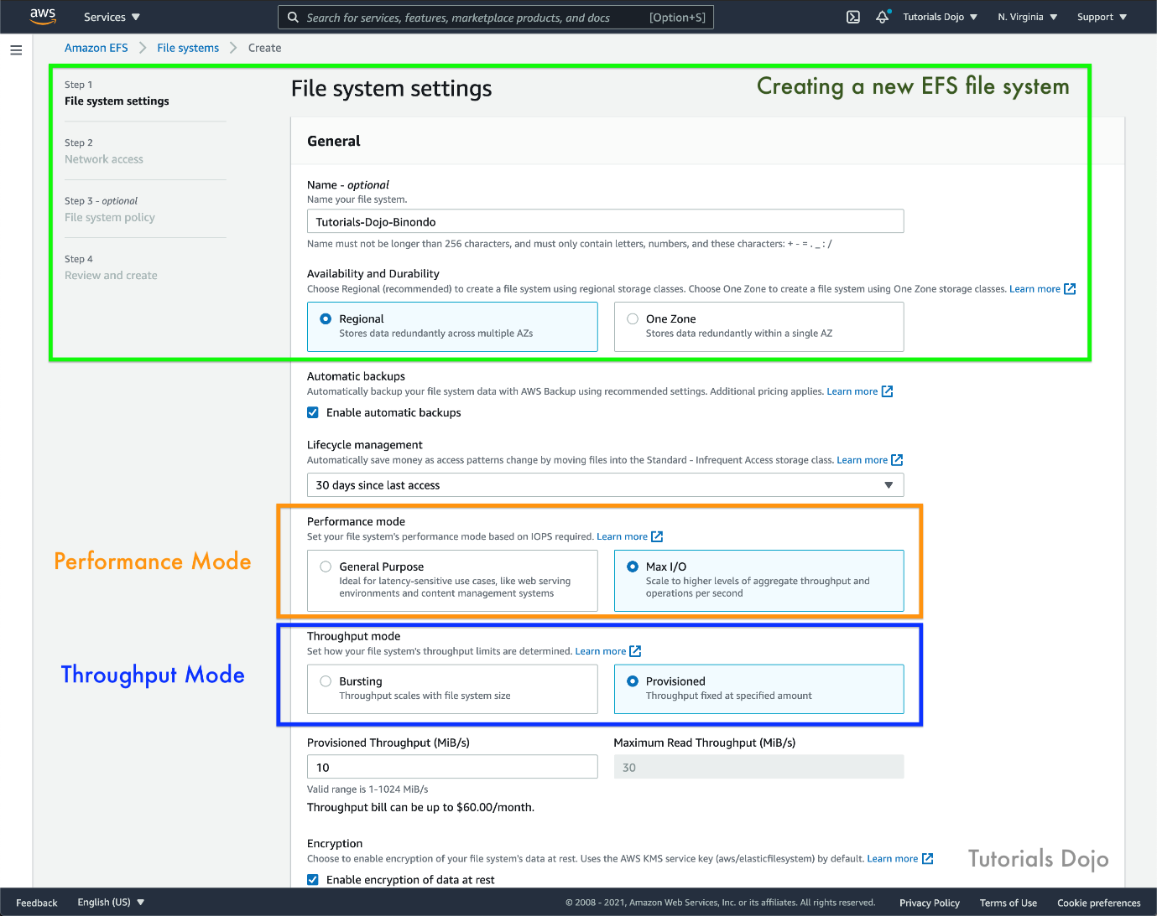

To support a wide variety of cloud storage workloads, Amazon EFS offers two performance modes:

- General Purpose mode

- Max I/O mode.

You choose a file system's performance mode when you create it, and it cannot be changed. The two performance modes have no additional costs, so your Amazon EFS file system is billed and metered the same, regardless of your performance mode.

There are two throughput modes to choose from for your file system:

- Bursting Throughput

- Provisioned Throughput

With Bursting Throughput mode, a file system's throughput scales as the amount of data stored in the EFS Standard or One Zone storage class grows. File-based workloads are typically spiky, driving high levels of throughput for short periods of time, and low levels of throughput the rest of the time. To accommodate this, Amazon EFS is designed to burst to high throughput levels for periods of time.

Provisioned Throughput mode is available for applications with high throughput to storage (MiB/s per TiB) ratios, or with requirements greater than those allowed by the Bursting Throughput mode. For example, say you're using Amazon EFS for development tools, web serving, or content management applications where the amount of data in your file system is low relative to throughput demands. Your file system can now get the high levels of throughput your applications require without having to pad your file system.

In the scenario, the file system will be frequently accessed by users around the globe so it is expected that there would be hundreds of ECS tasks running most of the time. The Architect must ensure that its storage system is optimized for high-frequency read and write operations.

Hence, the correct answer is:**Launch an Amazon Elastic File System (Amazon EFS) with Provisioned Throughput mode and set the performance mode to Max I/O. Configure the EFS file system as the container mount point in the ECS task definition of the Amazon ECS cluster.**

The option that says: **Set up an SMB file share by creating an Amazon FSx File Gateway in Storage Gateway. Set the file share as the container mount point in the ECS task definition of the Amazon ECS cluster** is incorrect. Although you can use an Amazon FSx for Windows File Server in this situation, it is not appropriate to use this since the application is not connected to an on-premises data center. Take note that the AWS Storage Gateway service is primarily used to integrate your existing on-premises storage to AWS.

The option that says: **Launch an Amazon Elastic File System (Amazon EFS) file system with Bursting Throughput mode and set the performance mode to General Purpose. Configure the EFS file system as the container mount point in the ECS task definition of the Amazon ECS cluster** is incorrect because using Bursting Throughput mode won't be able to sustain the constant demand of the global application. Remember that the application will be frequently accessed by users around the world and there are hundreds of ECS tasks running most of the time.

The option that says: **Launch an Amazon DynamoDB table with Amazon DynamoDB Accelerator (DAX) and DynamoDB Streams enabled. Configure the table to be accessible by all Amazon ECS cluster instances. Set the DynamoDB table as the container mount point in the ECS task definition of the Amazon ECS cluster** is incorrect because you cannot directly set a DynamoDB table as a container mount point. In the first place, DynamoDB is a database and not a file system which means that it can't be "mounted" to a server.

**References:**

<https://docs.aws.amazon.com/AmazonECS/latest/developerguide/tutorial-efs-volumes.html>

<https://docs.aws.amazon.com/efs/latest/ug/performance.html>

<https://docs.aws.amazon.com/AmazonECS/latest/developerguide/tutorial-wfsx-volumes.html>

**Check out this Amazon EFS Cheat Sheet:**

[https://tutorialsdojo.com/amazon-efs/](https://tutorialsdojo.com/amazon-efs/?src=udemy)

Bottom of Form

Top of Form

Question 64: Skipped

A company developed a financial analytics web application hosted in a Docker container using MEAN (MongoDB, Express.js, AngularJS, and Node.js) stack. You want to easily port that web application to AWS Cloud which can automatically handle all the tasks such as balancing load, auto-scaling, monitoring, and placing your containers across your cluster.

Which of the following services can be used to fulfill this requirement?

* ​

AWS CodeDeploy

* ​

AWS Elastic Beanstalk

**(Correct)**

* ​

ECS

* ​

OpsWorks

**Explanation**

**AWS Elastic Beanstalk** supports the deployment of web applications from Docker containers. With Docker containers, you can define your own runtime environment. You can choose your own platform, programming language, and any application dependencies (such as package managers or tools), that aren't supported by other platforms. Docker containers are self-contained and include all the configuration information and software your web application requires to run.

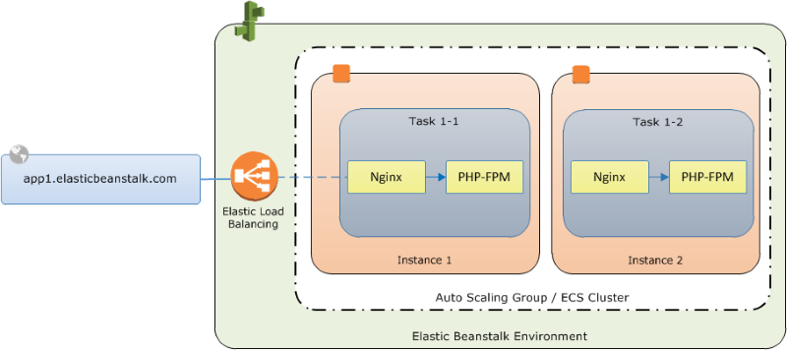

By using Docker with Elastic Beanstalk, you have an infrastructure that automatically handles the details of capacity provisioning, load balancing, scaling, and application health monitoring. You can manage your web application in an environment that supports the range of services that are integrated with Elastic Beanstalk, including but not limited to VPC, RDS, and IAM.

Hence, the correct answer is: **AWS Elastic Beanstalk.**

**ECS** is incorrect. Although it also provides Service Auto Scaling, Service Load Balancing, and Monitoring with CloudWatch, these features are not ***automatically*** enabled by default unlike with Elastic Beanstalk. Take note that the scenario requires a service that will***automatically****handle all the tasks such as balancing load, auto-scaling, monitoring, and placing your containers across your cluster.*You will have to manually configure these things if you wish to use ECS. With Elastic Beanstalk, you can manage your web application in an environment that supports the range of services easier.

**OpsWorks** and **AWS CodeDeploy** are incorrect because these are primarily used for application deployment and configuration only, without providing load balancing, auto-scaling, monitoring, or ECS cluster management.

**Reference:**

<https://docs.aws.amazon.com/elasticbeanstalk/latest/dg/create_deploy_docker.html>

**Check out this AWS Elastic Beanstalk Cheat Sheet:**

[https://tutorialsdojo.com/aws-elastic-beanstalk/](https://tutorialsdojo.com/aws-elastic-beanstalk/?src=udemy)

**Elastic Beanstalk vs CloudFormation vs OpsWorks vs CodeDeploy:**

[https://tutorialsdojo.com/elastic-beanstalk-vs-cloudformation-vs-opsworks-vs-codedeploy/](https://tutorialsdojo.com/elastic-beanstalk-vs-cloudformation-vs-opsworks-vs-codedeploy/?src=udemy)

**Comparison of AWS Services Cheat Sheets:**

[https://tutorialsdojo.com/comparison-of-aws-services/](https://tutorialsdojo.com/comparison-of-aws-services/?src=udemy)

Bottom of Form

Top of Form

Question 65: Skipped

A computer animation film studio has a web application running on an Amazon EC2 instance. It uploads 5 GB video objects to an Amazon S3 bucket. Video uploads are taking longer than expected, which impacts the performance of your application.

Which method will help improve the performance of the application?

* ​

Leverage on Amazon CloudFront and use HTTP POST method to reduce latency.

* ​

Use Amazon Elastic Block Store Provisioned IOPS and an Amazon EBS-optimized instance.

* ​

Enable Enhanced Networking with the Elastic Network Adapter (ENA) on your EC2 Instances.

* ​

Use Amazon S3 Multipart Upload API.

**(Correct)**

**Explanation**

The main issue is the slow upload time of the video objects to Amazon S3. To address this issue, you can use Multipart upload in S3 to improve the throughput. It allows you to upload parts of your object in parallel thus, decreasing the time it takes to upload big objects. Each part is a contiguous portion of the object's data.

You can upload these object parts independently and in any order. If transmission of any part fails, you can retransmit that part without affecting other parts. After all parts of your object are uploaded, Amazon S3 assembles these parts and creates the object. In general, when your object size reaches 100 MB, you should consider using multipart uploads instead of uploading the object in a single operation.

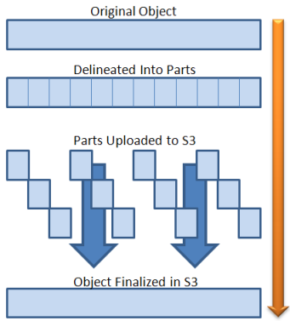

Using multipart upload provides the following advantages:

**Improved throughput** - You can upload parts in parallel to improve throughput.

**Quick recovery from any network issues** - Smaller part size minimizes the impact of restarting a failed upload due to a network error.

**Pause and resume object uploads** - You can upload object parts over time. Once you initiate a multipart upload, there is no expiry; you must explicitly complete or abort the multipart upload.

**Begin an upload before you know the final object size** - You can upload an object as you are creating it.

**Enabling Enhanced Networking with the Elastic Network Adapter (ENA) on your EC2 Instances** is incorrect. Even though this will improve network performance, the issue will still persist since the problem lies in the upload time of the object to Amazon S3. You should use the Multipart upload feature instead.

**Leveraging on Amazon CloudFront and using HTTP POST method to reduce latency** is incorrect because CloudFront is a CDN service and is not used to expedite the upload process of objects to Amazon S3. Amazon CloudFront is a fast content delivery network (CDN) service that securely delivers data, videos, applications, and APIs to customers globally with low latency, high transfer speeds, all within a developer-friendly environment.

**Using Amazon Elastic Block Store Provisioned IOPS and an Amazon EBS-optimized instance** is incorrect. Although the use of Amazon Elastic Block Store Provisioned IOPS will speed up the I/O performance of the EC2 instance, the root cause is still not resolved since the primary problem here is the slow video upload to Amazon S3. There is no network contention in the EC2 instance.

**References:**

<https://docs.aws.amazon.com/AmazonS3/latest/dev/uploadobjusingmpu.html>

<http://docs.aws.amazon.com/AmazonS3/latest/dev/qfacts.html>

**Check out this Amazon S3 Cheat Sheet:**

[https://tutorialsdojo.com/amazon-s3/](https://tutorialsdojo.com/amazon-s3/?src=udemy)

Bottom of Form